OUTCOMES 2024 - 2026
Denise Feasey Headteacher

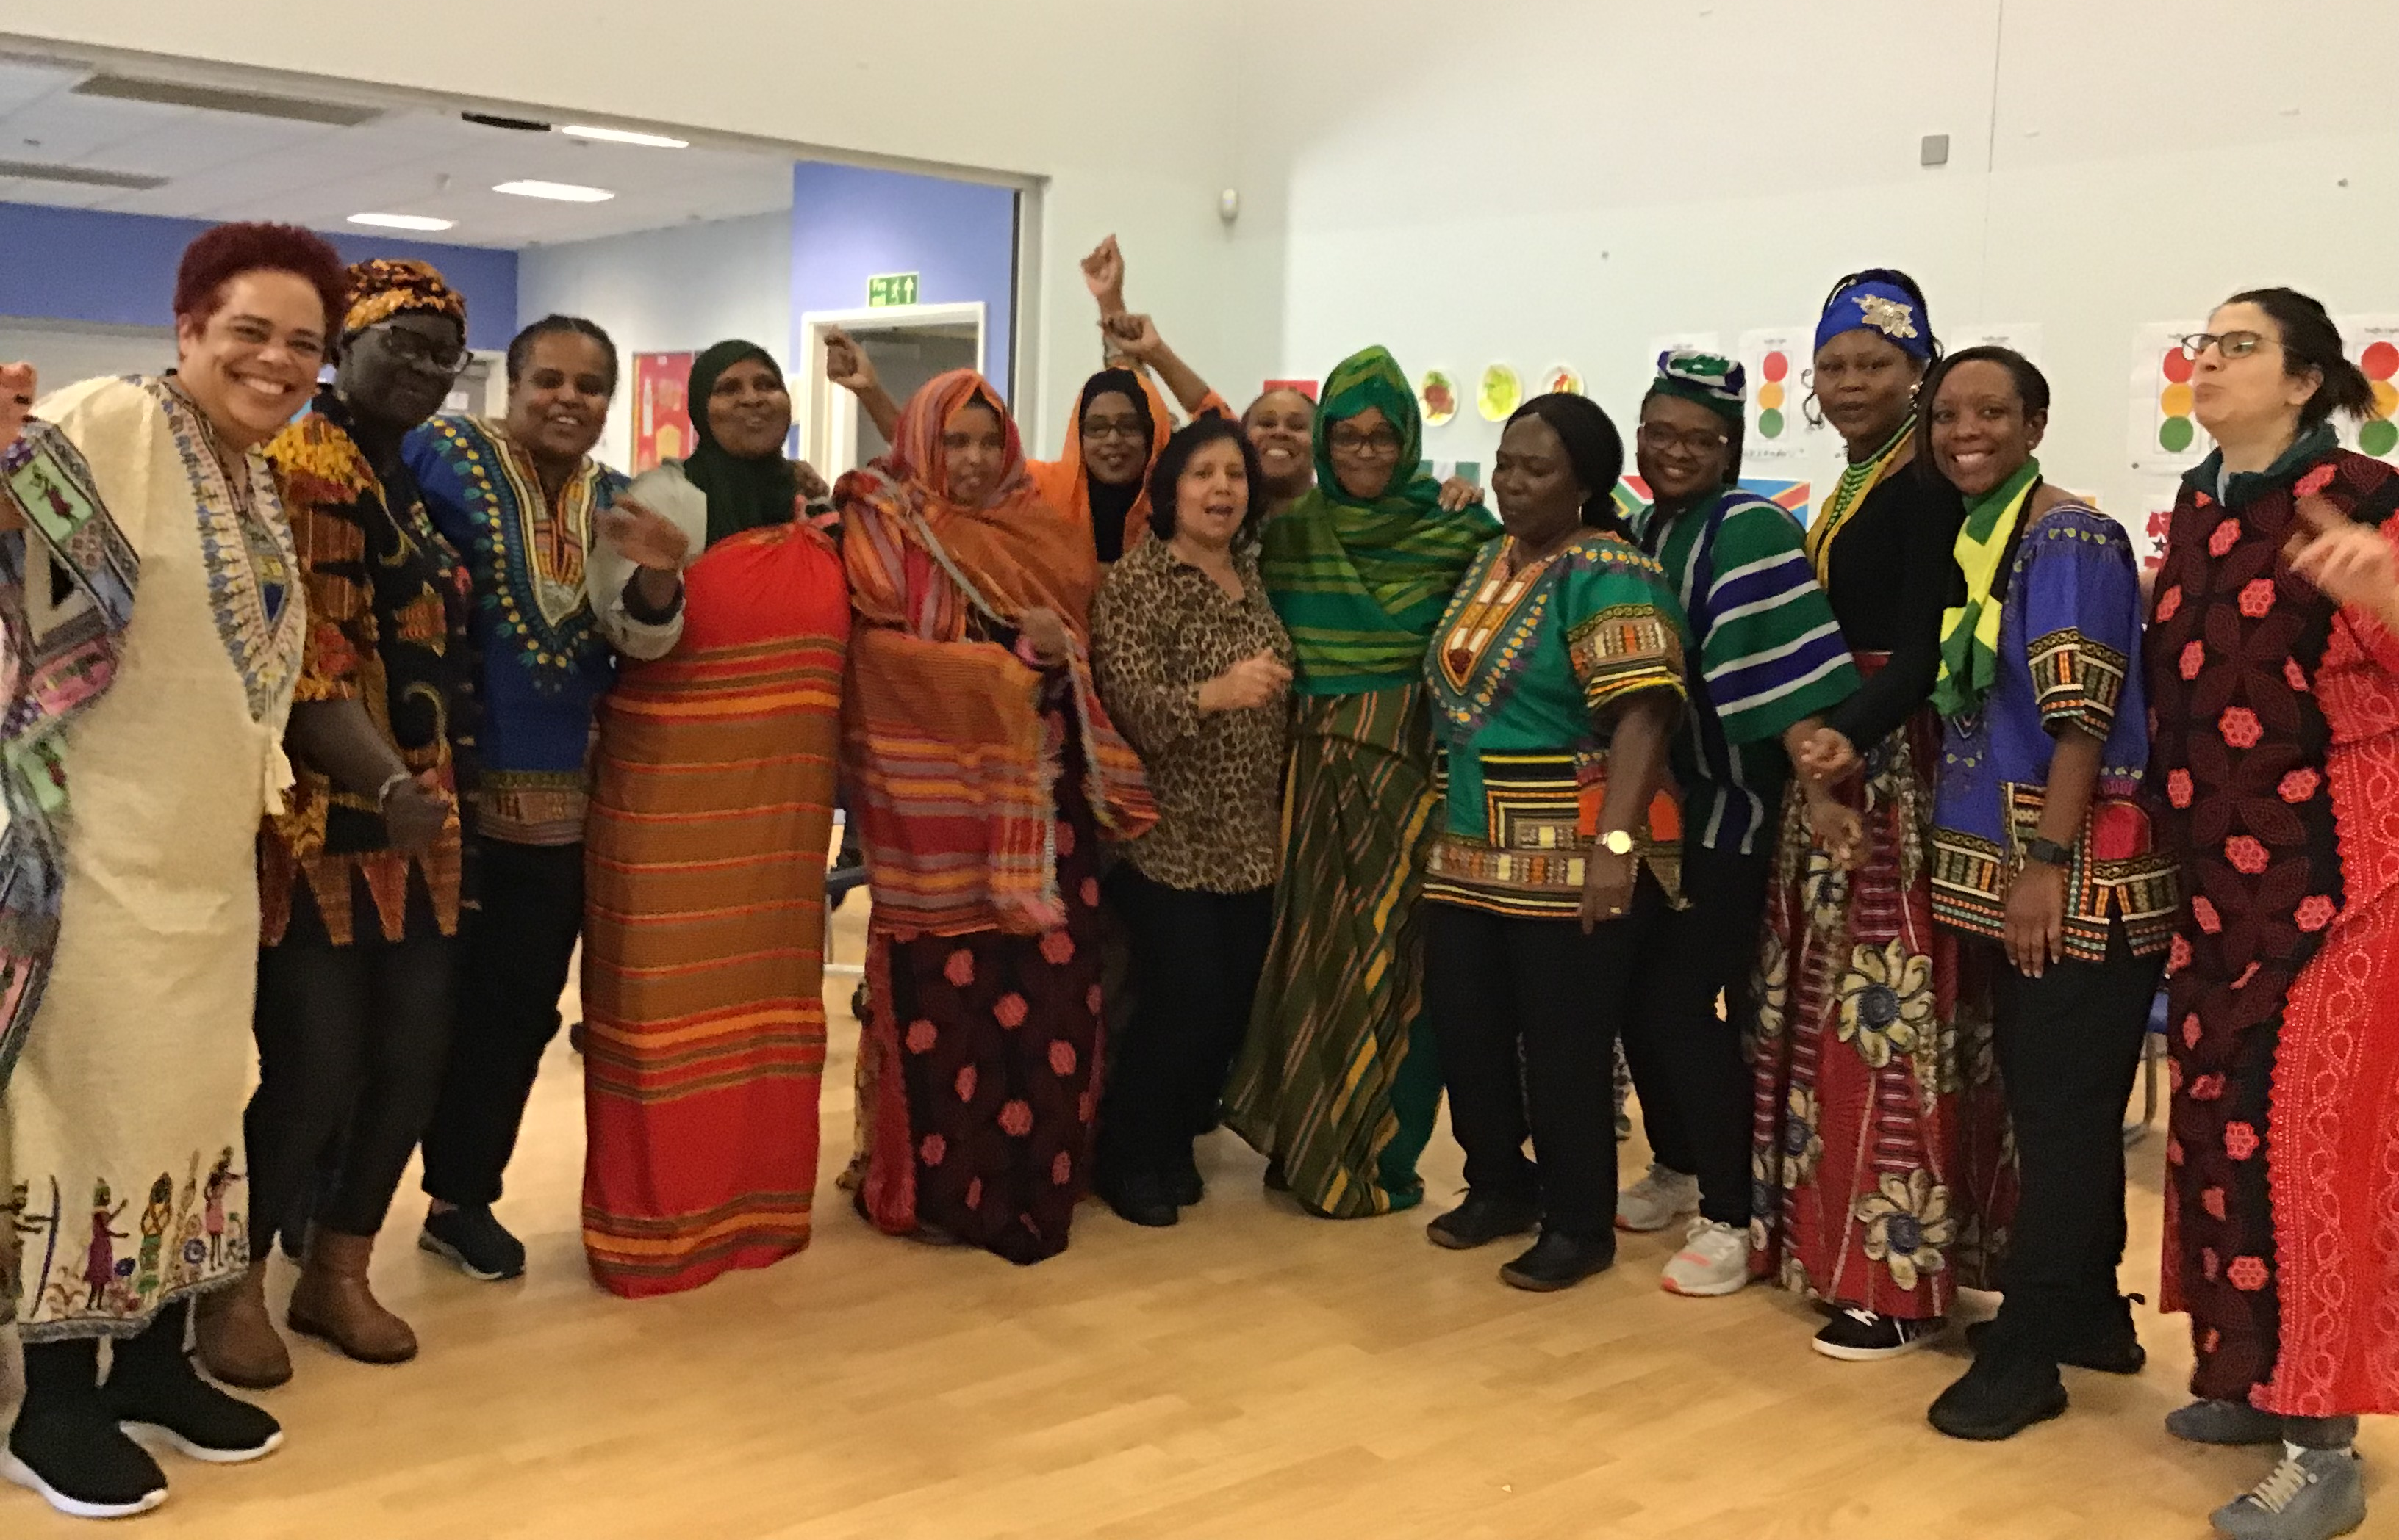
Mandeville School Improvement Plan

Celebrating Black History
OUTCOME 1
MANDEVILLE IDENTITY AND BUILDING PARTNERSHIPS
- Mandeville learning pathways - To continue to build whole school understanding of Mandeville’s five distinct pathways - ensuring they develop the same breadth and depth of knowledge for all staff.

- SEND and Inclusion – Support LA to build mainstream schools offer for SEND pupils –To develop the satellite site as high quality provision that meets the needs of children with SEND and explore ways of using the location to bridge the gap between mainstream and specialist education. To build partnership between SEND and Inclusion and EPL Learning and Achievement Committee (ELP working party).

Maintenance targets – oversight of established areas/small projects
- SEND and Inclusion – Chair of ELP SEND and inclusion committee (Head)
- Admissions guidance – LA working group (Head)

OUTCOME 2
STRENTHEN MANDEVILLE OFFER TO IMPROVE OUTCOMES FOR ALL PUPILS
- To provide mainstream schools with a bespoke outreach and training offer that supports the prevention of placement breakdown for pupils with SEND (funded by LA) – (2023-2026) – To continue to develop Mandeville offer for mainstream schools through a comprehensive outreach offer, including the development of mainstream curriculum and approaches for children with SEND (Income generating – cost neutral – supporting SEND in Ealing) – link business plan

- To embed Mandeville Relation Approach so that pupils feel supported and are better equipped to manage their sensory needs and emotions (2023-2026) To build a comprehensive (link to business plan, new funding arrangements and staffing structure changes)

Maintenance targets – oversight of established areas/small projects
- Communication and Interaction, cognition and learning, social emotional and mental health, sensory and/or physical needs through music therapy, poetry and occupational therapy Pupil premium 2024.2025
- Integrated work with social care – access to ASW information - link safeguarding action plan

OUTCOME 3
MANDEVILLE WORKING WELL FOR PUPILS, STAFF AND PARENTS
To build a sustainable model for staff development
- To introduce and develop the National College CPD platform at Mandeville. To build a bespoke platform so that a comprehensive training package informs our processes for induction, probation and career development opportunities
- Further develop the role of support staff – To ensure every member of Mandeville’s team fully understand the purpose and responsibilities of their role in terms of pupils’ learning and care.

Maintenance targets – oversight of established areas/small projects
- Mandeville working well group
- Events and parties working parties
- Special assembly working parties
- Mental health first aiders

OUTCOME 4
BUILDING PARTNERSHIP WITH PARENTS AND THE COMMUNITY
School has a partnership with parents based on the co-production model (2023-2026)

Appraisal target (2024-2025)
- Effective use of the community to support children’s learning and engagement of parents in the process (link to race equality)

Maintenance targets – oversight of established areas/small projects

- Seesaw success of and where next – throughout school and support system in place, how to use the data to inform practice – focus on involving parents who are not main carers
- Early birds training – model for working in class – evaluation of impact of training autism and behavior
- Buddy system – evaluate impact so far and continue or set as maintenance target

OUTCOME 5
HIGH QUALITY CURRICULUM AND ASSESSMENT
- Develop the understanding the world curriculum and approaches (including progression in science, past and present, people cultures and communities) – (2024-2026)- curriculum budget
- Develop a creative arts curriculum (music, art, drama) (2025-2026) – curriculum budget

Appraisal
- Pupils make progress in their outcomes through high quality teaching and learning by having access to learning and resources that reflects their cultural background (in the indoor and outdoor classroom and the local community) (2024.2025)
- Pupils make good progress from their starting point in named subject area (all staff have a subject based objective) 2024.2025

Maintenance targets – oversight of established areas/small projects

- Physical development – accessing specialist physical activities in the local community – sports premium HLTA
- Literacy – phonics –Mandeville whole school appraisal – curriculum budget and refer to pupil premium
- Sensory processing needs – CPD budget – refer to pupil premium
- Yoga - impact of training – CPD plan – refer to pupil premium
- Aromatherapy – impact of training CPD budget

OUTCOME 6
Race Equality – embedded in all development areas
- Leadership – embedding 3 year program (2023-2026)
- Engaging parents and communities as assets (link outcome 4) (2024-2026)
- Curriculum progression and inclusion (link outcome 5) (2024-2026)
- Developing cultures and behavior (De-colonisation the mind training for staff) (2023-2025)
- Inclusive recruitment and retention (2024-2026)

LA development area till 2026 – proposal needs to include cost implications over time – short and long term aims
https://www.egfl.org.uk/news/2022/09/ealing%E2%80%99s-race-equality-commission-and-inclusion-expectations-schools-2022-2026

School Accessibility Planning 2022 - 2025

- Learning pathways linked to Descriptors of needs
- Medical needs in school – review process with CCG – access to specialist health care
- Development of the satellite provision

Key staffing areas of issue | The line management structure takes account of staff expertise and experience and provides support and development opportunities. It is based on the principle of enabling and empowering staff so that leadership is developed and distributed at all levels within school. Senior leaders provide cover and support in classes where a need is identified through proactive planning or monitoring systems.  Governors have identified risks and opportunities within the current staffing structure, and these will be given consideration and consultation if they progress.
Budget information  Please also refer to Mandeville School Business Plan | Descriptors of need  Medical conditions in school

The School Improvement Plan runs alongside the School Business Plan

Actions taken from SEF to be included in SIP area action plans
- Moderation of learning targets – sharing good practice and sharper focus
- Further develop our shared understanding of what an achieved target looks like though moderation and discussion, internal and external.
- Moderate our understanding and the grading of the ‘working towards’ ‘emerging’ and ‘achieved’ criteria.
- Track progress for black heritage including Somali and adapt learning as appropriate.
- Appraisal targets linked to sustainable model for subject development
- Build model for supporting mainstream colleagues
- Work with LA SEND lead to share Mandeville curriculum with mainstream schools and other nurseries.
- Further develop our curriculum, resources, policies and practice to become a more culturally competent school.
- Race equality – further develop a curriculum that reflects and represents the cultural diversity of the school community.
- Involve parents from different cultures to support the development of the curriculum.
- Embed our Anti-Racist Policy
- Continue to build on the success of the NC learning platform.
- Become a Rights Respecting School

