Pupil premium strategy statement: 2024-2025 Mandeville School

This statement details our school’s use of pupil premium (for the 2024 to 2025 academic year) funding to help improve the attainment of our disadvantaged pupils.

It outlines our pupil premium strategy, how we intend to spend the funding in this academic year and the effect that last year’s spending of pupil premium had within our school.

School overview
Detail | Data
Number of pupils in school | 174
Proportion (%) of pupil premium eligible pupils | 30.5% (53 pupil)
Academic years that our current pupil premium strategy plan covers | 2024 – 2025  2025 – 2026  2026 – 2027 ye
Date this statement was published | 06 Nov 2024
Date on which it will be reviewed | July 2025
Statement authorised by | Denise Feasey  Headteacher
Pupil premium lead | Mundrika Bhanderi
Governor / Trustee lead | John Burgess

Funding overview
Detail | Amount
Pupil premium funding allocation this academic year | £78,440
Pupil premium funding carried forward from previous years (enter £0 if not applicable) | £0
Total budget for this academic year  If your school is an academy in a trust that pools this funding, state the amount available to your school this academic year | £78,440

Part A: Pupil premium strategy plan

Statement of intent
- At Mandeville School we aim to use pupil premium funding to support pupils from disadvantage backgrounds with achieving positive outcomes in key areas of their development (dependent on their individual needs).
- We aim to train our staff in teaching children using a wide range of teaching approaches so they can engage in personalised learning.
- The pupils will achieve positive outcomes in the key areas of their SEND development:
  - Communication & interaction
  - Cognition & learning
  - Social, emotional & mental Health difficulties
  - Sensory and/or physical needs
https://assets.publishing.service.gov.uk/media/5a7dcb85ed915d2ac884d995/SEND_Code_of_Practice_January_2015.pdf pg 97.

- Although our strategy is focused on the needs of disadvantaged pupils, it will benefit all pupils in our school, with a special focus on children who have transferred from mainstream provision. The funding is spent on:
  - High quality teaching
  - Targeted academic support
  - Wider strategies
- Our strategy will be driven by the needs and strengths of each young person, based on formal and informal assessments.

Challenges
This details the key challenges to achievement that we have identified among our disadvantaged pupils.
Challenge number | Detail of challenge
1 | The intake of children coming to Mandeville School are presenting with higher sensory needs and complex needs. We have identified a need to understand how to support the children to regulate and for staff to co-regulate. We have therefore adopted and developed the relational approach across the school to meet the needs of our children and staff.
2. | More of our families have experienced eviction over the last year. This impacted on the children’s emotional and physical needs. This process has also resulted in extended absences from school.
3 | Our internal assessments show that children with a disadvantage background achieved less in:  KS1: Literacy, Maths & Personal, Social Emotional Development  KS2: Literacy, Maths & Physical Development
4 | Intake of children from mainstream schools has been higher. Children have come from placements where staff were not trained, resources not available to meet their needs and were on reduced school timetable (many only a couple of hours a day), some eventually leading to a breakdown in provision.
5 | Children were born during or affected by COVID where they had limited access to services. Some children’s reports and EHCPs were written by professionals who carried out assessments and observations online, which resulted in less robust EHCPs (education health and care plans).

Intended outcomes
This explains the outcomes we are aiming for by the end of our current strategy plan for 2024 - 2025, and how we will measure whether they have been achieved.
Intended outcome | Success criteria
Children to make progress from their starting point (Sept 2024) in KS1 Literacy, Maths, PSED | Children achieve their individualised targets by July 2025.
Children to make progress from their starting point (Sept 2024) in KS2 Literacy, Maths and Physical Development | Children achieve their individualised targets by July 2025.
Pupils will develop communication skills, self-confidence and relationship with both adults and children | Through observations and progress from starting points.
Staff understand children’s emotional needs and are equipped to co-regulate with the children | Staff reflection on their own practice and well-being.  Staff can explain pupils needs with a deeper holistic understanding (taking into account pupils family background, emotional well-being and developmental needs)
Pupils understand and can actively engage in (with some adult support) a range strategies that meet their self- regulation, emotional and sensory needs | Children are better regulated and can access learning for longer periods

Activity in this academic year
This details how we intend to spend our pupil premium funding this academic year to address the challenges listed above.

High Quality Teaching
Budgeted cost: £50,500
Activity | Evidence that supports this approach | Challenge number(s) addressed
Music Therapy: in one to one and small groups children develop self-confidence, increased interaction with others, communication & language skills and social, emotional skills. | Music therapy is provided by Ealing Music Therapy.  “Through the use of music therapy, children and young adults can help make connections and build confidence such as people interactions and help put their emotions into words”.  https://www.ealingmusictherapy.org/ | 1, 2, 3
Poetry/ Call & Response sessions – in small group and whole group (whole class) sessions, children develop literacy, communication & language and personal, social emotional development skills. | NEED A LINK TO EVIDENCE BASED PRACTICE  CHECK WITH PHILIP | 1, 2, 3, 4
Physical Development – monitoring and moderation of children’s targets to ensure all targets are SMART | Ensuring the attainment of pupils with SEND is realistic and appropriate to pupils’ individual needs. SMART targets are set to ensure the pupils achieve and make progress within their learning.  https://schoolleaders.thekeysupport.com/curriculum-and-learning/raising-attainment/raising-achievement-specific-groups/raising-achievement-in-sen/ | 3

Targeted academic support (for example, tutoring, one-to-one support, structured interventions)
Budgeted cost: £19590
Activity | Evidence that supports this approach | Challenge number(s) addressed
Children make progress within their IEP targets through 1:1 tutoring (focus on maths, literacy, personal social emotional development in KS1 and literacy, maths in KS2)  Staff receive training on effect 1:1 tutoring strategies  Children make progress in Communication & Language, Literacy and PSED targets through small group tutoring (sensory stories and imaginative play skills) | Tutoring can have a positive impact on pupils’ academic progress. Evidence suggests that, compared to their peers who do not receive tuition, pupils who receive small group tuition may make, on average, 4 months additional progress and pupils who receive one-to-one tuition may make, on average, 5 months additional progress. This is likely linked to pupils receiving more feedback, being more engaged and completing work tailored to their specific needs.  On average, one to one tuition is very effective at improving pupil outcomes. One to one tuition might be an effective strategy for providing targeted support for pupils that are identified as having low prior attainment or are struggling in particular areas.  https://educationendowmentfoundation.org.uk/education-evidence/teaching-learning-toolkit/one-to-one-tuition | 3, 4, 5

Wider strategies (for example, related to attendance, behaviour, wellbeing)
Budgeted cost: £8780
Activity | Evidence that supports this approach | Challenge number(s) addressed
Through whole school training on Relational Approaches, staff have a better understanding of pupils social, emotional and self-regulation needs as well as co-regulating with the children | The relational approach suggests that children need consequences that teach them, rather than punishment. Relevant consequences, rather than arbitrary ones, are fairer and help children to understand the effect their behaviour has on others.  It is through relationships that children learn to feel safe, belong, understand themselves, others and the world. The relational approach is a universal.  https://www.devon.gov.uk/support-schools-settings/document/quick-guide-to-developing-relational-practice-and-policy/  https://www.wakefieldscp.org.uk/wp-content/uploads/2023/11/Relate-to-Educate-Relational-Guidance.pdf | 1 – 6
Four Teachers and school Occupational Therapist are trained to deliver Aromatherapy and cascade principles of massage, which supports pupils self-regulation and emotional needs as well as developing their communication skills. | Aromatherapy may enhance wellbeing as part of a healthy lifestyle, by offering therapeutic benefits for a range of physical and physiological conditions. This includes those related to stress, muscles, bones, breathing and skin, among others. It can be used to target not only the symptoms, but also the cause. For example, the same blend of oils that is used for a tension headache (caused by stress or lack of sleep), may also promote relaxation and a better sleep, thereby addressing the cause of the issue in the first place.  The International Federation of Professional Aroma therapists  https://ifparoma.org/what-we-do/#What-is-Aromatherapy  Having a range of staff across the school who are knowledgeable about SEND and different approaches that meet pupils needs, giving them access to learning. Staff are well trained, with regular professional development opportunities from various sources, covering theory as well as practice. | 1 – 6

Total budgeted cost: £78870

Part B: Review of the previous academic year

Outcomes for disadvantaged pupils
The data below shows the impact that our pupil premium activity had on pupils in the 2023 to 2024 academic year.
The comparative data is for those children on pupil premium who have achieved their learning targets in comparison to those not on pupil premium.
The data shows that children on pupil premium in key stage 1 made significantly less progress in Literacy, Maths and PSED than children not on pupil premium. They made similar progress in Communication & Language and Maths.
The data shows that children on pupil premium in key stage 2 made significantly less progress in Literacy and Physical Development than children not on pupil premium. They made similar progress in Communication & Language and Maths. They made significantly more progress than children not on pupil premium in Personal, Social, Emotional Development.

See Graphs below.

Findings.
Pupils on pupil premium achieved less of their targets than those who are not on pupil premium, in almost all areas of learning.
It should be noted that the interventions developed by the pupil premium money, benefits all children. We need to ensure that new initiatives for children on pupil premium are specifically targeted for these children. We will continuing with tutoring and music therapy and offer additional interventions specifically for children on pupil premium.
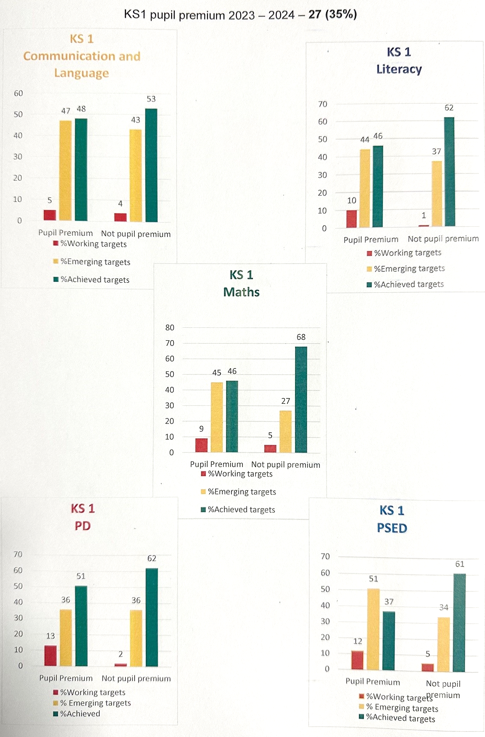
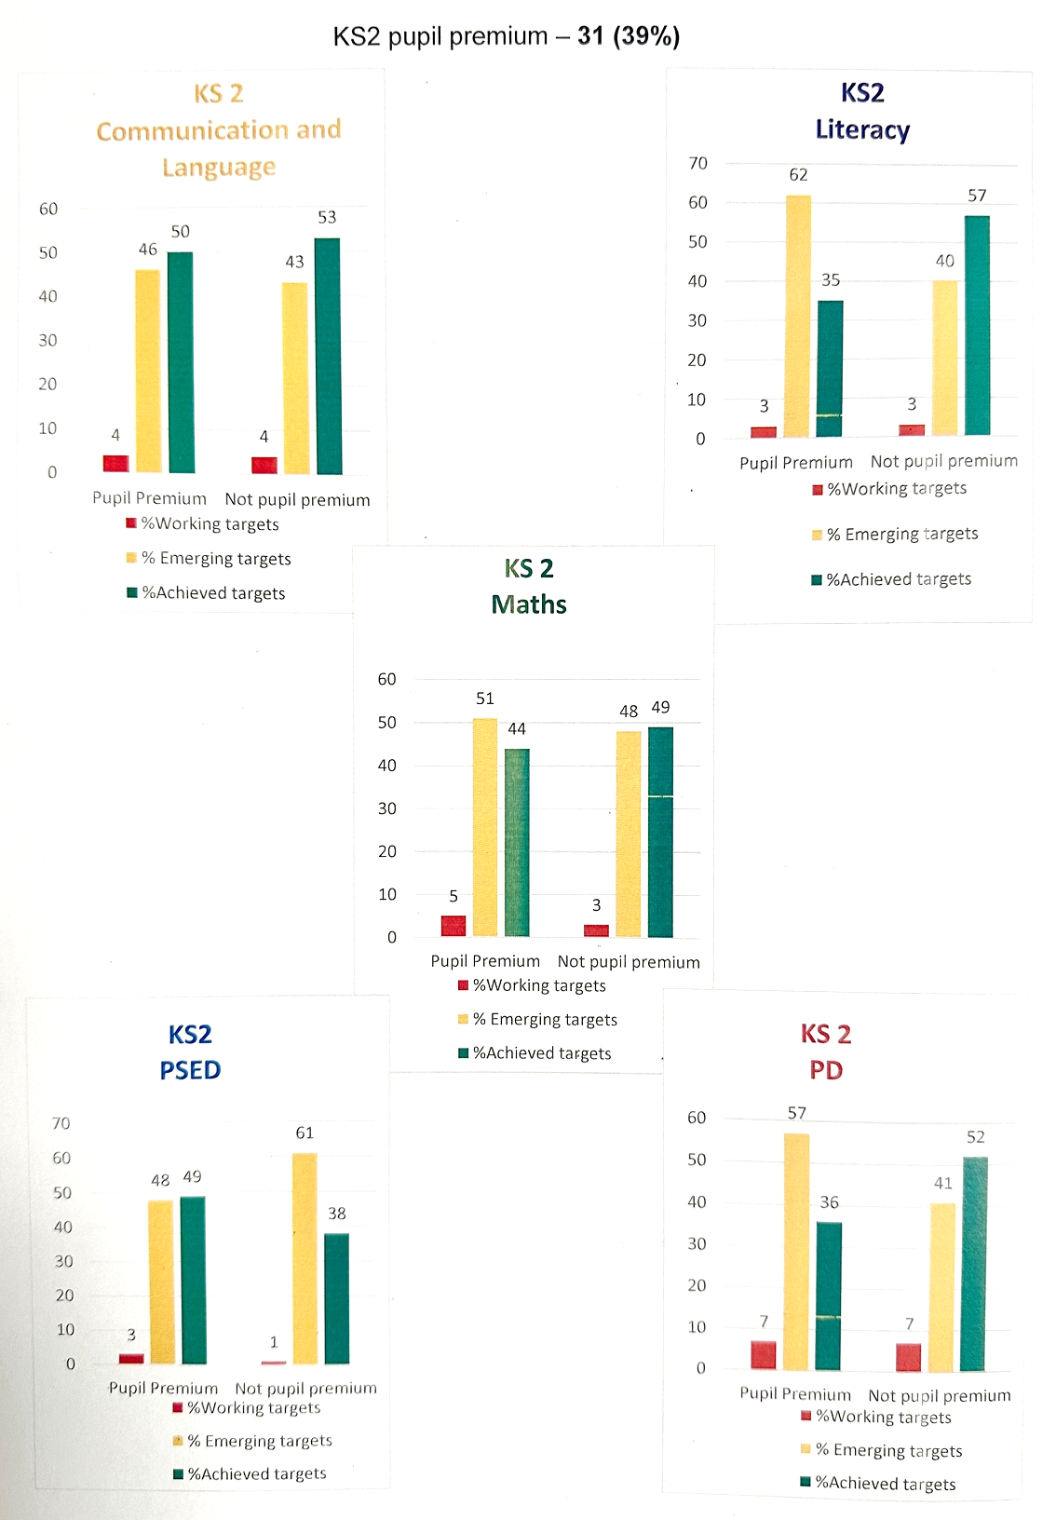

Externally provided programmes
Please include the names of any non-DfE programmes that you used your pupil premium to fund in the previous academic year.
Programme | Provider
N/A

Service pupil premium funding (optional)
For schools that receive this funding, you may wish to provide the following information: How our service pupil premium allocation was spent last academic year
N/A
The impact of that spending on service pupil premium eligible pupils
N/A

Further information (optional)
Use this space to provide any further information about your pupil premium strategy. For example, about your strategy planning, implementation and evaluation, or other activity that you are delivering to support disadvantaged pupils that is not dependent on pupil premium funding.

