
Mandeville School Hire of Premises Policy
MANDEVILLE SCHOOL
Facilities Rental
ROOM | FACILITIES AVAILABLE | CAPACITY | COMMUNITY CHARGE | COMMERCIAL CHARGE
Hall  (with capacity to extend into Dining hall) | Projector, music system, lighting system, chairs/tables, sliding folding partition | 104.7 m²  Approx 100 people sitting | £55 per hour or  £150 half day  £200 full day | £80 per hour  £200 half day  £450 weekend/ evening
Dining Hall PMLD | Tables and chairs | 90.1m²  Approx 50 people sitting | £45 per hour to a maximum of £200 per day | £70 per hour  £300 weekday  £350 weekend/ evening
Training Room/Meeting Room | Plasma screen, Whiteboard, foldaway tables & chairs | 40.2m²  Approx 20 people sitting | £35 per hour to a maximum of £200 per day | £75 per hour  £350 weekday  £400 weekend/ evening
Sound & Lighting Hall  (with capacity to extend into Dining hall) | Projector, Apple TV, high spec sound and lighting system | 78.5m²  Approx 35 people sitting | £55 per hour  £150 half day  £200 full day | £80 per hour  £400 weekday  £450 weekend/ evening
Dining Hall ASC | Tables and chairs | 64.6m²  Approx 25 people sitting | £45 per hour to a maximum of £200 | £60 per hour  £250 weekday  £300 weekend/ evening
Classroom/training room | Plasma screen, tables & chairs, sink, overhead hoist | 51.5m²  Approx 20 people sitting | £35 per hour to a maximum of £200 | £60 per hour  £250 weekday  £300 weekend/ evening
Swimming pool | Hydrotherapy pool, overhead hoist | 69.9m² | £65 per hour during weekdays.  £90 Per hour on a Sunday | £70 per hour
*Car Park |  | Room for 40 cars | £35 per hour | £35 per hour

* Please note there is no charge for car parking when using our rooms for hire. However parking spaces are available on a first come, first served basis.
* Discounted rates apply for multiple or termly bookings
Events organisers are expected to manage their own events. Reception services can be provided at an additional cost. Smoking and the consumption of alcohol is not permitted at events organised at Mandeville School.
The earliest start time is 7.30am. The latest finish time is 8pm. Events that continue outside of these hours will attract a further hourly rate charge.
All rooms are available to view Monday – Friday 10am – 5pm. Please contact Tanya Blandford or Frank Barry on 02088644921 or email admin@mandeville.ealing.sch.uk.
Hot water urns and WFI included if required.

- PAYMENT
A 50% deposit is required when booking. The remainder of the hire fee must be paid at least 14 days before the date of the event. Payment is required in full at time of booking.
The Governing Body reserves the right to make special arrangements for the charging of fees.

- HIRE AND LIABILITY

Third party liability insurance will be provided for single occasion events. However, organisers of multiple and termly lets must have 3rd Party Liability Insurance to the value of £5,000,000 and a photocopy of insurance cover and premium receipt should be sent 14 days before the first letting/lettings.
A holding deposit of £100 maybe required from the hirer to be set against any damages to the premises, its contents and any additional cleaning costs. If any damage, cleaning and/or replacement furniture is required as a result of the hirer's use, the cost (if any) will be deducted from the holding deposit with the balance being refunded to the hirer within 14 days of the hire. If the cost exceeds £100 a further payment shall be required from the hirer.

It is the responsibility of the hirer to check the premises before and after the event and to remove rubbish from the site.

3. CANCELLATION BY HIRER

Cancellation will only be accepted in writing. Refunds are at absolute discretion of the school but will normally only be made where at least 30 days’ notice of cancellation is given prior to the date of event.

- 30 days plus notice – full refund
- 15-29 days’ notice – 50% of hire cost refunded
- Less than 14 days’ notice – no refund

4. CANCELLATION BY MANDEVILLE SCHOOL
The School may by notice in writing to the hirer, cancel the hire agreement at any time seven days prior to the date of the event and all moneys paid to the School will be refunded.

5. SECURITY/HEALTH AND SAFETY

There will be a member of the School staff or contractor hired by Mandeville School on the premises throughout the duration of the letting/lettings. Please report to him/her on arrival and notify them of any problems during the letting/lettings.
On arrival please read the School's Health and Safety Policy and the fire instructions. Failure to comply with the Health and Safety Policy will result in the letting/lettings being terminated and your monies retained by the School.

A fully stocked first aid kit is available on site and its location will be given by the staff member.

Any electrical equipment brought onto site by the hirer must be less than one year old or must have a PAT test certificate issued by a competent person.
The use of smoke machines and/or candles on site is strictly forbidden

6. SAFEGUARDING
It is the hirers’ responsibility to ensure that they comply with the regulations for safeguarding of children and vulnerable adults.

TRANSFER OF UNDERTAKING PROTOCOL

The health and safety and safeguarding of those present (if not organised/managed by the school) is the responsibility of those ‘in charge’ not of the head and/or governing body members of the school.

7. GROUP SIZE

Please note that the maximum number of adults and children permitted on the premises at any time cannot exceed the capacity stated in the facilities rental (see front page). The School stipulates that there should be a pupil to adult ratio no greater than 20 to 1.

8. ALCOHOL & SMOKING

Smoking and the consumption of alcohol is prohibited during events on any part of the school grounds, including the access drives.

9. FOOD AND DRINK

The use of the school kitchen for cooking food is not permitted. No hot food should be placed on the hall floor as this could melt the vinyl. Food and drink may only be consumed in the school dining room. Eating in classrooms or playgrounds will result in the deposit being retained by the School.

10. GENERAL PUBLIC

Mandeville School cannot accept bookings for an event open to the general public.

11. EQUIPMENT

It is the hirer’s responsibility to supply all stationery such as pens, pencil, stationery etc. The school cannot supply these.

Computers and other visual aid equipment are available for hire by separate arrangement.

Users are not permitted to tape, staple, pin or velcro anything to the school walls.

12. STAFF HIRE

Members of staff may hire the school but the same Conditions of Hire apply. Staff will be charged on the community use tariff.

13. TIMES OF LETTING

The letting times of the premises will be between 7.30 am and 8.00pm with the premises being vacated no later than half an hour after that time. No letting will take place outside the times above.

14. GENERAL

14.1 The school and its governing body are not liable for:
(a) the death of, or injury to the hirer, its employees, or invitees to the premises; or
(b) damage to any property of the hirers or that of the hirers employees, or invitees to the premises; or
(c) any losses (including loss of profit or any indirect or consequential loss) , claims, demands, actions, proceedings, damages, costs or expenses or other liability incurred by hirer or the hirers employees, or invitees to the premises in the exercise of the rights granted to them by this hire agreement.
(d) any losses (including loss of profit or any indirect or consequential loss) , claims, demands, actions, proceedings, damages, costs or expenses or other liability incurred by the hirer and caused by an event beyond the reasonable control of the school or the governing body.
(e) any loss of income, profit, or any indirect or consequential loss arising under or in connection with a breach of this hire agreement by the school or its governing.
14.2 nothing in paragraph 14.1 shall limit or exclude the schools liability for:
(a) death or personal injury or damage to property caused by negligence on the part of the school or its employees or agents; or
(b) any matter in respect of which it would be unlawful for the school or governing body to exclude or restrict liability.
14.3
a) the hirer shall occupy the premises for the uses and terms specified in the hire agreement, but no relationship of landlord and tenant is created between the school and the hirer by this hire agreement.
b) this hire agreement is personal to the hirer and is not transferrable and the rights given to the hirer under this hire agreement may only be exercised by the hirer and its employees.
(c) the school shall be entitled at any time on giving reasonable notice to require the hirer to transfer to a comparable space elsewhere within the premises and the hirer shall comply with such requirement.
(d) the hirer agrees not to make any alteration or addition whatsoever to the premises
(e) the hirer shall not display any advertisement, signboards, nameplate, inscription, flag, banner, placard, poster, signs or notices at the premises without the prior written consent of the school (such consent not to be unreasonably withheld or delayed).
(f) the hirer agrees not to do or permit to be done on the premises anything which is illegal or which may be or become a nuisance (whether actionable or not), annoyance, inconvenience or disturbance to the school or any owner or occupier of neighbouring property.
(g) the hirer is responsible for any damage or loss to the premises during the period of hire.
(h) the hirer shall observe any reasonable rules and regulations the school makes and notifies to the hirer from time to time governing the hirer’s use of the premises.
(i) the hirer shall leave the premises in a clean and tidy condition and remove the hirers furniture equipment and goods from the premises at the end of the period of hire.
(j) The hirer shall indemnify the school and the governing body and keep the school and the governing body indemnified against all losses, claims, demands, actions, proceedings, damages, costs, expenses or other liability in any way arising from breach by the hirer of this hire agreement .

Signed by:

Chair of Governors: …………………………….. Date: …………………………

Head teacher: ……………………………………. Date: …………………………

Agreed at the Governing Body Meeting on:
Reviewed and re-ratified:

Reviewed and re-ratified :
Reviewed and re-ratified at Finance and Personnel:

Appendix 1 Booking Form
MANDEVILLE SCHOOL
MANDEVILLE SCHOOL
BOOKING FORM FOR HIRE OF SCHOOL PREMISES
This booking form must be returned to Tanya or Frank To check availability or if you require additional information about the facilities available, please contact the school on 0208864 4921 or email admin@mandeville.ealing.sch.uk.
DETAILS OF HIRER
APPLICANT (Name of person or organisation wishing to hire premises):

ADDRESS:

TELEPHONE NO (DAYTIME/MOBILE):

Details of Hire/Requirements
Type of Function:

Room required:

Date/s of Function:

Time of Function
Start

Finish
Number of people attending (Max)

Number of children under 12

Health & Safety  (please tick box confirming that you understand the following) | The hirer is responsible for arranging first aid provision whilst on the premises.
Safeguarding  (please tick box confirming that you understand the following)  Fee agreed | The hirer is responsible for ensuring that all safeguarding requirements are in place when events include children

Additional Requirements (e.g. Seating arrangements, IT, lighting)

Public Liability Insurance
All multiple are termly hirers of school premises are required to hold a minimum cover of £5million. The Local Authority will provide cover for single event. Hirers must obtain insurance for multiple events. You are required to provide a copy of your insurance certificate prior to the commencement of the event.
DECLARATION
I hereby acknowledge that I have read and fully understand the conditions of use which solely govern the provision of all services supplied by the school. I agree to be bound by the terms and undertake to comply with them in all respects.

Signed: ________________________________ Date: ____________________

Name (in block letters): __________________________________________________

On behalf of (if applicable): ______________________________________________

Please note that a booking of School premises exists only when it has been confirmed in writing by the School and all fees and charges have been fully paid.

For Office use:

Availability confirmed:

Insurance Certificate received:

Event approved and confirmation of booking provided:

Thank you for hiring accommodation at Mandeville school.

Appendix 2 Mandeville School

Lettings Health and Safety Checklist and Information Sheet

The checklist below will assist you in complying with Health and safety requirements. Additionally should an incident occur during your letting the following information will help you manage the situation.
Please keep this checklist and information sheet close at hand during your letting.
√
1. Read the Mandeville School Health and Safety policy.
2. Read the Lettings Leaders fire evacuation procedure (appendix 4).
3. Acquaint yourself with the nearest fire exit and fire assembly point.
4. The nearest first aid bag is in the Reception area in each building.
5. A defibrillator is available in the Reception area of each building.
6. In the event of an emergency please contact a member of Mandeville School staff. If the ambulance or police service is required you may use the telephone in the event room to dial the blue light services. Please dial 999. Do not use the telephone to dial any other numbers.
7. During evening and weekend lettings the Reception service is not always available, so please make sure that you collect a two-way radio from Reception prior to the commencement of your event and return it at the end of your event.
8. Acceptable use of ICT Agreement. Please refer to the details within the Hire of Premises Policy (appendix 3). It is imperative that all users of Mandeville School comply with The Acceptable Use of IT Agreement.

Appendix 3 – Mandeville School Hire of Premises Policy

Acceptable Use Agreement for ICT for Community Use and Hire of Premises.

- Purpose. This agreement is intended to ensure that:
  - Community users and those who hire the school premises will be responsible users and stay safe whilst using ICT systems.
  - School devices and systems are protected from accidental or deliberate misuse that could put security of the systems and users at risk.
  - Users are protected from potential risk in their use of these systems and devices.
- Acceptable Use agreement. I and my group understand that I must use school systems and devices in a responsible way, to ensure that there is no risk to my safety or to the safety and security of the systems, devices and other users. This agreement will also apply to any personal devices that I bring in to the school.
  - I understand that my use of school systems and devices and digital communications may be monitored.
  - I will not use a personal device that I have brought into school for any activity that would be inappropriate in a school setting.
  - I will not try to upload, download or access any materials which are illegal (child sexual abuse images, criminally racist material, adult pornography covered by the obscene publications Act) or which are inappropriate or may cause harm or distress to others. I will not try to use any programmes or software that might allow me to bypass the filtering or security systems that are in place to prevent access to such materials.
  - I will immediately report any illegal, inappropriate or harmful material or incident that I become aware of to the appropriate person.
  - I will not access, copy, remove or otherwise alter any other user’s files without permission.
  - I will ensure that if I take and/or publish images or others I will only do so with their permission. I will not use my personal equipment to record these images without permission. If images are published it will not be possible to identify by name, or by other personal information, who are featured.
  - I will not publish or share any information I have obtained whilst in the school on any personal website, social networking site or through any other means, unless I have permission from the school.
  - I will not, without permission, make large downloads or uploads that might take up internet capacity and prevent other users from being able to carry out their work.
  - I will not install or attempt to install programmes of any type on a school device, nor will I try to alter computer settings, unless I have permission to do so.
  - I will not disable or cause any damage to school equipment or the equipment belonging to others.
  - I will immediately report any damage or faults involving equipment or software however this may have happened.
  - I will ensure that I have permission to use the original work of others in my own work.
  - Where work is protected by copyright, I will not download or distribute copies (including music and videos).
  - I understand that if I fail to comply with this Acceptable Use Agreement, the school has the right to remove my access to school systems and devices.
I have read and understand the above ‘Acceptable Use of ICT Agreement for Community Use and Hire of Premises’ and agree to use the school digital technology systems (both in and out of school) and my own devices (in school and when carrying out communications relating to the school) within these guidelines.

Name…………………………………………………………………………………………………………………….

On behalf of………………………………………………………………………………………………………….

Date……………………………………………………………………………………………………………………….

Appendix 4 – Mandeville School Hire of Premises Policy

FIRE EVACUATION PLAN FOR LETTINGS LEADERS

Please read all of this evacuation plan before using the hired accommodation.
1. You should locate your nearest fire exit(s) and find your nearest assembly point from the attached plan. It is your responsibility to provide this information to your guests and clients.

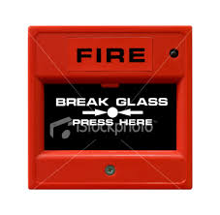
2. You are responsible for taking a register of children or class members in your care and checking this register at your assembly point once the building has been evacuated. Please advise your class where their nearest fire exit is located.

3. If you discover a fire you should break the glass in the nearest red box call point.
These are located around the school.

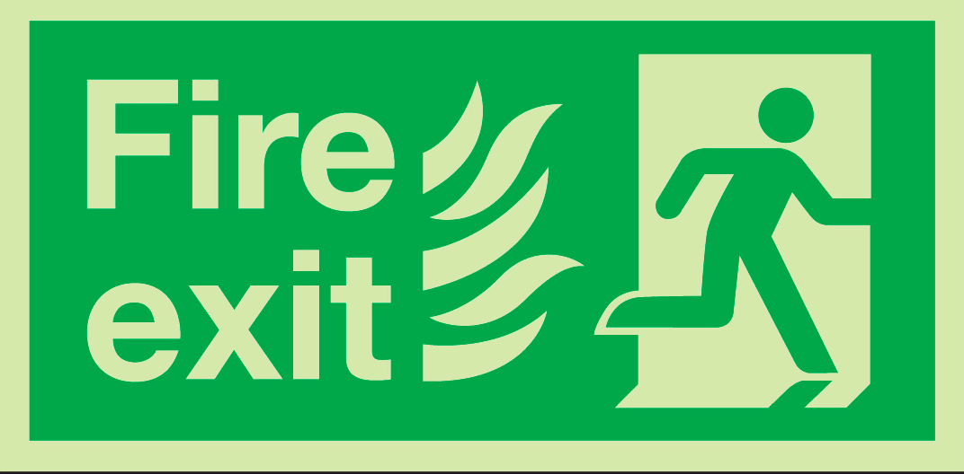
4. Upon hearing the fire alarm, leave the building via the nearest fire exit which are indicated by fire exit signs, and go to your allocated assembly point.

5. Swimming pool users should get out of the pool and leave by the nearest exit.

6. Do not attempt to use fire extinguishers unless the fire is preventing you from escaping the
building.

7. Do not re-enter the building until advised to do so by a Fire Officer or Fire Marshall.

