Pupil premium strategy statement 2023 – 2024 Mandeville School

This statement details our school’s use of pupil premium (and recovery premium for the 2023 to 2024 academic year) funding to help improve the attainment of our disadvantaged pupils.

It outlines our pupil premium strategy, how we intend to spend the funding in this academic year and the effect that last year’s spending of pupil premium had within our school.

School overview
Detail | Data
School name | Mandeville School
Number of pupils in school | 158 (allocation is for 142)
Proportion (%) of pupil premium eligible pupils | 35% (55)
Academic year/years that our current pupil premium strategy plan covers (3 year plans are recommended you must still publish an updated statement each academic year) | 2021 - 2024  Current year 2023/2024
Date this statement was published | 27.11.2023
Date on which it will be reviewed | July 2024
Statement authorised by | Denise Feasey  Headteacher
Pupil premium lead | Mundrika Bhanderi
Governor / Trustee lead | John Burgess
Funding overview
Detail | Amount
Pupil premium funding allocation this academic year | £65,475
Recovery premium funding allocation this academic year  Recovery premium received in academic year 2023/24 cannot be carried forward beyond August 31, 2024. | £45,820
Pupil premium funding carried forward from previous years (enter £0 if not applicable) | £0
Total budget for this academic year | £111,295

Part A: Pupil premium strategy plan

Statement of intent
- At Mandeville School we aim to use pupil premium funding to support pupils from disadvantage backgrounds with achieving positive outcomes in key areas of their development (dependent on their individual needs).
- We aim to train our staff in teaching and engaging our pupils within their learning using a wide range of teaching approaches. The pupils will achieve positive outcomes in the key areas of their development, which are identified through their cognitive ability, physical needs, sensory needs and behavioural needs leading them to achieve their individualised learning targets.
- Although our strategy is focused on the needs of disadvantaged pupils, it will benefit all pupils in our school where funding is spent on whole-school approaches, such as high-quality teaching and training. Implicit in the intended outcomes detailed below, is the intention that outcomes for non-disadvantaged pupils will be improved alongside progress for their disadvantaged peers.
- Our strategy will be driven by the needs and strengths of each young person, based on formal and informal assessments.
- Our strategy is integral to wider school plans for education recovery following the COVID-19 pandemic, notably through engagement with the National Tutoring Programme for pupils that have been worst affected, including non-disadvantaged pupils.

Challenges
This details the key challenges to achievement that we have identified among our disadvantaged pupils.
Challenge number | Detail of challenge
 | Our observations and discussions with families at the pupil’s individual multidisciplinary Annual Review meetings, indicate that disadvantaged pupils need additional support to achieve their targets in communication and language and Literacy
 | Through our discussions with families we found that the pandemic had a significant impact on pupils social and emotional development. Disadvantaged children did not have the quality of living space or access to outdoor space which had a significant impact on pupils social and emotional development.
Through observations and conversations with families, we find that disadvantaged pupils generally have fewer opportunities to develop their physical development due to a lack of safe outdoor space and due to the pandemic a lack of opportunity to visit the local and wider community.
Pupils did not have the opportunity to regularly carry out their physiotherapy and occupational therapy programmes whilst they were isolating at home. This had an impact on their physical and emotional development.
 | Discussions with families have highlighted that parents struggle with understanding their child’s sensory difficulties and how to support their child.
 | Our assessment shows that majority of the children made the least progress in Literacy - 2021-2022 2022-2023
Additional to 2023/2024:
Data report shows that children made the least progress in Maths, Physical Development and Personal, social, emotional development.23-24

Intended outcomes
This explains the outcomes we are aiming for by the end of our current strategy plan, and how we will measure whether they have been achieved.
Intended outcome | Success criteria
2021 – 2022, 2022 - 2023  Improve attainment for disadvantage pupils in communication & language.  2023-2024  Improve attainment for pupils in Maths and Physical Development | 2022-2023  Using a Total Communication approach, Pupils are able to consistently communicate in their preferred mode of communication (PECS, Makaton, body signing, objects of reference and gestures).  Through Attention Autism lessons, children make progress from their starting point in attending to the sessions and vocalising/ saying more words related to the activity.  2023-2024  Teachers trained on planning maths and physical development lessons which meet individual pupils needs using a range of teaching approaches and resources to engage pupils in learning.
2021 - 2024  Training staff on using sensory integration programmes throughout the day, enables them to confidently carry out pupils’ programmes.  2023-2024  Staff have a better understanding of pupils’ behavioural, emotional and sensory needs allowing them to plan activities/ lessons to meet those needs throughout the day. | 2022-2024  Staff have a good understanding of alerting, organising and calming activities to meet the pupils’ sensory needs. They carry out activities with the pupils with an understanding of what type of activity the pupil needs.  Pupils are more regulated when sensory needs are met. This leads them to be more focussed and ready to learn which enables them to make better progress in all learning areas.  Pupils participate in a range of activities which meet their sensory needs, allowing them to regulate, focus and be ready to learn.  2023-2024  Through training, staff will have tools to assess children’s individual sensory needs. They will confidently provide appropriate learning environment that supports pupils’ sensory regulation.  Through OT training, teachers are more confident in understanding how to support children who are selective eaters and who are reading for toilet training
2021-2024  Through music therapy pupils make progress with their communication skills and personal social emotional development (play skills, developing positive relationships with adults/peers/siblings, developing confidence within self)  2021-2022: 1 day a week  2022-2023: 2 days a week  2023-2024: Increased to 3 days a week | Pupils achieve positive outcomes with developing positive relationship and interactions with therapy partner; increase vocalisations and gain confidence within self. They develop some stability with their emotional, physical and emotional well-being. The small group sessions will allow pupils/siblings to form relationships together and begin to understand some fundamental social skills such as turn taking, sharing and waiting.
2021-2024  Training staff on engaging pupils through a wide range of teaching approaches dependent on pupils’ needs (outdoor learning, sensory stories, schemas, exploratory/ messy play, smart platform, rebound therapy, positive looking, phonics, drama). | Pupils engage in a range of motivating activities throughout the day (dependent on their needs) which enhances their learning opportunities and making progress from their starting point in Sept 2023.  Pupils are able to express themselves through drama lessons, focusing on call and response, communication (inc. listening), recognising emotions and engaging more with peers around them.
Increase pupils play skills through well planned play group sessions for specific pupils with some imaginative play skills and communication skills. | Selected small group of pupils with some imaginative play skills and communication skills will develop and enhance their play skills, social skills and communication skills with other pupils of similar abilities
2021-2024  Pupils have 1:1 tutoring for 15 hours to enhance their learning on key skills identified on their IEP targets. | Pupils make progress in their learning through 1:1 tutoring. This learning is generalised across settings, people and between home and school
2022-2024  Relational Support Team support parents in understanding their child’s behaviours and strategies they can use to support their child where behaviours are a barrier to their learning.  Ensuring consistency in approaches between home and school to help child achieve their full potential.  Embedding the relational approaches to behaviour management | Parents have a better understanding of their child’s behaviours which are a barrier to learning. They are able to observe their child, understand why their child is behaving this way and how they can support their child through strategies which are consistent between home and school.  Staff build relationships with children who learn to feel safe, understand themselves, others and the world around them. Through the relational approach children have clear consequences and understanding of what is expected of them, instead of negative language used to describe their behaviours which the children do not understand or cannot relate to.

Activity in this academic year
This details how we intend to spend our pupil premium (and recovery premium funding) this academic year to address the challenges listed above.

Teaching (for example, CPD, recruitment and retention)
Budgeted cost: £43,500
Activity | Evidence that supports this approach | Challenge number(s) addressed
1.Teachers trained on planning maths and physical development lessons which meet individual pupils needs using a range of teaching approaches and resources to engage pupils in learning. | https://help-for-early-years-providers.education.gov.uk/physical-development | 1, 6
2.Staff training on planning a mixture of activities throughout the day which meets pupils’ sensory needs using alerting activities, organising activities and calming activities during sensory circuits.  Introducing the sensory needs profile to teachers which will help identify the child’s sensory difficulties and then sharing this with parents to give them a better understanding.  Purchase resources to meet children’s sensory and emotional needs | The sensory circuit runs in three sections based on theories of sensory processing and sensory integration – Alerting activities, organising activities and calming activities.  https://www.adhdfoundation.org.uk/wp-content/uploads/2022/05/Sensory-circuit.pdf  https://www.childrenschoicetherapy.co.uk/sensory-circuits/ | 4, 6
3.Training for the Relational Approaches team. To embed the relational approach across school and link to behaviour management.  Training relational support staff to work with parents in understanding their child’s needs (coproduction training)  Supervision sessions for the relational support team. | The relational approach suggests that children need consequences that teach them, rather than punishment. Relevant consequences, rather than arbitrary ones, are fairer and help children to understand the effect their behaviour has on others.  It is through relationships that children learn to feel safe, belong, understand themselves, others and the world. The relational approach is a universal.  https://www.yorkshiretanetwork.co.uk/seecmsfile/?id=52  https://www.devon.gov.uk/support-schools-settings/document/quick-guide-to-developing-relational-practice-and-policy/ | 4,5, 6
4.Pupil access the local community on a regular basis, allowing them to extend their learning in the wider community. Additional support for class teams to take children out in the community. | Pupils’ learning is embedded when they have opportunities to generalise skills learnt to a wide range of areas within and outside of school and home. | 2, 3
Staff training on delivering engaging Music and Drama lessons which enhances pupils learning.  Note: The curriculum focus next year 2024-2025 will be on Music Art and Drama | By working together and using role-play, storytelling the children increase their levels of self-confidence and self-esteem.  https://www.artsonthemove.co.uk/education/drama-and-students-with-special-needs.php | 1, 5, 6
5.Staff training on using sensory rooms and assistive technology (AAC and switches) to enhance pupils learning and generalise skills. | A sensory area is a space that has been optimised for positive sensory input, typically using lighting, sounds and tactile equipment. They are used by those with sensory processing difficulties or those prone to sensory overload.  https://www.experia.co.uk/blog/benefits-of-sensory-rooms-in-schools/  Assistive technology can support individuals with special educational needs and/or disabilities (SEND) to improve or maintain their daily quality of life.  https://lordslibrary.parliament.uk/assistive-technology-in-education-and-employment/ | 1, 5, 6

Targeted academic support (for example, tutoring, one-to-one support structured interventions)
Budgeted cost: £67,500
Activity | Evidence that supports this approach | Challenge number(s) addressed
6.One to one and small group music therapy sessions | Music therapy is provided by Ealing Music Therapy.  “Through the use of music therapy, children and young adults can help make connections and build confidence such as people interactions and help put their emotions into words”.  https://www.ealingmusictherapy.org/ | 1, 5, 6
7.One to one tutoring through National Tutoring Programme, focusing on pupils individualised learning targets (mainly communication & language, person social emotional development and literacy) | Through the recovery premium (https://www.gov.uk/government/publications/recovery-premium-funding/recovery-premium-funding)  All pupils will receive one to one tutoring for 15 hours, to enhance pupils engagement and learning using a wide range of approaches. | 1-6
8.Specialist staff plan lessons using a range of teaching approaches in small group sessions, enabling children to make progress in their learning. These approaches/lessons are embedded in school by all staff through training. | Pupils learn better when they have opportunities to learn through a range of teaching approaches which engage them and motivate them in their learning – phonics, Write Dance, Poet, Charanga,  Using specialist resources like the Smart Platform, Eyegaze, positive looking, Clevertouch, sensory stories etc allows children to access the curriculum leading to better progress in all areas of their learning. | 1,2, 3, 5, 6
9.Through TAC (team Around the Child) meetings, train and support parents in understanding their child’s behaviours and strategies they can use to support their child where behaviours are a barrier to their learning  Teachers meet with parents to discuss child’s behaviour support plan and strategies used. | Evidence built up at Mandeville School overtime, shows that consistency between home and school enhances pupils learning.  Parents understanding their child’s behaviours and been able to support them effectively supports the well-being of parents, the child and the school staff.  National Autistic Society | 4

Examples of children benefiting from pupil premium initiatives:
1.Teachers trained on planning maths and physical development lessons which meet individual pupils needs using a range of teaching approaches and resources to engage pupils in learning.

Curriculum meetings have taken place to discuss the Maths and Physical development curriculum.
The teachers reviewed and updated both learning areas in terms of curriculum rationale, aim, curriculum offer and approaches.
Teachers have developed their practice of writing maths lessons plans and shared as a whole group, good practice in maths. A peer review with another specialist school in Ealing had a focus of Maths as an area of inquiry. Outdoor learning with a maths focus was seen as a strength. Lessons where maths was taught in small groups or individually is recommended.
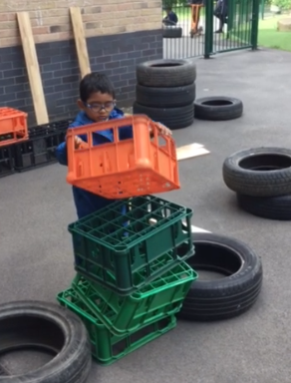
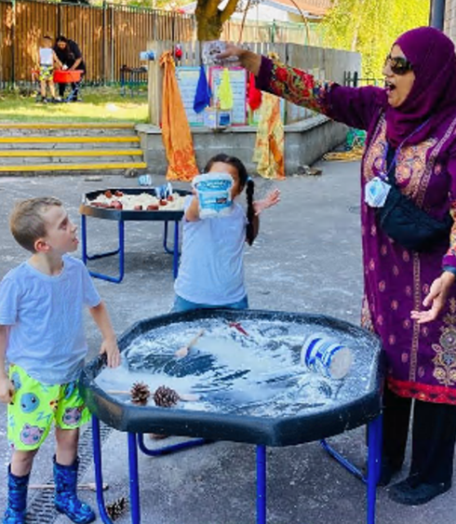
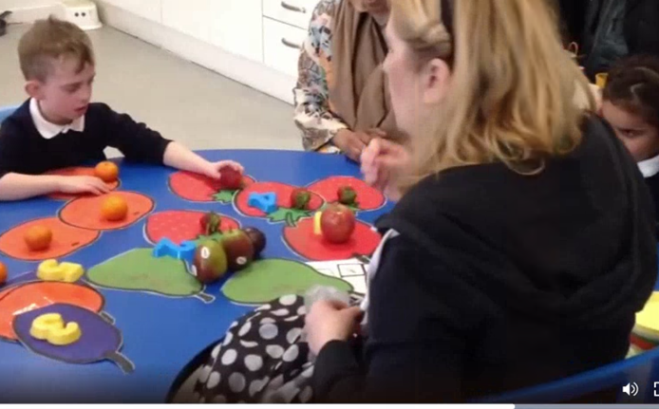
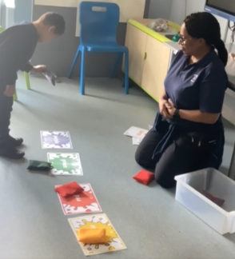

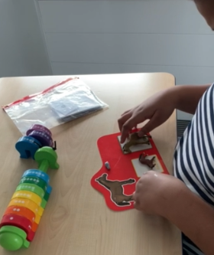
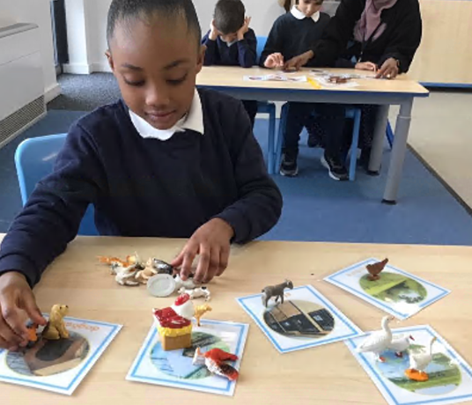

Teachers have received training on the physical development curriculum. Additional support has enabled pupils to develop their physical skills. Independence skills, including dressing and asking to go to the toilet have been a focus. When children go for a walk using walking aids as part of their physical development curriculum, the walk has a clear focus which may include phonics or developing communication.
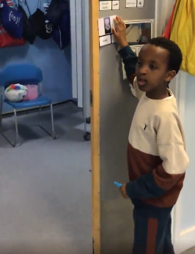
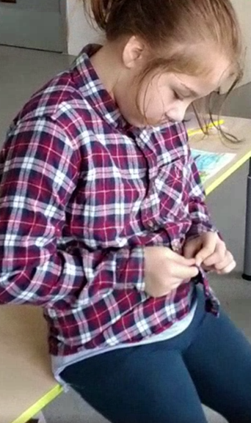
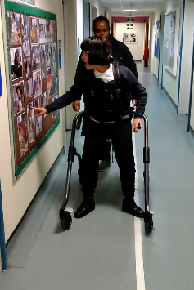
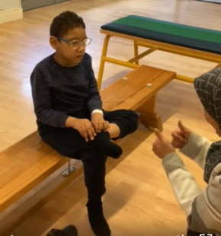
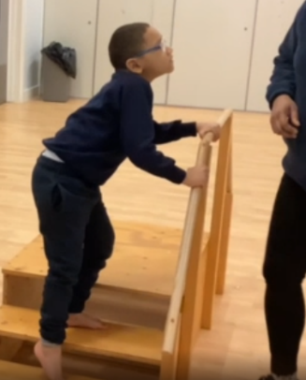
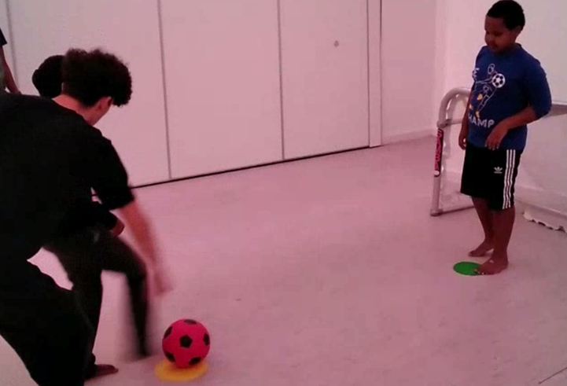

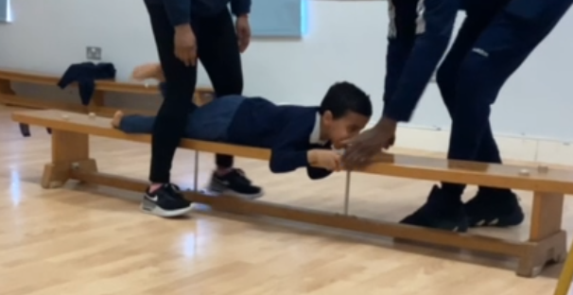

2.Staff training on planning a mixture of activities throughout the day which meets pupils’ sensory needs using alerting activities, organising activities and calming activities during sensory circuits. Introducing the sensory needs profile to teachers which will help identify the child’s sensory difficulties and then sharing this with parents to give them a better understanding.

Staff have received training from the OT regarding supporting children with sensory regulation throughout the day. Children are working on alerting, organising and calming activities throughout the day.
Mandeville has developed a bespoke observation proforma to support with our understanding the children’s sensory needs.
Developing self-confidence: Children have developed much more confidence, independence and have been able to regulate themselves through using the sensory circuit equipment in the allocated rooms and accessing sensory regulation programmes in class or the outdoor gym.
Being able to follow instructions – pupils developed an understanding of following a routine and following instructions on what piece of equipment to use next.
Self-regulating – pupils are calmer, focused and ready to learn after having used the sensory circuit and/or outdoor gym.

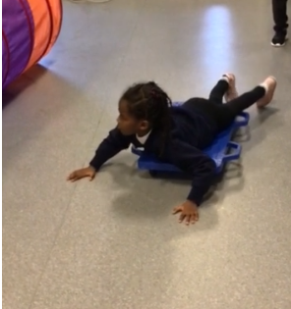
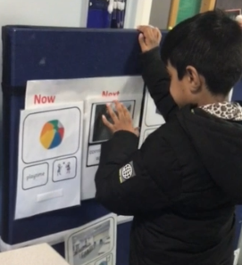

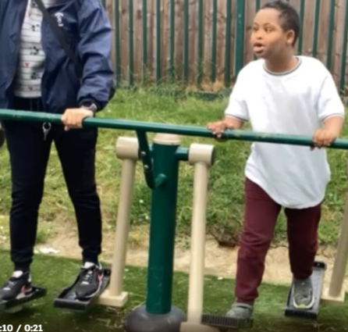
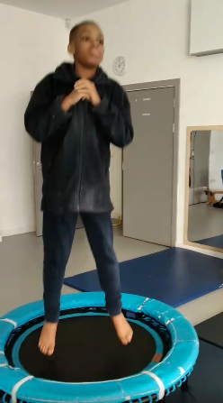
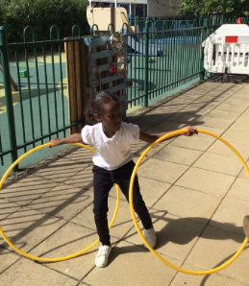
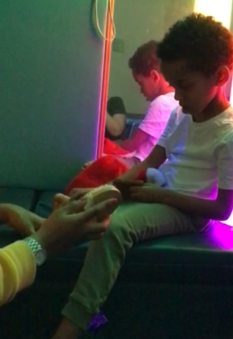

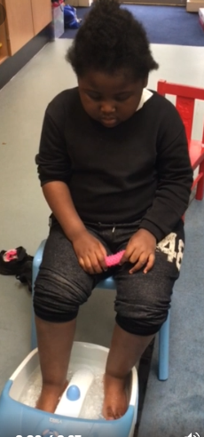
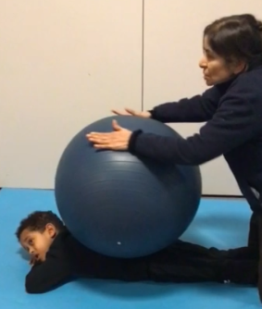

3.Training for the Relational Approaches team. To embed the relational approach across school and link to behaviour management. Training relational support staff to work with parents in understanding their child’s needs (coproduction training) Supervision sessions for the relational support team.

All staff have had training on the relational approach. We have a trained team of staff named the STAR team. The STAR team is made up of behaviour support staff, a clinical psychologist and mental health first aiders. The team supports every class with a focus on supporting children who are experiencing dysregulation. Pupils are given individual support from a Mandeville trained adult; looking at the environment, curriculum offer and teaching approaches to best support the child. An adult will work for a number of weeks with the child and advise the class team on how to support the child. Systems are put in place that continue once the STAR team member works with a new child. This enables consistency for the children. All school staff have developed their skills which has had a positive impact on how staff support children when they are dysregulated.
The focus this year has been to support the emotional well-being of children and staff throughout the school.
4.Pupil access the local community on a regular basis, allowing them to extend their learning in the wider community. Additional support for class teams to take children out in the community.
Pupils accessed a wide range of facilities and resources in the local community.
They were able to: Develop an understanding of what was expected of them when visiting shops/supermarket. Pupils have developed the confidence in visiting the local shops and supermarket and walked around happily. They learnt to look at their shopping list and buy what they needed. They also learnt to choose items, how to wait in a queue, exchange money and put the food in a bag and carry back to school. Pupils had the opportunity to develop their road safety skills.
Transition to new places without getting upset – some pupils who found it difficult in new environments, were able to successfully build their self-confidence and independence skills. They were also able to follow instructions from others in the community.
Some children learned how to access public transport.
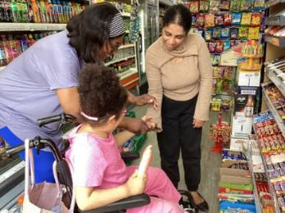
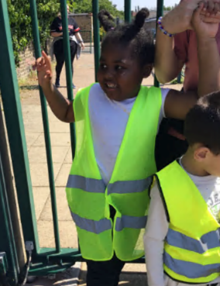
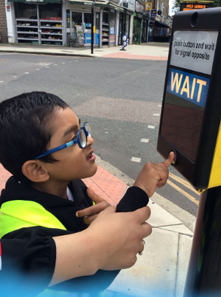

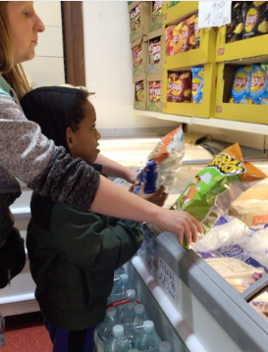
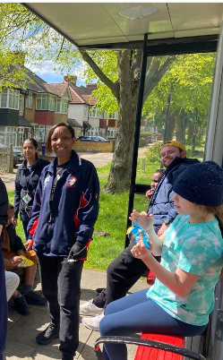
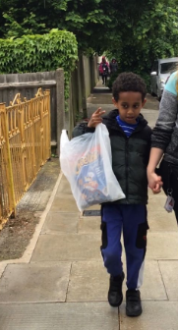

5.Staff training on using sensory rooms and assistive technology (AAC and switches) to enhance pupils learning and generalise skills.
All staff have received training on how to effectively use sensory rooms to support children’s learning. Guidelines have been developed with input from all staff.
Children access a range of technology to support them to achieve their learning intentions.
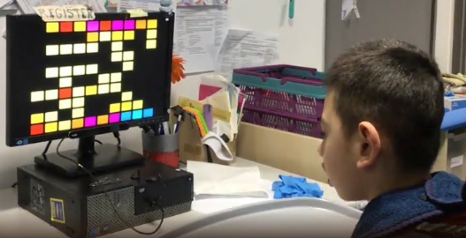
Children work independently using eye gaze, for example completing the box eye gaze programme.

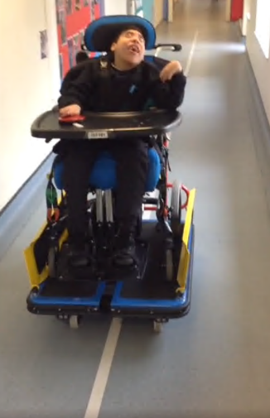

Children learn to use a switch so that they can travel along the corridor independently

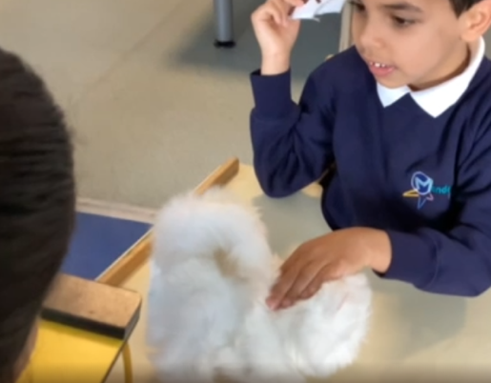
Children learn that a switch can operate a toy and learn to play independently

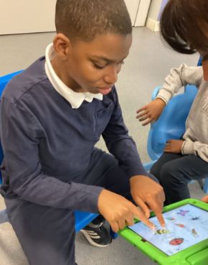

Children use a range of communication aids to communicate with an adult and to make choices.

6.One to one and small group music therapy sessions – see music therapy report below.

7.One to one tutoring through National Tutoring Programme, focusing on pupils individualised learning targets (mainly communication & language, person social emotional development and literacy)
Report from the tutor:
At the beginning of the programme I started by building a relationship with the children I worked with. This was the key to successful learning. The other main factor was a quiet room with just myself and the child. I started building relationships by having fun with the children and finding out what they liked.
Below are examples where significant developments in learning were made as a result of the tutoring.
- A pupil in year 2 was able to sequence numbers 1 to 10. By the end of the programme she could sequence numbers 1 to 20. She was also very happy to come to the group room and as soon as she saw her learning bag, she would get up and come to the door. She also started the program doing a 9-piece jigsaw and could do a 12 piece by the end.
- A child in year 3 liked to play with letters. In our last session she spelt out words and I read to her what they were, these words were different colours and body parts. She was so proud of herself and had the biggest smile.
- A child in year 3 at the end of the programme was able to tap out the syllables of his name on the drum as part of a phonics session.
- A child in year 2 was very busy in the classroom. When he went to the group room, to do learning, he found it helpful for him to self-regulate. He became very calm and focused well on his tasks.
- A pupil in year 1 showed no interest in holding a pen or mark making, we got pencils out every day, different types, and different paper. At the end of the tuition period, he was independently choosing to hold sponge markers and mark make.
- A child in year 6 was very happy to come to a quiet room to do his learning. During this time, he asked for the toilet less and needed to have blue tack a lot less. (This he uses for self-regulation). At the end of our learning time, he was reluctant to leave the quiet room. He was also very happy to see me once we had established a routine and he understood what we were doing.
- A year 2 pupil who occasionally used words in class would look at a book and say the words frequently. (The words used were animals)
- Year 1 pupils showed a variety of skills in the group room which he was reluctant to show in class. For example, building a tower of bricks, counting, completing an inset puzzle, interaction for songs and sitting on his chair upright ready to engage.
I feel that the children had the potential to achieve their learning goals once the relationship was built and the children had a regular routine of the same time each day and the same place. A small room which is quiet, and just one adult and child. They were given the quality time that they needed without distraction. At the end of the 3 weeks’ block of tuition, teachers have noted the progress made and will aim to continue to provide regular 1 to 1 support when possible.

8.Specialist staff plan lessons using a range of teaching approaches in small group sessions, enabling children to make progress in their learning. These approaches/lessons are embedded in school by all staff through training.

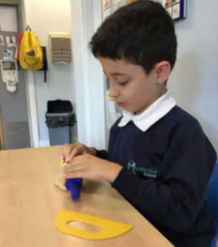
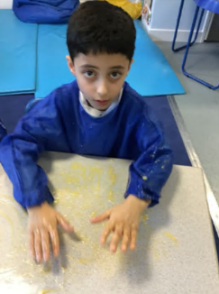
Children have developed fine motor skills and early mark making skills in ‘write dance’ lessons.

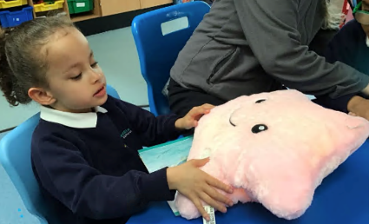

Children have learned letter sounds using interactive resources during phonics lessons

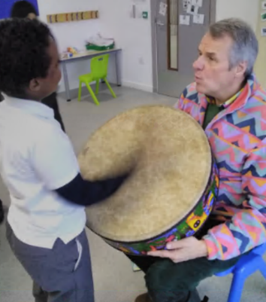

Children have engaged in our Poetry sessions with our poet Philip, exploring rhythm and sound, start and stop.

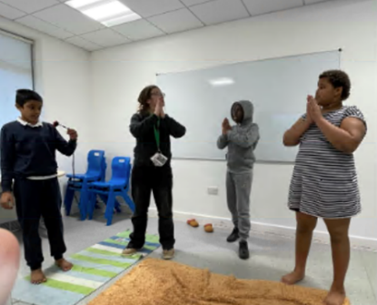
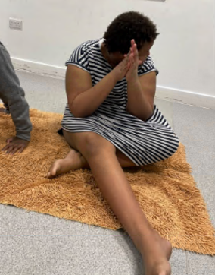
Children learn to follow a yoga routine. When they enjoy it they learn to ask for yoga by putting their hands into the "namaste"

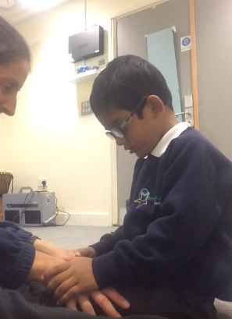

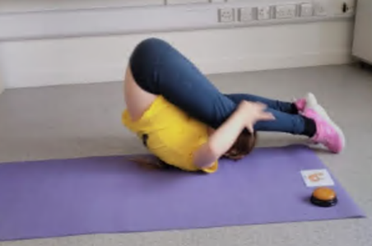
Children learn to independently copy yoga poses once looking at the picture. They are focused, calm and engaged.

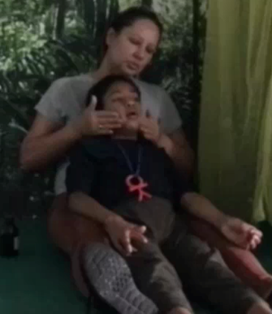
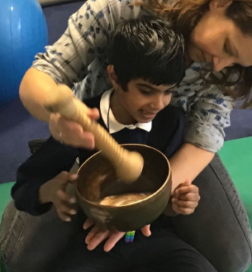
Children are very relaxed during aroma care and yoga sessions. They work on posture and the ability to be calm for extended periods.



Children develop positive relationships during intensive interaction. This supports them to develop trust and a curiosity to learn new things.

9.Through TAC (team Around the Child) meetings, train and support parents in understanding their child’s behaviours and strategies they can use to support their child where behaviours are a barrier to their learning

Two case studies demonstrate the impact of the support provide during and post TAC meetings.
Case study 1 : Year 2 child.
Annual review was held in March 2024. Parents raised concerns about child’s behaviour change in April 2024. The class team noticed a change in his behaviour
Behaviours that were a concern. There were obvious changes where the behaviours become more challenging. The only way he was able to express if he was in pain was to hit himself. In April the child had a wobbly tooth. Parents put less demands on him, e.g. letting him watch TV. Transitioning became more difficult. If he doesn't want to do something, he will start hitting himself. Now pinching himself, biting his fingers and pulling his own hair. He had significant bruises on his face and body. Parents were exhausted. It became difficult for mother to take him alone in a community, both parents must be present.
Input from class team. The teacher focused on the transition in the morning being difficult. She created a cosy corner and he was accessing lessons from his cosy corner. The class team started implementing a sensory plan and behaviour was recorded at home and in school
The member of the STAR team behaviour assistant, observed the class for 2 weeks and suggested strategies to the class team and parents at home.
- Parents to check with the GP if it could be something internal.
- Dentist appointments
- OT to come and observe (OT came in to observe child and suggested different way of giving him sensory input)
- Giving more time to process information
- Gradually needed someone next to him
- To check all the Triggers – noise, wet, hungry,
- Lying on floor – rubbing and at times being happy (wait and observe his body language if ready for the next activity).
TAF (Team around the family) meetings 05/06/24 Attending: Parents, Senior leader, Education social worker, Allocated social worker, Occupational therapist, clinical psychologist, Class teacher, STAR team
Actions
- Sensory and learning activity in group room, 4 times a day in group room with everything he likes and then take certain thing out one at a time. Gradually build up the time back in class (Deep breathing, Chewy, Activities to send home on daily basis Screen ,1:1 in group room, ignore behaviour Staff having strategies for staying calm.
- Aromatherapy session with trained teacher for 4 sessions then the class team followed.
- The OT put in place a personalised timetable. Shared with parents.
- The use of symbols consistently.
- Mother came in to observe the class team and we shared symbols and sensory materials with them.
- The carer came and observed to class team working with the child.
- The allocated worker came and observed the child in school
- Mother and carer were pleased with the strategies that we had in place and started putting them in place at home and in the community.
- Class staff were trained by the OT (joint compression)
- Regularly meeting to review the behaviour support plan and new approaches
- Regularly communicating with parents and updating SLT and social workers.
Follow up review meeting 26/06/24
- The child uses the group room until 11:00am then goes to the classroom then gradually we will reduce it before summer holidays.
- Since Monday 1st July, he spent whole days in the class.
- The child has joined the class with community visit to the park last week and this week.
- The child copes better with transition now as long as he is on his pushchair.
- Mother reports that the self-injury is less and he is generally much calmer
- The child is happy to be with the parents when they are in the park.
- Mother is happy about the increase of hours with the carer.
- Education social worker will liaise with Log cabin for him to have a space during summer time.
- Communication every day at the beginning of the day and ending really helps parents and school with how to manage the child’s emotions both at school and at home.

Case study 2: Year 6 child.
MDT meeting Present: Speech and language therapist, OT, Clinical psychologist, class teacher, social worker, senior leader.
What is working well
- Strong bond with TA and good relationship with teacher.
- Regular attendance
- Responds well to table work
Concerns
- Child highly dysregulated. Tended to throw heavy things at other children at school. At home he would pull the radiators off the wall and show significant frustration. Mother requested at the annual review if residential school would be arranged for the child due to the fact that she felt unable to continue to support him at home.
- Struggles with loud noises from peer – tends to poke her when she is quiet or shouting.
- Requires 1 to 1 otherwise he engages in moving furniture and hiding, trajectory schema, looks to play with an adult for more strong physical contact, significant OT needs.
- Likes timetable symbols – posts favourite symbols in the radiator
- Cries significantly or bangs head (protecting with arm) if he struggles to have needs met.
- Needs an adult eye all the time.
CP advice
- Main focus to be on strategies at school to then use at home.
- Carers to observe at school and take strategies at home. Agency has been contacted.
- Time for observations to be set
- NB school is a safe place and a relational approach will be adopted.
- EP explained that the stress related responses from the child due to difficulties at home which would be normal.
- Discuss with class team how to respond to child most appropriately
- NB the school environment is very different from home
- Safer and more contained at school. Keep expectation of behaviours realistic in the context
SW feedback A lot of change in home environment. ‘Need to know’ information shared.
Actions
- Support at home is required for the child to go into the community. Senior leader to speak to OT re safety at home.
- OT to do a home visit.
- NB Sibling is regularly hurt at home Referred to MAST based around family relationships
Care package – weekend is 6hrs
ESW to Re Refer to CWDT – to safeguard all family. Social care package to increase.
The case has been escalated to Egress managers and ASW manager
- EP to talk to the class team
- NB need for x2 people to be in care package to go out into the community
- Request for residential noted on the referral.
- Care workers to visit Mandeville one visited last Monday. Suggest visit to the park with carer
- Manager of unite arranged carer to visit
- CP send mother list of help lines and resources
- CHAMS referral update, SW to follow up with SC team manager
- Fridays for carers to visit Mandeville.
- Teacher to Suggest to the carer that he takes photos of visuals to use on outings.
- Teacher to explain to the carers: Reduce demand on JK when things escalate. Offer Deep pressure. Intensive interaction. Explain the reasons for the approaches
All actions followed up.
Continued support:
Class staff speaking the same language as mother significantly helped to build positive communication and a trusting relationship with mother
- Safeguarding disclosure to the class teacher escalated to SLT and ESW immediately and monitored regularly using CPOMS
- ESW offered mother regular meetings to help with the situation at home
Help and meetings from ESW and senior leader with the external agencies involved in housing for the family and helping parents to repair their relationship
- Meetings set up involving staff from the child’s sisters school
- Input received from external agency - PBS (Positive behavioural support) - with regards to home strategies
- Regular contact with the family and their social worker
- Tracking child’s behaviour data on paper and on SIMS, smooth running of the school's safeguarding and communication systems
- An additional staff member supported the child (initially the member of STAR team, later agency)
- Training from CP on relational approach from clinical psychologist
- Regular input and meetings with class team and clinical psychologist
- Regular discussions/team meetings with ESW
- Visuals and strategies shared with home. Visits in class and discussion on BSP and strategies with respite staff and direct payment staff
- Careful and planned strategy developed to help transition the child to a Haydock house residential respite (once a month)
Update from teacher shared with CP and senior leader – May 20224
The targeting of another child has stopped completely, as has the same behaviour at home towards his little brother. He is generally much happier and calmer at school and at home. We do not see many compulsive behaviours anymore. The child is happy to engage in learning 1:1, in small groups and in whole group sessions. He enjoys positive praise from adults and has very warm and affectionate relationship with both his key worker and the rest of the team. The child appears less irritable and has more tolerance to things that used to trigger him (noise, vocalisations, etc.). At school we continue with the relational approach and that seems to work very well.
The positive changes at home (relationships and the house itself) and change of the direct payment to his granny (dad's mum) are two main factors which contributed to this. Granny takes him to the park and to shopping centres and it seems this is going really well. She attended the parents' evening alongside mother and was asking about ways to occupy the child at home if the weather doesn't allow for a going out.
The child is now getting support at home from PBS. We just had a meeting with them a week ago with regards to the initial observations and action plan. We should be getting a very detailed Behaviour Intervention Plan within a couple of weeks. This will be shared with school and we will use the same strategies across both settings.
Haydock house transition visits are planned (overnight respite once a month) and are starting on 16.05.24. Visuals and a social story for the visits have been made so that he can get used to the idea.
The child has settled very well during the respite sessions.

6.One to one and small group music therapy sessions.
Therapist | Input | Day
Robert (qualified therapist) | 7 children received music therapy input,  4 individual children and 3 children in a group | Friday
Gemma (qualified therapist) | 6 children received individual music therapy | Monday
Gemma (qualified therapist) | 9 children received music therapy input,  3 children individuals and 6 children in a group | Wednesday
Oli (MT trainee) | 1 child received individual music therapy | Wednesday (2 terms)
Rebecca (MT assistant): | Supporting with one individual child and running a communication and music group in the nursery ASC class . | Monday (2 terms)

Individual music therapy: Impact on children in the school includes support with development of social and communication skills, attention, focus and engagement as well as supporting emotional expression and wellbeing.
Child’s initials | Area of referral | Summary of progress
NC | Communication, Attention, social interaction | - Able to transition to music therapy room with help of teaching staff and symbols  - Able to engage and focus in using musical play for short periods of time using piano, ocean drum and horn.  - Able to engage in joint play using bubbles with therapist -popping and taking turns to blow.  - Able to explore pre-verbal vocal sounds in a communicate way.
HM | Engage in using new activities, instruments, develop attention and interaction skills with another person | - Able to engage in the full 30-minute session playing different instruments with the therapist.  - Able to express humour when using play skills with the therapist.  - Able to take risks to initiate playing different instruments away from the piano.  - Able to explore his voice and different vocal sounds he can make in a communicative way with the therapist.  - Able to use preverbal social interaction skills with an adult including looking, turn-taking, waiting, responding and initiating new musical ideas.
PJ | To support his emotional wellbeing. To engage in joint play and interaction with an adult | - Able to attend 20 minute sessions with the therapist.  - Engage in playing musical instruments in the room.  - Engaging in joint play including sharing of use of puppets, bouncing a ball on the drum between himself and therapist.  - Beginnings of vocal interactions
GS | To develop purposeful preverbal social and communication skills through musical interactions. | - Engage in purposeful drum playing during joint musical play.  - Able to alternate between using a shaker, clapping hands and tapping the drum.  - Exploration of his voice varying pitching and intonation.  - Ability to follow the therapist’s lead in which instrument to play e.g. play drum when therapist plays it. Showing greater awareness of another person and being able to respond to them.  - Engage in music-making for full 30 minute session showing develop in attention and engagement when interacting with an adult.
AA | Communication, social interaction, attention and purposeful play. | - Engage in music-making for full 3o minute session.  - Motivated to use a playful and child-led approaches.  - Responding by looking towards the therapist, vocalizing and exploring the instruments.  - He used to want Gemma to play on piano, but he now joins in playing on the piano showing a development of joint play and turn-taking.  - Able to communicate through body movements and expression. Sometimes dances on the beat of the drum.  - Able to take more risks and explored new things.  - Is now using his voice more confidently vocalising certain sounds like dada, mama, nana and sounds he has learnt in phonics.
HM | Music therapy assessment | - Able to tolerate coming to the music therapy room and staying for up to 15 minutes.  - Short moments of interactions with bubbles.  - Short moments of musical play. Music only tolerated by H
CM | Support emotional wellbeing and development of social and communication skills with another person | - Significant improvement in transitions to & from class; no longer requires additional support & instances of running away have stopped  - Noticeably more expressive within sessions (increasing eye contact & laughter)  - Increasing use of voice in sessions; engaging in call and response games with the therapist  - Increasingly playful with sessions, often initiating games
AG | Support emotional wellbeing, tolerate and initiate interactions with another person | - Ability to tolerate musical sounds created by the therapist.  - Flexibility to share instruments with therapist to create music together.  - Playing together on the piano using turn-taking.  - Exploring emotions, she is experiencing naming them through words and songs to help her process her feelings  - Use words she likes of experiences she has had and familiar cartoons she watches within songs created in sessions.  - Use words purposefully in sessions to name aspects she can see outside, names of instruments and colours of objects.  - Full engaged and focused for 25 minutes.
HF | Supporting to reduce levels of anxiety in interacting with another person and taking risks to play unfamiliar instruments | - Ability to explore vocal sounds through communicative exchanges.  - Ability to share instruments with therapist.  - Ability to take risks in trying new instruments offered.  - Ability to initiate trying new instruments in recent weeks.  - Ability to interact with therapist away from door in the main section of the room.  - Therapist support H to identify emotions he is feeling on a weekly basis through pictures.
DM | Supporting attention and ways of positively interacting with an adult | - Benefits from a child led approach.  - Able to participate in play type games such as hide and seek and bubbles.  - Able to share instruments with the therapist including drum, piano and guitar.  - Initiating more musical playing by exploring purposeful play on instruments.  - Able to focus in sessions up to 20 minutes.  - Ability to express humour through laughing, hiding and smiling and looking towards therapist to see what her reaction is.
SR | To provide support with his communication skills and social development. | - Able to engage in brief musical play with the chimes and lightly strumming the therapist’s guitar.  - SR prefers and enjoys the therapist singing the songs that he chooses.  - Responds well to humour and often gets very excited when the therapist sings songs in a variety of speeds and dynamics. He also responded by smiling when the therapist changes the musical key of the song.  - Increased motivation and confidence during the sessions. He immediately initiates interactions with the therapist and has begun to explore a variety of song choices.
NA | To provide support with communication skills, self-expression and emotional regulation. | - Benefits from a combination of structure and some flexibility for child to engage. structured with a now and next chart.  - Able to transition well between the classroom and the therapy room. A TA is present in every session while the therapy room has changed from last term. This has helped manage the child’s anxieties and created a safer environment, resulting in them staying in the therapy room for longer.  - Has demonstrated brief moments of musical interactions with the therapist with the assistance of the TA. This has involved cohesive drumming activates and prolonged, sensitive interactions using the ocean drum.  - Has enjoyed choosing various songs each session. With the assistance and encouragement from the therapist and TA.
KS | Support with communication skills, self-expression and emotional regulation. | - Benefits from a child led approach  - Use of books to create stories and songs to engage child.  - Uses therapist’s finger to hit the image while expressing loud vocalisations. Other times they will place the therapist’s finger gently on the image. This exercise has empowered KS and given him the opportunity to project and communicate to the therapist his feeling state. The story board has provided an opportunity to develop their creative play skills and a way for him to interact positively with another person.
AdG | To provide support with his communication skills, self-expression, emotional regulation and socialisation. | - Able to enjoy playing with various instruments with the therapist but only for brief moments.  - Enjoys it when the therapist plays gentle piano chords while he looks outside the window. He will communicate to the therapist that this is what he’d like to hear.  - Enjoys listening to the therapist singing various songs. Can become excited and move from side to side in a seated position during various tunes. He has on occasion even danced in the center of the room.  - Starting to engage more when the child’s actions are being reflected through the therapist singing about what he is doing in the room. He is showing aware of what the therapist is singing about.

Group work
Group in Angelfish class with three pupils
Aims:
- Support communication skills (verbal and non-verbal)
- Develop choice-making abilities
- Develop social awareness and peer relationships
- Develop interactions that support their processing needs
Find your voice group:
Collaborative therapy group with music therapy and speech and language therapist
Aims:
- To prompt different ways of the pupils using their voice, sounds and words to communicate through music.
- Develop choice-making abilities
- Develop social awareness and peer relationships
Outcomes:
- Making choices
- Ability to use whistles on command and create a sound
- Ability to throw and catch ball to therapist to support turn-taking and two-way communication.
- Increased vocal exploration
- Use of purposeful words linked to songs or choices
- Increased use of play skills within music-making on instruments
- Increased awareness and curiosity of peers and adults in the group
- Ability to blow bubbles
- Predicting and expecting what is expected of the children over the period of the group.
- Anticipate and verbalize to parts of songs spontaneously

Nursery group
- Aims
- To engage in music making either threw singing and/or playing one of the instruments.
- To have at least 80% of the children attend for the full session.
- Those children will sensory regulation needs to focus on at least one activity.
- To engage in choice-making to choose an animal in a song.
- For the children to engage in turn-taking and waiting for their turn in at least two activities.
Outcomes:
- Increased engagement in participating in the group.
- Increased attention to each activity.
- Increased use of words within familiar songs
- Increased imitation of the words and play demonstrated by assistant therapist.
- Helping to put object away.
- Predicting and anticipating the activities in the session
Festival of Flight
Choir
Aims
- to promote total communication through Makaton signing, communicative actions, spoken words and choice-making.
- To work on singing and signing familiar songs
The part of the choir made their debut in the flash mob and Christmas. Many of children found this a fantastic opportunity. It was lovely for them to be part of a planned activity in the communitive which they may not have experienced previously.
Festival of flight development:
Claire and I had been working clinically with many of the children in the school and had observed a whole range of different skills the children had from, drumming, to blowing bubbles, to singing to dancing, to drawing.
We wanted to create an opportunity where as many of the children if not all could be part of a festival of talents. Where the children of Mandeville as community could show case what they can do. The festival of flight idea was born.
The idea is to link in with the topic of the term of travel. We thought flight is a great metaphor for our children at Mandeville in thinking of their own individual journey of learning and the skills they develop and build on at their time at the school. We also want to bring together ideas of culture and we are such a rich diverse community which needs to be celebrated. Claire (SLT), Philip (school poet), Bryony (Deputy headtacher) and myself worked together to bring the festival together and co-ordinate it on the day.
We envisaged the ‘festival of flight’ being a day of showcasing the children talents in different forms. We worked together to bring ideas together for the festival which then took place in July.
Our music therapy assistant gathered the ideas of the teachers in order to draw extravaganza together.
The choir was one part of the festival where the children have been working on songs linked to flight. Some of the repertoire including, ‘three little birds, ‘reach for the stars’, ‘firework’, ‘five little men in a flying saucer’. The idea of the songs is that it will create different points to where the festival will travel. The choir represents the talents of the different ways in which our children at Mandeville can communicate.
We added in elements that allow the children to be as active in the participation as possible enabling moments of the children being animated spontaneous.
Outcomes on the day:
- Opportunity for the children to spontaneous in ways that they would not necessarily demonstrate in the classroom.
- Generalize learnt skills such as transitioning, sharing ideas and objects of interest,
- Moments of free improvised dancing, joining different groups, collaborative play and tolerance of being with others.
- Following instructions from teaching staff out of their team.
- Free play with other peers.
- Ability to tolerate a noisy environment, multi-sensory environment.
- Ability to tolerate unpredictable timetable and participate in each classes section.
- Waiting their turn to come in to the hall.

Wider strategies (for example, related to attendance, behaviour, wellbeing)
Budgeted cost: £
Activity | Evidence that supports this approach | Challenge number(s) addressed

Total budgeted cost: £111,000

Part B: Review of outcomes in the previous academic year. Pupil premium strategy outcomes
The data below shows the impact that our pupil premium activity had on pupils in the 2022 to 2023 academic year.
The comparative data is for those children on pupil premium who have achieved their learning targets in comparison to those not on pupil premium
KS1 pupil premium – 27 (35%)

KS2 pupil premium – 31 (39%)

It should be noted that the interventions developed by the pupil premium money, benefits all children. We need to ensure that new initiatives for children on pupil premium are specifically targeted for these children. We will continuing with tutoring and music therapy and offer additional interventions specifically for children on pupil premium.

Externally provided programmes
Please include the names of any non-DfE programmes that you purchased in the previous academic year. This will help the Department for Education identify which ones are popular in England
Programme | Provider
NA

Service pupil premium funding (optional)
For schools that receive this funding, you may wish to provide the following information:
Measure | Details
How did you spend your service pupil premium allocation last academic year? | N/A
What was the impact of that spending on service pupil premium eligible pupils? | N/A

