Rationale:
We understand the importance of providing an emotionally and physically enabling environment for pupils to develop their personal social and emotional skills. In developing positive relationships with others and a better understanding of self, pupils will become more confident and resilient. Pupils will develop a greater feeling of self-worth.
Aim:
Pupils will be given the opportunity to learn to understand themselves in relation to others and how to understand their own and other’s feelings. We recognise and celebrate all achievements and have a key worker system, which helps the pupils to feel valued and special and gives them a sense of self-worth. Pupils will develop a greater understanding of their school environment and the wider community. They will be supported to learn to be safe. Pupils will have the opportunity to experience and develop skills in the following aspects of learning:

Mandeville 1 | Mandeville 2
Making relationships  - Interaction with adults  - Interaction with children  Self-Confidence  - Body awareness  - Awareness of gender and privacy  - Managing feelings and behavior  Life in the Community  - School environment  - Wider community | Making relationships  - Interaction with adults  - Interaction with children  Self-Confidence  - Body awareness  - Awareness of gender and privacy  - Changing bodies  - Develop an awareness of self  - Undertake tasks of responsibility  - Managing feelings and behavior  Life in the Community  - School environment  - Wider community

Teaching approaches include:

- Zones of regulation
- Talking mats
- Community visits
- Intensive interaction
- Yoga
- Drama
- Music therapy
- Aromacare
- Positive reinforcement and rewards
- Discrete girls groups and boys groups for YR 5 and 6 pupils.

Individual children have a curriculum assessment tool that tracks progress in the Mandeville PSED 1 AND Mandeville PSED 2 curriculum over time.
The learning outcomes for PSED in each aspect of learning are mapped onto the tracker.
When children start at Mandeville they have a baseline assessment which is shown in brown on the assessment tracker.
When outcomes are achieved a colour coding system is used to map yearly progress.
The assessment tool allows us to see a pupils individual leaning profile and to guide us to next steps for learning.
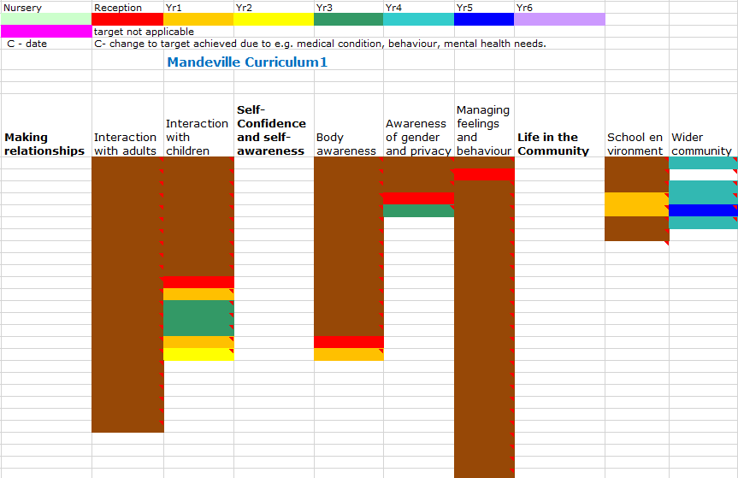

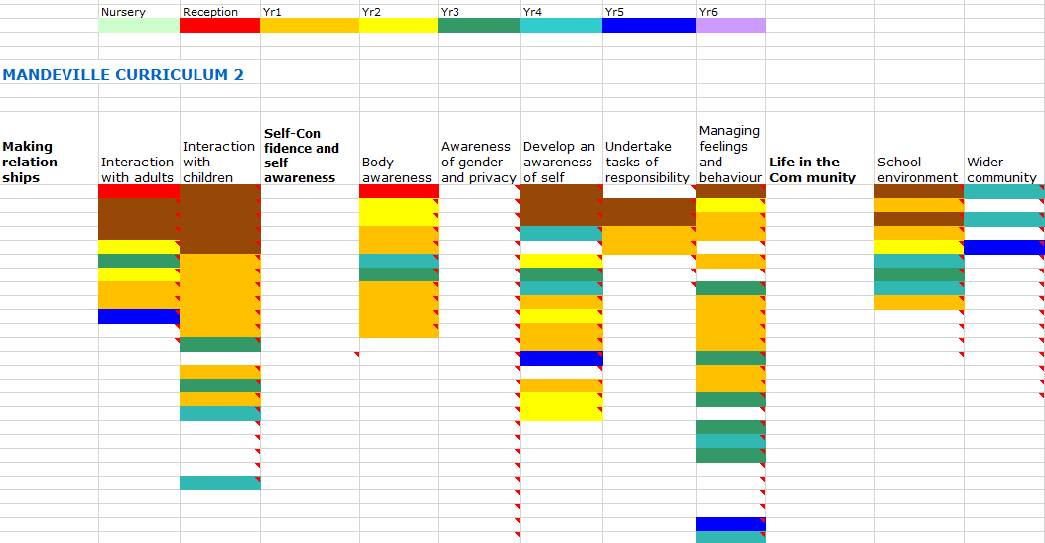

Page 1 of 12 OF PSED MANDEVILLE CURRICULUM 1
MAKING RELATIONSHIPS
ASPECT: INTERACTION WITH ADULTS
Learning intention | How to support learning | Suggested activities
- Experiences being held by an adult e.g., cradling, co-active rocking,  - Responds intermittently during social interaction with a familiar adult, e.g., smiling, facial movements, body movements  - Consistently responds to being held.  - Responds consistently during social interaction with a familiar adult, e.g., smiling, facial movements, body movements  - Positively responds to close physical contact by relaxing against an adult  - Sometimes expresses pleasure during a social interaction with a familiar adult e.g., facial expression, vocalising, body posture, smiling  - Consistently expresses pleasure during a social interaction with a familiar adult e.g., facial expression, vocalising, body posture, smiling  - Gazes at a familiar adults face and copies facial movements. E.g. sticking out tongue, opening mouth and widening eyes.  - Responds when talked to, for example, moves arms and legs, changes facial expression, moves body and makes mouth movements. | - Ensure staff are aware of the importance of attachment in relationships.  - Ensure the key person is paired with a ‘buddy’ who knows the pupil  - Make sure pupils have their own special person in the setting, who knows them really well and understands their wants and needs. Ensure staff are aware of the importance of attachment in relationships.  - Tune in sensitively to pupil, and provide warm, loving, consistent care, responding quickly to needs.  - Regularly hold and handle pupils, as sensitive touch helps to build security and attachment.  - Display photos of family and other special adult people.  - Makaton symbols Photos of adult friends in school | - Sherborne (see appendix 1)  - Holding therapy (see appendix 14)  - Rebound therapy (see appendix 15)  - Massage  - Aromacare  - Tac Pac  - Body awareness songs  - Repeat greetings at the start and end of each session, so that pupils recognise and become familiar with these daily rituals.  - At times of transition make sure staff greet and say goodbye to pupils. This helps to develop secure and trusting three-way relationships.  - Plan to have one-to-one time to interact with pupils when they are in an alert and responsive state and willing to engage.

Page 1 of 18 OF PSED MANDEVILLE CURRICULUM 2
MAKING RELATIONSHIPS
ASPECT: INTERACTION WITH ADULTS
Learning intention | How to support learning | Suggested activities
- I can Recognises familiar adults for example, during circle times, pointing at an adult, choosing photo of adult, walking towards adult.  - I can use a familiar adult as a secure base from which to explore independently in new environments, e.g. ventures away to play and interact with others, but returns for reassurance if becomes anxious.  - I can particípate in a mutual activity with an adult, though not yet working towards a common goal  ASSOCIATIVE PLAY This stage of play invites social interaction as children find the need to share tools for their activities.  - I can play cooperatively with an adult, solving a problem by working together to achieve a common goal - COOPERATIVE PLAY e. g. rolls a ball back and forth  - I can play cooperatively with a familiar adult e.g. Seeks adult to share experiences - CHILD LED COOPERATIVE PLAY  - I can initiate play with an adult, offering cues to other pupils to join me.  - I can show affection and concern for adults who are special to me  - I can keep play going with an adult by going and responding to what adults are saying or doing.  - I can initiate conversations/interactions with an adult  - I can attend to and takes account of what the adult says. | - Regularly evaluate the way you respond to different children  - Ensure pupils have the opportunity to join in.  - Help pupils to recognise and understand rules for being with others e.g. waiting for a turn  - Talk about feelings such as sadness, happiness or feeling cross
  - Play name games to welcome children to the setting and help them get to know the adults.
  - Provide matching items to encourage adult and pupil to mimic each other in a cooperative game e.g. two identical instruments.
  - Create an area in which pupils can sit and chat with an adult, such as a snug den and cosy spaces.

