Rationale:
Physical development promotes growth and development. It will support pupils to develop gross and fine motor skills, help to maintain a healthy body weight including developing muscle strength. Improve self-esteem and social skills. Physical Development leads to improved levels of physical and emotional well-being. It supports self-regulation and it maintains motivation in other areas of the pupils’ learning including attention, concentration, cause and effect and the motivation to reach out, explore, and learn about the things that are around them. Physical development promotes independence and self- care.

Aim:
We share the EYFS aims for Physical development for all our pupils at Mandeville. We recognise the importance of

"providing opportunities for young children to be active and interactive; and to develop their co-ordination, control, and movement. Children must also be helped to understand the importance of physical activity and to make healthy choices in relation to food."

Our Physical development curriculum includes health and self-care as well as developing fine and gross motor skills throughout the school day.

Pupils will have the opportunity to experience and develop skills in the following aspects of learning:

Mandeville 1 | Mandeville 2
Health and self-care  - Undressing/Dressing  - Washing and showering  - Teeth and hair brushing  - Eating and drinking  - Personal care in the bathroom  Games  - Feet legs and football with friends  - I can climb up, climb along and climb down  - Stop! Go! Action!  - Pickup, carry and drop  - Travelling: Position and direction  - Moving and handling  - Positional language  - Dance  - Rebound  - Bounce Jump and Land  - Swimming | Health and self-care  - Undressing/Dressing  - Washing and showering  - Teeth and hair brushing  - Eating and drinking  - Personal care in the bathroom  Games  - Feet legs and football with friends  - I can climb up, climb along and climb down  - Stop! Go! Action!  - Pickup, carry and drop  - Travelling: Position and direction  - Team games  - Forces  - Positional language  - Dance  - Rebound / Bounce Jump and Land  - Swimming lessons

Teaching approaches include:
- Changing clothes for PE and swimming lessons.
- Outdoor learning
- Sensory circuits
- Physio and OT programmes.
- Deep pressure and joint compression
- Yoga
- Aromacare
- Tac pac
- Fidget dance
- Rebound therapy
- Discrete PE lessons cover the Games aspect of the curriculum. Lessons are planned for pupils with Autism and pupils with PMLD.

Games Schemes of work

Autism classes
Term 1 – Games - Ball skills
- Stop! GO! Action!
- Feet legs and football with friends
- Pickup, carry and drop and throw

Term 2 - Gymnastics / Dance
- Forces
- Travelling: Positional language
- I can climb up, climb along and climb down
- Travelling: Position and direction

Term 3
- Sports day activities – Team games
Ocean:
Team games - Relay race – Skittles – beach volleyball - Parachute games
Sky:
Team games – Obstacle course – bean bag relay race – running relay race – score a hockey goal.
PMLD classes
A termly Topic is used to support the planning of teaching and learning.
Every PE lesson is individualised according to pupils’ needs.
Each lesson will follow elements from the programme below.
Warm up – physio programme/yoga stretches
Moving handling
Travel - position – direction
Body awareness
Dance
Use of equipment – physio balls, specialist balls, tunnels, spinner, tumble form Stretch Rock Roll Slide Dance Relax
Cool down – relaxation – music/images – parachute, deep pressure

Individual children have a curriculum assessment tool that tracks progress in the Mandeville PD 1 AND Mandeville 2 curriculum over time.
The learning outcomes for PD in each aspect of learning are mapped onto the tracker.
When children start at Mandeville they have a baseline assessment which is shown in brown on the assessment tracker.
When outcomes are achieved a colour coding system is used to map yearly progress.
The assessment tool allows us to see a pupils individual leaning profile and to guide us to next steps for learning.

Example of an individualised assessment tracker for a Yr 4 pupil

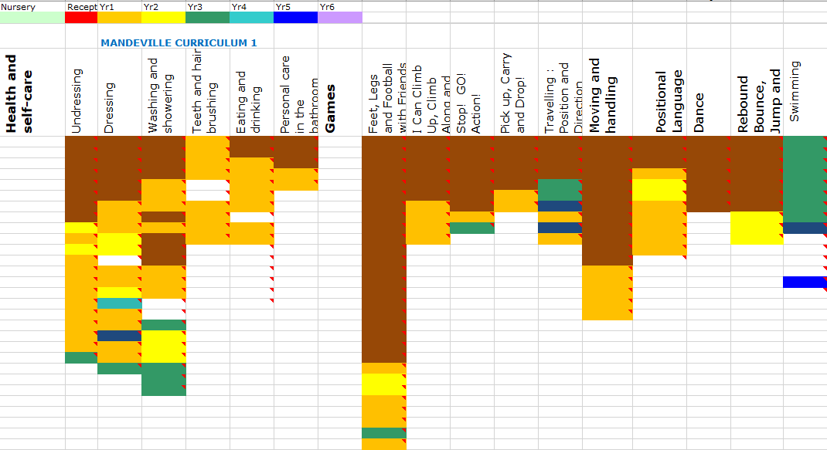
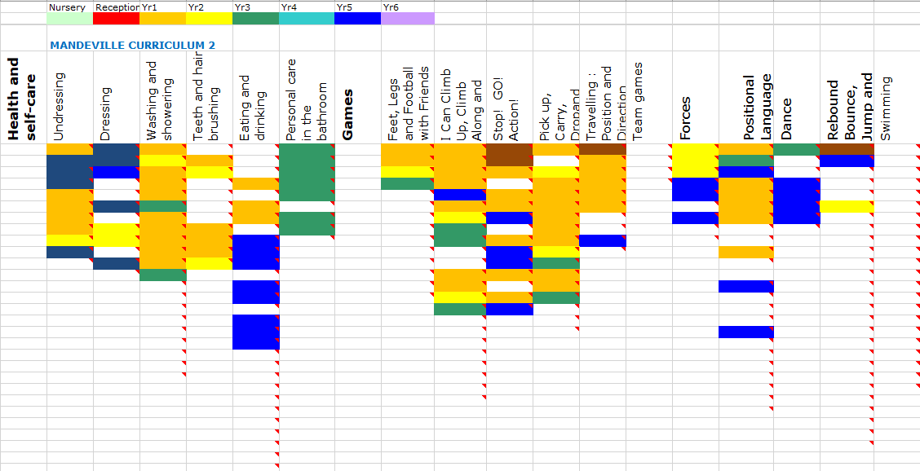

PAGE 1 OF 32 OF PD MANDEVILLE CURRICULUM 1
HEALTH AND SELF-CARE
ASPECT: UNDRESSING
Learning intention | How to support learning | Suggested activities
- Encounters/experiences being undressed  - Responds intermittently to being undressed e.g. stills, smiles, vocalises, turns towards, eye movements, cries.  - Responds consistently to being undressed e.g. stills, smiles, vocalises, turns towards, eye movements, cries.  - Moves head to cooperate when clothing is taken off.  - Removes fabric from head (face) during interactive games e.g. peekaboo  - Removes hat independently  T-shirt –loose top  - Bends arm to cooperate when loose clothing is taken off – adult supporting by holding the clothes  - Pulls arm out of sleeve in loose clothing with adult holding the clothes  - Independently pulls arm out of sleeve in loose clothing  - Independently removes upper clothing from head. Adult has supported child bringing clothes up to head.  Loose trousers  - Bends leg to remove clothing with adult prompts - child in sitting position or lying supported | - Notice individual pupil cues when spending special one-to-one time with them to ensure they are ready to engage.  - Introduce gentle massage sessions that make the pupil feel nurtured and promote a sense of well-being prior to the activity. | - Fine motor skills (see appendix 17)  - Dressing songs and rhymes e.g ‘This is the Way we put on our clothes’ (see appendix 4)  - Social stories (see appendix 5)  - Refer to backward chaining technique

PAGE 1 OF 34 OF PD MANDEVILLE CURRICULUM 2
HEALTH AND SELF-CARE
ASPECT: UNDRESSING
Learning intention | How to support learning | Suggested activities
T-shirt –loose top  - I can independently remove my upper clothing from my head.  Buttons  - I can independently undo buttons and take off a buttoned shirt/dress.  - I can independently undo buttons on my trousers.  Loose trousers  - I can independently pull trousers down over my hips and pull my feet from my trousers.  Socks and shoes  - I can undo shoes - State laces or velcro  - I can pulls off socks independently  - I can remove shoes independently  - I can independently removes socks and shoes.  Coat  - I can unzip my coat and remove it independently.  - I can unbutton my coat and remove it independently.  - I can take off all my clothes independently when changing for PE or swimming. | Ensure sufficient time and opportunities are given to practice skills in context e.g. PE, swimming, home time.  Use symbols of clothes to teach the order for undressing. | - Fine motor skills (see appendix 17)  - Dressing songs and rhymes e.g ‘This is the Way we put on our clothes’ (see appendix 4)  - Social stories (see appendix 5)  - Refer to backward chaining technique

