GUIDING PRINCIPLES  Children learn in a communication and language rich environments in which communication is encouraged throughout the day.  Adults use a range of strategies to support children’s language and communication development.  Well planned learning environment and learning activities ensure that learning is individualised for all children.  The listening environment supports children’s development of attention and listening and takes account of children’s sensory and medical needs.  Skilled observation of the child’s responses allows the adult to adapt and guide learning.  Tuning into learning allows the adult to balance the level of support needed so as not to interrupt the interaction.  Knowledge of the child’s emotional development and zones of regulation allow the adult to dynamically assess the child’s ability to communicate at different times of the day and in different situations.  Understanding of working and long term memory on learning means the adult supports the child to retain information and have a greater depth of learning that can be used in many different ways. | UNDERSTANDING (RECEPTIVE)  Adults use total communication at the children’s developmental levels.  Visual supports are used throughout the day to support children’s understanding:  - Gestures    - Tone of voice, varying intonations and volume  - Facial expression  - Objects of reference  - Pointing  - PECS  - Visual timetables (whole class or individual)Individual symbols  - Now & Next board  - Communication books/ boards  - Signing  - Timers  - Photos      How are the team working to support total communication?  Supporting communication through the senses:  - Auditory cues (response to sound, recognition of sound, event markers)  - Kinaesthetic cues - (touch)  - Proprioception (raising arm - body signing)  - Olfactory (aromacare)  - Child is given sufficient time to process and respond (at least 10 secs and individual to each child)  - Memory - child is given opportunity to practise, repetition, extend learning    Supporting pupils who have complex physical and sensory needs:  - Body signing  - Larger objects  - Bright colours strong contrast  - Visual and hearing passports  - Limit -visual/auditory/sensory distractions  - Eye gaze | COMMUNICATION (EXPRESSIVE):  Opportunities created throughout the day to ensure children can express themselves through body language and vocalisations.).  Children are given frequent opportunities to use total communication through all learning. (question - what does that mean?)    - Body language  - Eye pointing  - Facial expressions  - Body signing  - Eye Gaze, switch, iPad, Apps  - Gestures (pointing, guiding by the hand)  - Vocalisations or speech  - Visuals: Objects of reference, Makaton, PECs, Communication Books  - Signing  - Auditory sense -response to or recognition of sound    What is the child’s zone of regulation?  Where do you think they would score themselves?  How are you adapting learning for this?  Adults model good listening by:  - Being available for the child  - (consider personal space, preference of child)  - Giving children time to process information  - Pacing the learning experience - know when to step in and repeat  - Opportunities for repeating expressive communication (adapt environment to make it communication rich, create communication temptations)  - Acknowledge the child’s expressive communication  - Responding to what the child is expressing (using positive language, simple language, symbols etc)  - Guide the communication through total communication when necessary ie if request made is not directly available (re-direct, now and next) | DEVELOPING VOCABULARY (RECEPTIVE AND EXPRESSIVE)  Create a stimulating and interactive communication environment  - Keep It Short & Simple (KISS)  - Use one key word and build on this  - Check for processing  - Use appropriate tone of voice  - Declarative language - comment  - Use intonation and timing to bring focus to the spoken word or sound  - Model so that the child hears and sees the words relevant to what they are doing  - Repeat back (sign or vocalisation, speech)  - Joint attention  - Use of written word - write and speak the word in front of the child  - For initiating communicative interaction:  - Intensive interaction  - Mirror play  - Burst pause technique    - Extend communication  MOTIVATION:  Adults use resources/ toys/ music to motivate those with specific interests.  Access to a wide range of good quality resources and toys based on the child’s age and developmental level. For example small world objects, loose parts and real/ natural resources are available to support children’s development of play.  - Construction  - Imaginative play  - Sequential play  - Symbolic play  - Adults facilitate and extend play  - Model play | INTERACTION:  Adults use natural gestures and key words signing when interacting with children.  They interact face to face at the child’s level maintaining personal space.  Opportunities are created and children assisted to interact with each other (child initiated play, turn taking, play alongside)  Understanding of play – knowing how the child plays and engage then at that level  Stages of play:  Sensorimotor, Organised, Functional, Pretend, Imaginary  Stages of social play:  Unoccupied, Solitary, Onlooker, Parallel, Associative, Social  Schematic play:  Trajectory, Transporting, Enclosing, Rotational, Enveloping, Connecting, Orientation, Positioning  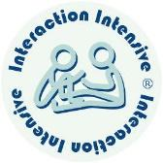  Use of and opportunities for Intensive Interaction as where appropriate throughout the day  PRAISE:  Specific praise is given to children to support their understanding of expected behaviours e.g. “good listening/ good sharing/ I like …” etc, making it more personal rather than “good boy”.  Adults always use positive language to describe expected behaviours e.g. “Good walking, pick it up, gentle hands, feet down”  Do not overuse – be mindful of child’s understand  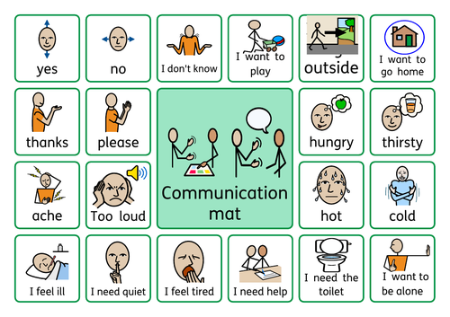
Need to develop consistency Need training/ SaLT input

