Rationale:
We recognise that Communication and Language skills are crucial to a child’s overall development. Being able to communicate, to understand others, to express feelings and ideas and interact with others are fundamental building blocks for a child’s development. The quality of adults' interactions with children affects their vocabulary acquisition and cognitive development. Relational approaches support children to express themselves. Communicating at the child's level of understanding using their preferred communication system is critical to supporting the child's confidence to express themselves and to support the development of their understanding and use of language.
Supporting a child to express themself is integral to showing their understanding and knowledge across all learning areas.

Aim:
We teach communication and Language across all activities and experiences offered.
Our Communication and Language curriculum includes Listening and attending, understanding and speaking including expressive skills.
Pupils will have the opportunity to experience and develop skills in the following aspects of learning:

Mandeville 1 | Mandeville 2
Listening and attending  - Response to sounds  - Response to voices  - Response to human touch  - Developing eye contact.  - Interaction with objects  - Interaction with people  Understanding  - Anticipation  - Comprehension  Speaking  - Motivation  - Body movement/gesture  - Facial expression  - Vocal expression  - Imitation  - Turn taking  - Requesting  - Choosing  Speech development | Listening and attending  - Listening  - Attention  - Understanding – receptive and expressive  Speaking
Teaching approaches
Teaching approaches include:

- Body signing
- Burst pause
- Gesture and Makaton signing
- Objects of reference
- PECS
- Talking mats
- Intensive interaction
- Yoga
- Free flow play
- Developing play by scaffolding schema
- Attention autism

Individual children have a curriculum assessment tool that tracks progress in the Mandeville Communication and Language curriculum1 and 2 over time.
The learning outcomes for Literacy in each aspect of learning are mapped onto the tracker.
When children start at Mandeville they have a baseline assessment which is shown in brown on the assessment tracker.
When outcomes are achieved a colour coding system is used to map yearly progress.
The assessment tool allows us to see a pupils individual leaning profile and to guide us to next steps for learning.

Example of an individualised assessment tracker for a Yr 4 pupil

Mandeville Curriculum 1

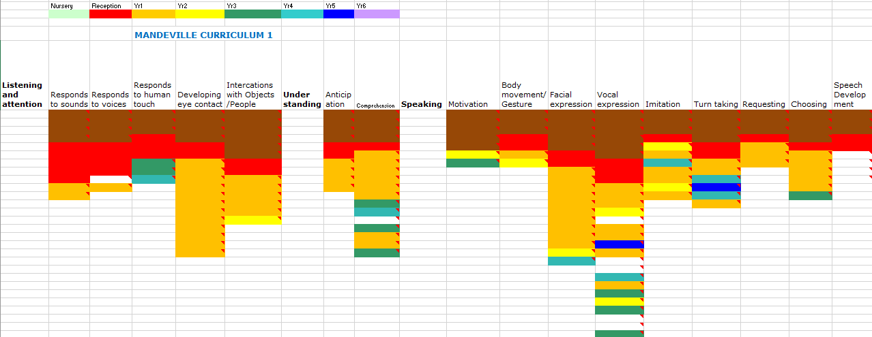

Mandeville Curriculum 2

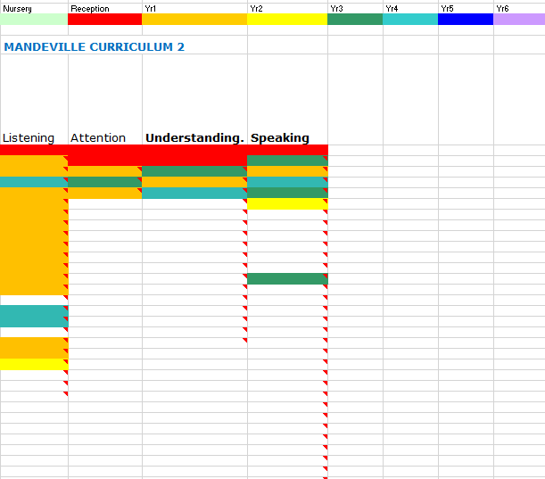

PAGE 1 OF 22 OF COMMUNICATION AND LANGUAGE MANDEVILLE CURRICULUM 1
LISTENING AND ATTENTION
ASPECT: RESPONSE TO SOUNDS

Learning intention | How to support learning (what teacher can do and provide) | Suggested activities (planning)
- Encounters/experiences loud sound, (may show simple reflex responses.)  - Encounters/experiences a quiet sound (may show simple reflex responses)  - Responds intermittently to loud sounds e.g. stills, smiles, vocalises, turns toward, body/eye movement.  - Responds intermittently to quiet sounds e.g. stills, smiles, vocalises, turns toward, body/eye movement.  - Responds consistently to familiar quiet sound e.g. stills, smiles, vocalises, turns toward, body/eye movement.  - Responds consistently to familiar loud sound e.g. stills, smiles, vocalises, turns toward, body/eye movement.  - Moves whole body to sounds they enjoy such as music or a regular beat.  - Will make a choice between a preferred and non-preferred sound making toy  - Make a choice between two sound making toy/instrument that they like. | - Use and give children access to a range of musical instruments throughout day.  - Play pieces of music to the children and vary the type and the volume of the music.  - Sing songs and rhymes during every day routines and vary pitch and volume of own voice.  - Use musical instruments to support transitions e.g. shake tambourine to tell children it’s time to finish.  - Give children opportunities to choose sound making toys and instruments. | - Sounds of Intent http://soundsofintent.org/  - Sherborne (see appendix 1)  https://www.sherbornemovementuk.org/  - TAC PAC (see appendix 2)  https://tacpac.co.uk/  - Look and listen with sound toys (see appendix 3)  http://www.drumbeatasd.org/attachments/download.asp?file=102&type=pdf  - Exploratory bags and boxes with sound making objects inside  - Yoga (appendix 11)
PAGE 1 OF 6 OF COMMUNICATION AND LANGUAGE MANDEVILLE CURRICULUM 2
LISTENING AND ATTENTION
ASPECT: LISTENING

Intended learning outcomes | How to support learning | Suggested activities
- I can associate a sound with an object  - I can gaze from speaker to speaker during conversation  - I can listen to rhythmic patterns in rhymes and stories  - I can anticipate key words and phrases in rhymes and stories  - I can listen to others one to one or in small groups, when conversations interest me  - I can respond appropriately to requests made by adult  - I can sit for a reinforcing activity  - I can sit for a familiar preferred activity  - I can look at object in my hand  - I can look at an adult when they are talking  - I can look at objects/props the adult is using  - I can track objects I am using  - I can track object someone else is using  - I can attend to, concentrate and sit quietly when completing a familiar activity (whole duration of activity) | - Draw attention to different sounds in the environment, e.g. someone knocking on the door, class phone ringing, someone dropping an object, moving a table, bird tweeting, someone crying in playground  - Use same rhymes, vocalisations for a picture, object  - Repeat sounds/vocalisations several times  - Use actions to go with rhyme and/or sound, e.g. ‘swinging through the jungle’ – sway arms side to side and then say ‘wheee wheee’  - Read rhyming books with big clear pictures  - Use gestures, signs, visuals to encourage pupil to understand and follow what you are saying  - Sing rhymes, imitate pupil’s vocalisations, make vocalisations when pupils are playing with toys  - Use auditory cues to indicate start and finish of activities  - Play a range of music at particular times of day, e.g. calming music at start and end of day, rhymes after lunch.  - Adult plays range of sounds, pupil labels the sound or finds correct picture representing the sound, e.g. hear toilet flushing and gives adult picture of toilet  - Draw attention to different sounds in the environment, e.g. someone knocking on the door, class phone ringing, someone dropping an object, moving a table, bird tweeting, someone crying in playground | - Sensory stories (see appendix 5)  - Sound stories https://www.cvijourney.com/interactive-stories/  - Nursery rhymes and poems  - Phonics stage 1 (see appendix 12)  ​

