Rationale:
Maths activities support pupils to develop cognitive skills to:
Explore using all the senses, Develop their own spatial awareness, make connections, problem solve, explore patterns and shapes, develop an understanding of number and compare sizes, generalise and apply maths to practical situations.

Aim:
Pupils will have the opportunity to; explore with and develop their senses, problem solve in order to develop flexibility of thinking, develop an understanding that number refers to quantity, develop their working memory in order to remember instructions and carry out tasks, develop their play skills, learn skills to support independence e.g. sorting clothes, using a phone.

Pupils throughout the day, are given the opportunity to
- Explore their environment
- Develop confidence in their ability to think things through.
- Solve meaningful and practical problems.
We promote the use of functional and meaningful maths activities throughout the day in a range of experiences and in daily routines.

Pupils will have the opportunity to experience and develop skills in the following aspects of learning:

Mandeville 1 | Mandeville 2
Number  - Response to objects  - Visual exploration  - Tracking  - Object permanence  Shape space and measure  - Object play  Using and Applying  - Cause and Effect  - Matching and Sorting | Pre Key Stage Standards are weaved throughout the Mandeville Maths curriculum  Number and Numerical patterns  - Read and Write Numbers  - Counting  - Understanding of quantity  - Comparing Numbers and Place Value  - Ordering Numbers  - Addition & Subtraction  - Fractions  Shape Space and Measure  - 2D & 3D Shape  - Position and Movement  - Measurements  - Time  - Money  Using and Applying  - Colours  - Colour mixing  - Size  - Sorting  - Puzzles  - Same and different  - Patterns  - Matching  - Play-Doh  - Construction & Functional Use of Objects in Role Play (Brick play / Blowing objects / Ball play / sand and water play)
Teaching approaches include:
- Sensory/exploratory play  - Technology – eye gaze, switch operated toys, sensory rooms, dark dens.  - ICT games - clever touch  - Attention autism  - Outdoor learning  - Play skills including – people play, object play and imaginary play  - Cooking  - Shopping at local shops/tuck shop  - Practical Maths games – using resources such parachute, co-op band, instruments. |  | - Tuff tray – small world  - Floor play  - Life skills e.g. sorting socks, setting up snack time.  - Tidy up time/routine and set up/chores - sorting and organising.  - Active games and PE - maths language  - Stories  - Life skills -problem solving  - Drama games nursery rhymes.  - Number blocks – Twinkle

Individual children have a curriculum assessment tool that tracks progress in the Mandeville Maths 1 AND Mandeville 2 curriculum over time.
The learning outcomes for Maths in each aspect of learning are mapped onto the tracker.
When children start at Mandeville they have a baseline assessment which is shown in brown on the assessment tracker.
When outcomes are achieved a colour coding system is used to map yearly progress.
The assessment tool allows us to see a pupils individual leaning profile and to guide us to next steps for learning.

Example of an individualised assessment tracker for a Yr 4 pupil
MANDEVILLE CURRICULUM 1
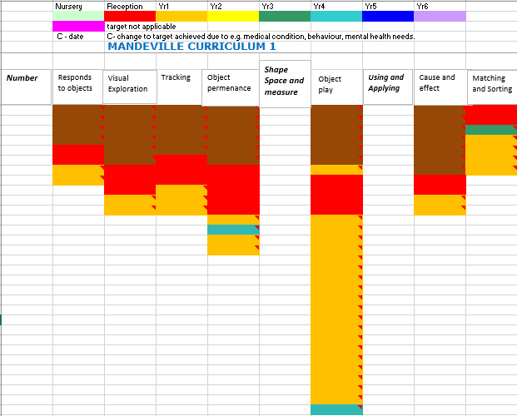
MANDEVILLE CURRICULUM 2

Page 1 of 11 OF MATHS MANDEVILLE CURRICULUM 1
NUMBER
ASPECT: RESPONDS TO OBJECTS
Learning intention | How to support learning | Suggested activities
1. Experiences/encounters a preferred object presented close to them.  2. Responds intermittently to a preferred object presented close to them e.g. stilling, moving body parts, eye movement.  3. Responds consistently to a preferred object presented close to them e.g. stilling, moving body parts, eye movement.  4. Will find a preferred object placed just out of reach and explore it e.g. reaching, swiping, touching, looking and listening.  5. Will let go of an object in order to play with another object.  6. Follows a counting sequence by looking at objects as an adult points to them moving from left to right.  7. Notices changes in number of objects in group of up to three  8. Develops an awareness of number names through enjoyment of actions rhymes and songs that relate to their experience of numbers. | - Display motivating and eye catching objects in classroom  - Join in with pupils as they play with objects, and move objects slowly and in different directions for pupil to track  - Create hanging mobiles, occasionally changing the number of items you hang on it.  - Encourage pupils to explore and show an interest in discovering new things.  - Sing number rhymes as you play with a pupil and during personal routines  - Move with the pupil to the rhythm patterns in familiar songs and rhymes.  - Encourage pupils to join in tapping and clapping along to simple rhythms.  - Collect number rhymes which are repetitive and are related to pupils’ actions and experiences, for example, ‘Peter Hammers with One Hammer’.  - Collect number and counting rhymes from a range of cultures and in other languages. This will benefit all pupils and will give additional support for pupils learning English as an additional language | - Visual activities (see appendix Elk p22-23)  - Number rhymes (see appendix 4)  - Look and Listen (see appendix 3)  - Sensory stories (see appendix 5)  - Visual activities (see appendix 20)

Page 1 of 25 OF MATHS MANDEVILLE CURRICULUM 2
NUMBER
ASPECT: READ AND WRITE NUMBERS


