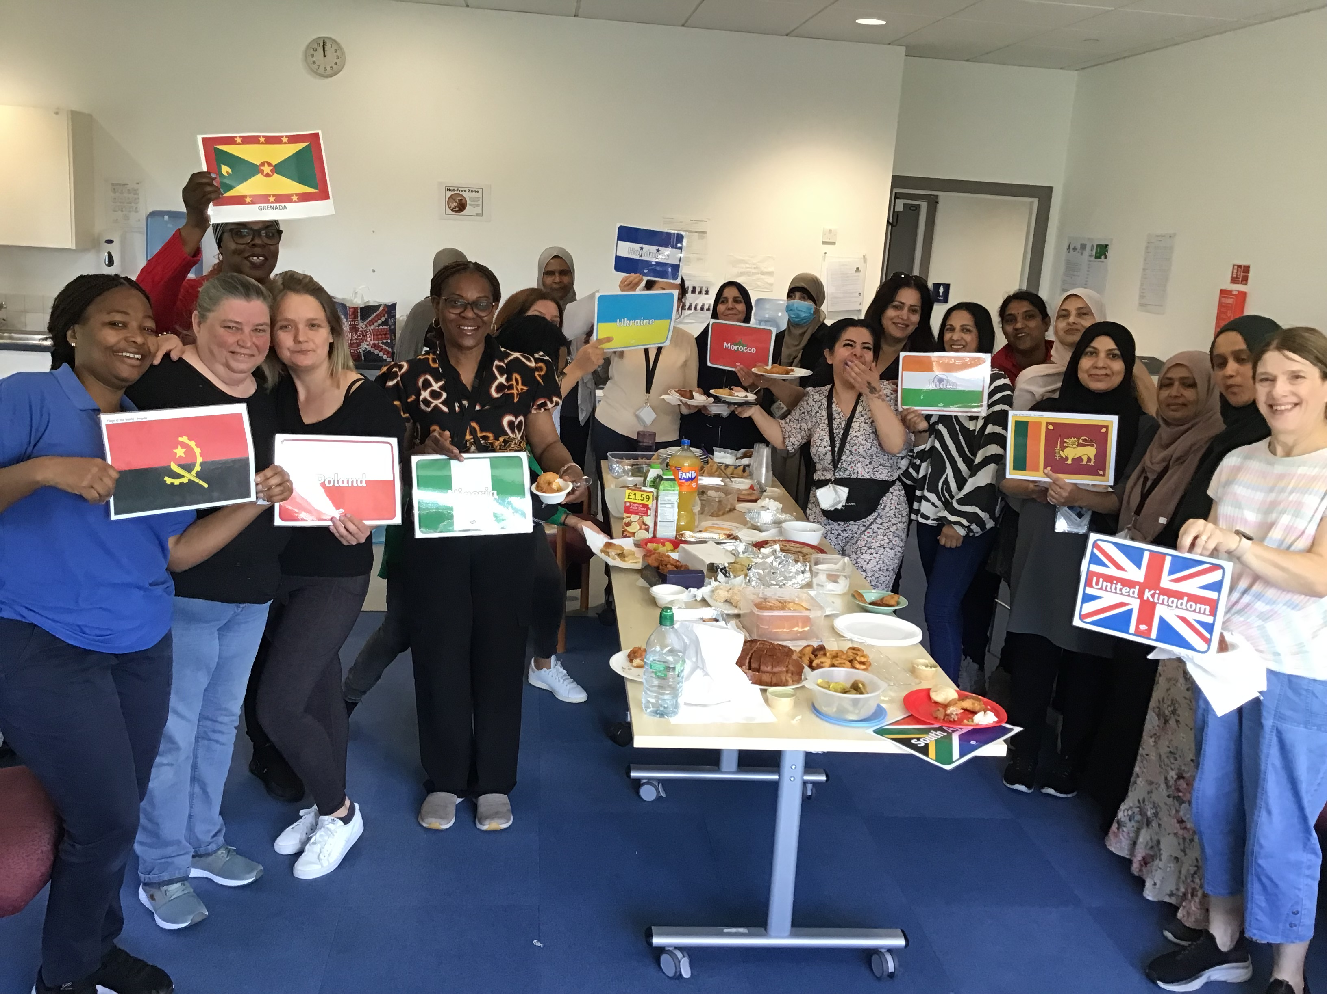

SMSAs Celebrating International Week
Denise Feasey Headteacher
Mandeville School Improvement Plan – working document
September 2024.
OUTCOME 1
MANDEVILLE IDENTITY – BUILDING PARTNERSHIPS
- Progression pathways for SEND pupils - all pupils have a clear provision pathway that meets their needs (2023-2024) – strategic planning for significant increase in pupil numbers, response to change in descriptor of need, partnership with St Ann’s secondary provision, partnership with nursery schools, sharing good practice with other special schools - support for SLT (£15,000 from LA buildings project).
Impact statements:
  - Mandeville data collated from the descriptors informs partnership work with other special schools and strengthens pupil place planning. (Evidence - data spreadsheet, minutes from partnership meetings with St Ann’s and LA,
  - Mandeville data informs trends over a 6 year period so that governors can make informed decisions about provision at Mandeville. (Evidence: data spreadsheet – table, graph and projections)
  - Our collaboration and partnership with St Ann’s has led to better outcomes for pupils at secondary transfer. (transition planning, shared information e.g. google drive, teacher visits, headteacher visit to observe Festival of Flight, new AHT previously worked at St Ann’s – strengthens links and partnership)
  - A collaborative approach to training and development has improved understanding across the primary and secondary phase and as a result has enhanced quality of provision for Mandeville and St Ann’s School. (training - lesson plan, VI, play)
  - Through mentoring, training and support Mandeville leaders and teachers are impacted on quality of teaching and learning in the nursery setting (support for Rec group maintained place there, improved teaching practice, impact on classroom organization and teaching approaches.)
  - Mandeville has had a significant influence on practice across special schools in Ealing (Seesaw training and support for 3 schools –all implemented. Autism pathway C – joint understanding of provision)
  - Mandeville has impact on SEND practice in mainstream (teaching play in the mainstream SEND influence on practice ML and SaLT, outreach)
  - Mandeville has an influence at a LA level (engaged proactively with descriptor work led by LA, SEND and inclusion committee Chair, interview panel for AD post at LA, Chair interview panel for CwD nursery manager, Medical Needs Policy Working Group).
  - Sharing practice In reach – specialist nurseries, a range of professionals and mainstream colleagues learning from our practice – (japan, EdPsy, EHCCs, mainstream SENDco and heads drop in)
  - student placements
  - Sharing curriculum with Windmill Nursery
Work in progress:
  - Staff have a better understanding of pathway C and the provision needed to meet the needs of these children – work in progress. (training day focus on individual child and pathway C – class teams working together to problem solve)
Next steps:
  - Continue the work with teachers and all staff to develop pathway progression
  - Continued to strengthen partnership with St Ann’s (leaders)
  - Feedback from Windmill and other nurseries re Mandeville Curriculum
  - Consider wider use of Mandeville curriculum for mainstream

- The design and build for the satellite site meets the needs of EYFS pupils who have autism and SLD (2023-2025)– building partnership with Oldfield Primary School, project management, phasing into new building, project management, resourcing and recruitment for September 2024 (Head and facilities manager) link business plan

The Project Team (Finance and Personnel Manager, Facilities Manager and School Business Manager from Oldfield Primary) took over form the headteachers to lead us through the building works, handover, relocation and snagging stages. This has been led very successfully and the building has now been handed over to Mandeville and contractor work complete with a few outstanding snagging issues. The main work to complete broadband and ICT set up (scheduled 16th August).

Recruitment has taken place and all positions filled. The new AHT was appointed and started in June. This has had a very positive impact on the overall project and has helped to support staff and parents through the transition so far. All home visits have been completed and many parents were able to attend the New Parents Coffee Morning at Mandeville main site. It has always been our intention that the satellite site is part of the main school and this has driven decision making along the way.

There will be an addition fourteen pupils in school which will bring our total numbers to 174 (R to year 6) plus 14 (nursery) – 188 in total
Additional therapy time has been secured for occupational therapy and speech and language therapy to support the needs of the children joining.

Work in progress:
Next steps:

  - Shared values, approaches and practice
  - Developing a model for working alongside the mainstream school
  - Develop a model for working together with the main site

Maintenance targets – oversight of established areas/small projects
- SEND and Inclusion – Chair of ELP SEND and inclusion committee (Head)
- Admissions guidance – LA working group (Head)

OUTCOME 2
STRENTHEN MANDEVILLE OFFER TO IMPROVE OUTCOMES FOR ALL PUPILS
- To provide mainstream schools with a bespoke outreach and training offer that supports the prevention of placement breakdown for pupils with SEND (funded by LA) – (2023-2025)
Impact statement:

Please see outreach evaluation report Oct 2023

- Develop relational approaches so that children are supported to co-regulate/self-regulate their sensory and emotional needs (2023-2026) (link to business plan, new funding arrangements and staffing structure changes)
Impact statements:
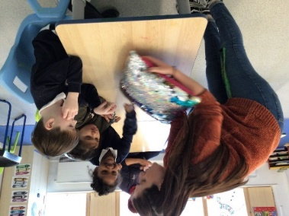
  - Aroma Care trainers are improving outcome for children across school and throughout the curriculum (4 trained teacher, supporting own classes, Powerpoint presentation, impact statements

‘The children showed a lot of amazement during our sensory Colour story. It is lovely to hearing some of them repeating words or spontaneously commenting during the story.’

  - As a result of the training staff report they are ‘more confident to use massage techniques’, children are developing joint attention’ and ‘massage and positive touch opportunities have increased’. (ref to Impact of training document)

  - Our middle leader has led sessions for parents, Mandeville staff and other professionals on the benefits of massage and this has been used successfully to support children’s emotional and physical well-being, having a positive impact on learning (Refer to Data Report)

Relational Approach
  - The STAR team, consisting of the AHT for Provision, a middle leader and two senior TAs is now well established in school and having a positive impact across classes, during special events and supporting pupils who become dysregulated.
  - The team work collaborative with the Clinical Psychologist commissioned by school.
  - Training on our relational approach has had a positive influence on whole approaches to supporting dysregulated children. It has been recognized by visitors to school who comment on the strength of relationship the staff have with the children.
  - Training - Early Stages of Emotional Development (Sept 2023) and Compassionate and nurturing approaches (Oct 2023) both delivered by Clinical Psychologist with excellent feedback.

‘Staff build relationships with children who learn to feel safe, understand themselves, others and the world around them. Through the relational approach children have clear consequences and understanding of what is expected of them, instead of negative language used to describe their behaviours which the children do not understand or cannot relate to’ Pupil Premium Report 2024

Next steps
Relational approach:
  - Continue to embed the approach at whole school level
Maintenance targets – oversight of established areas/small projects
- Communication and language, physical development, sensory regulation, music therapy, teaching approaches, play, 1:1 tuition, parents understanding of behaviours that challenge Pupil premium – to be updated
- Integrated work with social care – access to ASW information - link safeguarding action plan
- Aromacare – Middle leader to support and monitor practice

OUTCOME 3
MANDEVILLE WORKING WELL FOR PUPILS, STAFF AND PARENTS
Career pathways for Mandeville workforce
- Staff have access pathways for career progression at Mandeville (2023-2024)
- link to CPD plan
Impact statements:
- We have an enthusiastic, creative and committed teacher workforce
- We empower staff to develop their career pathway
- We have invested in highly skilled TAs to become teachers through the Mandeville career pathway. (1 teacher successfully passed ECT (July 24), 1 transferring QTS, 2 unqualified teacher under assessment route only, volunteer now agency TA, 1 student teacher now an ECT at Mandeville, NPQML)
- Teachers are gaining a greater depth of knowledge about specialist teaching which impacts on pupils learning and builds a strong workforce for the future
- The interview process has been reviewed and is more robust in terms of being focused on a deeper knowledge and understanding of learning at all levels and cross references back to the job description and person specification (Interview task planning sheet)
- Opportunities across school all levels of development - Volunteers to TA, parents to TA, TA to teacher
- We access funded career development opportunities through Egfl and Dfe initiatives (NVQ level 1 and 2, SENDCo training) – this builds capacity in school and for the SEND workforce
- Our newly appointed AHT for the satellite site is a qualified Mental Health First Aider and has the NPQSL, this has added further capacity to the SLT
Work in progress:
- Improve knowledge and understanding of the different routes into teaching
- Share information with all staff so that the can prepare for their individual pathway

- Early Careers Teachers (ECT) have a comprehensive network of support during the early stages of their career leading to successful outcomes (2023-2025)
Work with appropriate body to adapt ECT programme for Mandeville teachers so that the model is supportive and challenging and reflects the needs of Mandeville pupils - link to CPD plan
Impact:
- The level of support from Mandeville ECT mentor has had a very positive impact on career development however the challenge has been the appropriateness of the ECF (Hillingdon SCITT)
- Significant impact on the ECT and AHT and adapt the existing framework to reflect specialist provision.
Work in progress:
- Explore options for more specialist Early Careers Framework for future ECTs

Maintenance targets – oversight of established areas/small projects
- Mandeville working well group
- Events and parties working parties
- Mental health first aider role

OUTCOME 4
BUILDING PARTNERSHIP WITH PARENTS AND THE COMMUNITY
- School has a partnership with parents based on the co-production model (2023-2026)
Impact statements:
- Co-production has developed and has resulted in increased involvement of parents in decision making and in leading our offer to parents. (three experienced and trained parents leading the development of the buddy system, parents for parents, ground rules for parents, online parents evening)
- More efficient systems for communicating with all parents have improved parental engagement with school (Seesaw and texting service, newsletters, buddy, attendance at specialist assemblies, school choir event, and annual reviews).
- Focus on engagement of fathers has led to more involvement in their child's education (pupil information to both parents, Seesaw, arrangements for fathers not living in the home, proactive involvement of fathers at annual review, parents evenings and Early Birds training)
- Significant increase in the uptake for coffee mornings 'parents for parents'. Parents tell us that the coffee mornings are a safe place to express themselves, share experiences and challenges and support each other. (46 parents at last coffee morning, including a number of fathers, parent feedback)
- Our therapy drop in session for parents was very successful and identified areas of needs at home that could be worked on proactively
- School led WhatsApp group for parents has allowed a safe platform for parents to share ideas, resources and place to go. (parent feedback)
- Effective system in place to provide parents access to information and services so that they are enabled to make informed choices for their child (webpage link on newsletter, weekly sharing of information through newsletter, CwD page on website, holiday information, access to services etc, CPOMS additional categories to records when parents are accessing services and training at individual level)
- Systems in place for parents to observe their child in school as part of the Early Bird Training and now more general practice
- Excellent examples of parents working alongside teachers in class, supporting their learning in specified areas (Eating and drinking).
- Parental involvement in International Festival and Festival of Flight enhanced the experience and the children’s learning (mothers and fathers sharing cultural practice, food, customs, resources, dance, language)
- Formalised training supports parents to understand Autism and how their child is making sense of the world. Empower parents to problem solve and support their child to progress holistically. See EarlyBird parent feedback. (EarlyBird parent feedback)
- Two parents represented on wider co-production training – interview as part of the training JM – Rachel Wright
Next steps:

- Use WhatsApp group for feedback about the newsletter
- Clearer data on fathers involvement – monitor impact
- Parent friendly website
- Feedback from parents re impact of visiting class

- Appraisal target (2023-2024)
Effective use of the community to support children’s learning and engagement of parents in the process
(link to race equality)

Maintenance targets – oversight of established areas/small projects

- Seesaw success of and where next – throughout school and support system in place, how to use the data to inform practice
- Early birds training – model for working in class – evaluation of impact of training autism and behavior

OUTCOME 5
HIGH QUALITY CURRICULUM AND ASSESSMENT
- Develop the understanding the world curriculum and approaches (including progression to science) – (2023-2025)- curriculum budget
Impact statements:
- Specialist workshops have raised the profile of subject specific areas of the curriculum and enhanced it's delivery (Professor Bubble Works)
Medium term planning has been reviewed for science and as a result teachers have a better understanding of the science curriculum and resources to support learning.

Work in progress:
Next steps:
- Science learning walk — assess impact on learning.
- Moderation of individual pupil targets to ensure consistency
- Understanding of the World

- Develop a creative arts curriculum (music, art, drama) (2023-2026) – curriculum budget
Impact statements:
- Specialist workshops have raised the profile of subject specific areas of the curriculum and enhanced its delivery (London Children's Ballet, Hospital Music, Second Hand Dance, Wallace Collection - national museum).
- Find your voice group has meant that children have developed their confidence and enjoyment of using their voice to communicate (annual review reports – increased vocalisations, functional language).
- Interactive poet uses poetry and music to tune into the child, develop responses and level of engagement in creative processes which have a dramatic impact on pupils' communication and interaction (drawing out musical skills, impact of drumming, impact of body percussion, video and photo evidence).
- The profile of Makaton has been raised significantly through music (Makton Flashmob, Makaton choir led by SaLT and music therapist, use of Makaton in assemblies to teach parents)
- Joint agency working increases the depth of knowledge and understand about learning.
Work in progress:
- Introduced Charanga music education online platform which provides help and resources for teachers to deliver music lessons.
- Ealing Music Service supporting school delivery of Charnaga approach
Next Steps:
- Curriculum development training to support teacher delivery of the creative arts
- Develop poetry webpage and share with parents (inc video and photos)
- Develop Find Your Voice webpage and share ideas with parents

- Curriculum links to appraisal
Nursery, EYFS and KS 1 (2023-2024)
Pupils make good progress from their starting point in physical development (refer to data report)
KS 2 (2023-2024)
Pupils make good progress from their starting point in mathematic (refer to data report)
Work in progress:
- Teachers revisited rationale, aim and teaching approaches for physical development and mathematics.
- Leadership moderated medium term plans for maths which informed us that there needed to be more focus on functional maths, using and applying, shape space and measure.
- Lesson plans for maths were shared, moderated in small groups and improvements taken forward by individual teachers which is resulting in greater breadth of maths in the curriculum.
Next steps:
- Review teachers to subject
- Lesson observation — cognition and maths for all teachers

Maintenance targets – oversight of established areas/small projects

- Physical development – accessing specialist physical activities in the local community – sports premium HLTA
- Literacy – phonics –Mandeville whole school appraisal – curriculum budget and refer to pupil premium
- Sensory processing needs – CPD budget – refer to pupil premium
- Yoga - impact of training – CPD plan – refer to pupil premium
- Aromatherapy – impact of training CPD budget

OUTCOME 6
Race Equality – our journey towards becoming a culturally competent school
- Leadership – embedding 3 year program to promote race equality (2023-2026)
Work in progress:
- Working with consultant Karen Brookes (specialist in black British history, school curriculum decolonisation, black British culture and cultural identity.
- Rolling out the Decolonising the Mind training and whole school training on Anti-racism in January 2024. https://www.oshuneducation.co.uk/karen-brooke-1 -
- Decolonising the Mind Training – opened up staff minds to the lasting impact of colonisation and start to explore how we as a school can redress the balance.
- We now have an established group of staff leading in this area and as a group we are gaining a better understanding of our own cultural behavior through research and debate.

Background reading for the group:
White Fragility: Why it’s so hard for white people to talk about racism Robin DiAngelo https://www.theguardian.com/books/audio/2019/mar/26/why-is-it-so-hard-for-white-people-to-talk-about-racism-books-podcast

Why I’m no Longer Talking to White People about Race Reni Eddo-Lodge https://www.theguardian.com/world/2017/may/30/why-im-no-longer-talking-to-white-people-about-race

- Our Anti Racist Policy and revised Equalities Policy are ready for fuller consultation with staff
Next steps:
- A curriculum that reflects and represents the cultural diversity of school
- An understanding of the differences between cultures (link outcome 5)
- Effective communication and interactions with people across culture (link outcome 4 parental engagement)
- Systems and structures in our schools support race equality (link - recruitment and retention, data report, benchmarking)

LA development area till 2026 – proposal needs to include cost implications over time – short and long term aims
https://www.egfl.org.uk/news/2022/09/ealing%E2%80%99s-race-equality-commission-and-inclusion-expectations-schools-2022-2026

School Accessibility Planning 2022 - 2025

- Descriptors of need – agree across specialist provision (LA led) – access to appropriate funding to meet need
- Medical needs in school – review process with CCG – access to specialist health care
- Engagement – extend work on engagement curriculum – approaches and practice

Key staffing areas of issue | The line management structure takes account of staff expertise and experience and provides support and development opportunities. It is based on the principle of enabling and empowering staff so that leadership is developed and distributed at all levels within school. Senior leaders provide cover and support in classes where a need is identified through proactive planning or monitoring systems.  Governors have identified risks and opportunities within the current staffing structure, and these will be given consideration and consultation if they progress.
Budget information  Please also refer to Mandeville School Business Plan | Descriptors of need  Medical conditions in school – funding impact and attendance
The School Improvement Plan runs alongside the School Business Plan

