

Sensory Strategies
& Keeping Active at Home during Summer holidays




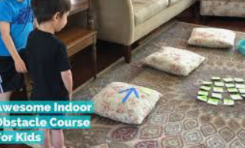


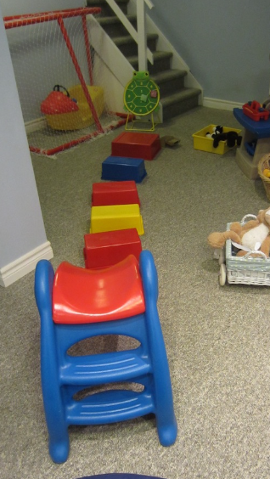
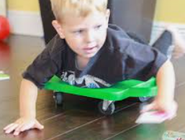



Wednesday 12th July 10-11:30am at Mandeville school

Aims of Parent workshop:
- To discuss importance of keeping active during Summer Holidays
- Tips/ideas for keeping your child active at home
- Calming sensory strategies to help your child settle at home
- How to embed calming activities into your child’s daily routine
- Sharing resources and activities available in the community
- Space for Parents to share suggestions and experiences

Paediatric Occupational Therapy Service
Brooke Woodfield OT

Silvia Pinto OT

