

Monday 5 December 2022

Expansion of Mandeville Special School on a satellite site at Oldfield Primary School Consultation on the Proposal - from Monday 5 December 2022 to Monday 23 January 2023

Dear Parents / Carers, Pupils, Staff, and other interested parties,
The Proposal. The governing boards of both schools and the Council are seeking views on a proposal to expand Mandeville school by up to 24 pupils and accommodate them in a building at Oldfield Primary School. It is proposed that the Oldfield satellite site will be used by Foundation stage and Key stage 1 classes, with a focus on pupils with severe learning difficulties many of whom also have a diagnosis of Autism. The increase would be phased over two years starting with extra places in 2023 and ending in 2024. The proposed expansion will require investment in buildings on the Oldfield Primary School site. This will be funded by the Council.
To make the satellite work it is proposed to remodel the early years block at Oldfield to form SEN classrooms, specialist learning spaces. Extra teaching and non- teaching staff would be recruited by Mandeville. At the same time other spaces at Oldfield Primary school will be remodelled to accommodate the foundation stage classes moved from the current early years block. In developing the plans further, the Council will seek to maintain as much as possible of the external play space on the Oldfield Primary School site and the works would also include fencing and landscaping. The accommodation would meet government requirements and guidelines. The remodelled accommodation will be carefully designed to optimise the use of holidays for the build period when Oldfield Pupils are off site.
Why is the expansion being proposed by Ealing Council? The proposal for expansion of Mandeville Special School has been prompted by Ealing Council in response to a further significant rise in the proportion of pupils born in the last 5 years seeking special school places in the borough. There has been a specific rise in pupils with severe learning difficulties or profound and multiple learning difficulties, many of whom also have a diagnosis of Autistic Spectrum Disorder. Mandeville has already been expanded in response to the rising demand in the primary phase age group and no further expansion on the site is possible.

Oldfield Primary School is less than two miles from the Mandeville. Oldfield Primary has a good Ofsted report and has been a two-form entry school (420 pupils) until recently. However, falling pupil numbers in the area has led the school to reduce to (315 pupils). This will allow one of the
buildings on the site to be available for the proposed satellite.

Mandeville has a borough wide catchment and provides a nursery and primary school education children aged 2 to 11 who have the most severe learning disabilities. We have three cohorts of students, those with Profound and Multiple Learning Difficulties, (PMLD), those with complex Severe Learning Difficulties (SLD) and those with an additional diagnosis of Autistic Spectrum Disorder (ASD). All of these young people have complex learning needs that require input from a highly skilled multidisciplinary team and specialist facilities to meet their learning, therapeutic and care needs but with an increasing roll Mandeville will need additional space to deliver a consistently high-quality education and maintain health and safety requirements
The views of Mandeville Special School on the proposal

Mandeville is a well-resourced school built to meet the needs of pupils with severe and profound learning difficulties. Pupils who attend Mandeville come from across the whole of Ealing. The existing Mandeville building was opened in 2008. Subsequent expansions of the nursery block, conversion of classes to respond to the growing number of pupils with profound learning difficulties and provision for 10 classes of pupils with autism and severe learning difficulties has meant that pupil numbers have increased from 86 to 156 over the past 10 years.

The current Mandeville site has reached capacity in terms of places; the proposal for a satellite site at Oldfield offers a different and exciting opportunity to provide an education for some of our Early Years Foundation Stage pupils who have autism and severe learning difficulties. The Oldfield site will allow additional 24 places for pupils who will be educated by Mandeville staff. Once pupils have completed the EYFS they will move to the main Mandeville site and a new intake will start at Oldfield.

Mandeville proposed unit at Oldfield Primary. The proposed building at Oldfield (current EYFS) can be adapted to meet the needs of our children. The intention is for reception children and some year one children to be educated there. The current building will require a limited amount of adaptation to meet our needs. The proposed design is for three classrooms, a small sensory room and small soft play, small mixed-use space and office space for an administrator and teachers. It will also have an area for parents to meet. The outdoor space behind the building offers a small nature area, which is ideal for outdoor learning; landscaping will include a walkway through the trees, which would be of benefit to both schools. The front of the building has existing outdoor learning and play space and will include equipment to promote physical development, and defined spaces for us to extend the curriculum.

Expertise in SEND. Working next to Oldfield Primary School will bring opportunities for both schools. We have a very experienced leadership team at Mandeville and a highly skilled staff team. We have expertise in the SEND curriculum, assessment and approaches. Staff members are qualified trainers in the following: Team Teach; Makaton; yoga; moving and handling; swimming and sports. Our integrated work with the multi-disciplinary team including therapists and the medical profession has strengthened practice for all our staff. Having such a comprehensive skill base at school means we can provide training and outreach to mainstream schools. Being near Oldfield Primary means, their staff can benefit from expertise of the Mandeville staff and in turn, Mandeville staff will widen their knowledge of the EYFS and SEND in mainstream schools, this will enhance our practice.

Extending our community. We have an inclusive approach to learning and recognise the importance of building a school community that celebrates the uniqueness of every child. We believe in acting together to make things better for all. Our overall vision is to influence how young people with special educational needs and disabilities (SEND) can be part of their local community. We welcome this opportunity to be with Oldfield and are keen to explore possibilities of including pupils and parents in the wider community. Our approach is to work with and educate people so that children with SEND can extend their learning beyond school and be part of community life. There is a short distance between Mandeville School and the Oldfield site. The unit at Oldfield will be an integral part of the whole school community. Mandeville parents will have access to all training and support. Parents and children will have the opportunity to join planned special events and will have access to extended learning activities at Mandeville.

The views of Oldfield Primary School on the proposal.

Oldfield is a small school which prides itself on the high level of pastoral provision alongside maintaining high standards. Pupils here show high levels of consideration for their peers, meaning Mandeville children would receive a warm welcome. Like all schools, Oldfield is seeing an increase in children with special needs entering our mainstream provision. The presence of Mandeville professionals onsite gives us the opportunity to draw on their expertise. Both schools would explore the options of certain staff working and training across both organisations. As Oldfield has spare capacity, we feel we can offer the space to benefit the community as places in Specialist Settings are much needed in Ealing. In addition, this would help our school economise by reducing the upkeep costs for empty classrooms.

Oldfield would remain a separate mainstream school. The most important thing to emphasise is that although Oldfield and the Mandeville satellite will share the same site, they will in effect be 2 different schools. Mandeville children will not be attending lessons at Oldfield or sharing the playground. Oldfield will be catering for mainstream children of a range of abilities and teach its current curriculum. The SEND unit will be run by a member of Mandeville’s senior leadership team while Oldfield will be managed by Mr McCormack and his team.

The benefits of working in partnership. As Mandeville has been judged as an outstanding school by Ofsted, the benefits for Oldfield are clear in terms of support the partnership would offer. Like all schools, Oldfield is seeing an increase in children with special needs coming into our mainstream provision. The presence of Mandeville professionals onsite gives us the opportunity to draw on their expertise. Oldfield would also like to explore the options of certain staff working across both organisations as well as offering Teacher Training across both schools.

Upgrade of facilities for Oldfield. With Ealing Council funding the project, Oldfield would benefit from a renewal of certain parts of the existing building such as the new year 1 and 2 classrooms and the new EYFS block. The new area for EYFS would provide a much larger outside area with upgraded play equipment. It would back directly onto small, raised beds and an enclosed field. Contained within a square space, the children will be able to mix more freely than present. Year 1 and 2 would benefit from an outside enclosed grass area and shade that they do not currently have. The new KS1 classrooms, leading directly onto this garden could utilise the space to enrich learning. It would also offer the opportunity for children who need more transition time into year 1, to access more physical and play based learning at times. The council will also be developing the nature area behind the current EYFS block. This would be timetabled for use by both Mandeville and Oldfield. In addition, certain Oldfield students who may have more complex needs, could by arrangement, use Mandeville’s sensory room.

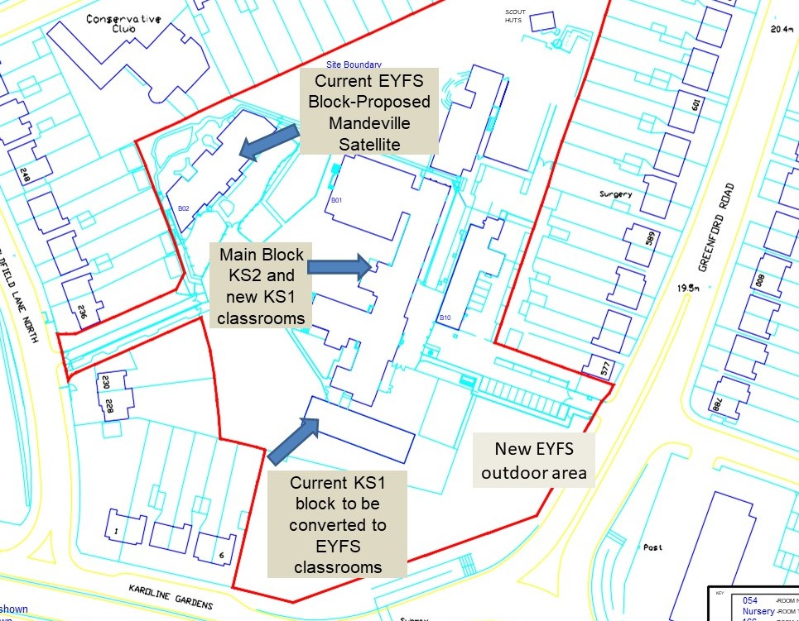

Enhancing Oldfield as a community. As Oldfield has a smaller number of students, we feel that there is an opportunity to bring the different age groups into a more cohesive unit rather than EYFS being the opposite side of a large playground. Nursery and Reception children would be part of the main school and could interact more freely with older children. Likewise, the KS1 children would be closer to KS2 children which would allow greater interaction. On certain occasions, children from both Mandeville and Oldfield could come together for special occasions such as non-uniform days and productions. Pupils would come to know children with special needs and appreciate the diversity in our community.

More effective use of resources. Next year OPS will have 4 spare classrooms as a result of consolidating into a 45 per year group entry. This is without a reduction in its official intake so it is likely with the projections for Greenford Northolt and Perivale (GNP) central that there could be further downward pressure on numbers which is being experienced by all schools. The fact that Oldfield would be able to relinquish the upkeep of one of the buildings, would reduce expenditure on maintaining empty classrooms. This could save up to 25% of these costs as we would employ fewer cleaners, use less energy and could make saving by sharing premises staff. This would mean that Oldfield would be able to direct more resources into the children’s teaching and learning rather than “on-costs”

Consultation Process

Who are we consulting? We are consulting parents / carers, pupils, staff, associated professionals, and other interested parties.

How to have your say. Detailed information on the expansion proposals can be accessed on Mandeville and Oldfield websites

Please return any comments to the school by midday on Monday 23rd January 2023. Boxes for comments will be placed in both schools’ office reception area. Alternatively, please post to:
Mandeville School Expansion at Oldfield Primary School
Horsenden Lane North, Greenford, Middlesex UB6 OPA
Or
Mandeville School Expansion at Oldfield Primary School
Oldfield Lane North, Greenford, Middlesex UB6 8PR

What happens next?

- 5 December 2022 consultation starts.
- Consultation Meetings - Dates to confirmed on School Websites
- 23 January 2023 deadline for responses to the consultation Governors of both schools consider consultation responses and decide whether to proceed. Update for parents on progress.
- February 2023 Ealing Cabinet decides to publish a Statutory Notice for the Proposal
- February / March 2023 statutory notice published in local paper
- March / April 2023 Ealing Council Cabinet will determine the proposal
- Preparations begin for September 2023 implementation.

Please take time to complete the attached questionnaire so that we can get your feedback. For us to collate your responses, please return the questionnaire to school by midday on Monday 23rd January 2023.

Alternatively, you can fill out the online Questionnaire in the link below:

https://forms.gle/EXCAfjZXjui8UH3F9

Yours faithfully,

Tom Lindsay James McCormack Denise Feasey
Education Planning Adviser Head teacher Head teacher
Ealing Council Oldfield Primary School Mandeville School
Mandeville Special School Expansion on a satellite site at Oldfield Primary School Feedback Form

Please indicate your views on the proposal to expand Mandeville School by up to 24 pupils from September 2023 by ticking the most appropriate box.

An expansion at of Mandeville at Oldfield Primary would mean we could: | Strongly Agree | Agree | Neither agree nor disagree | Disagree | Strongly Disagree | Don’t know
Improve Special Educational Needs (SEN) facilities for children:
Help meet the growing demand for this type of provision:
Support both Oldfield Primary and Mandeville school by working together:

To what extent do you support the proposed expansion of Mandeville School on the Oldfield Primary Site?
☐ Completely
☐ Very much
☐ Moderately
☐ Slightly
☐ Not at all
☐ Don't know / Can't say

Please add other comments on the proposal (continue overleaf if necessary):

For your views to be counted, you must provide your full name and address. Only one response per person will be accepted. We will not pass on your personal information to a third party. Your views will be treated as strictly confidential.
Name: _______________________________________________________
Address__________________________________________ Postcode ______________
I am a:
Parent/Carer Member of Staff Local Resident

Governor at School Prospective Parent Other, specify _

Please return the questionnaire to school by midday on Monday 23rd January 2023. Boxes for completed forms will be placed in both schools’ office reception area. Alternatively, please post to:

Mandeville School, Horsenden Lane North, Greenford, Middlesex UB6 OPA
Or
Oldfield Primary School, Oldfield Lane North, Greenford, Middlesex UB6 8PR

