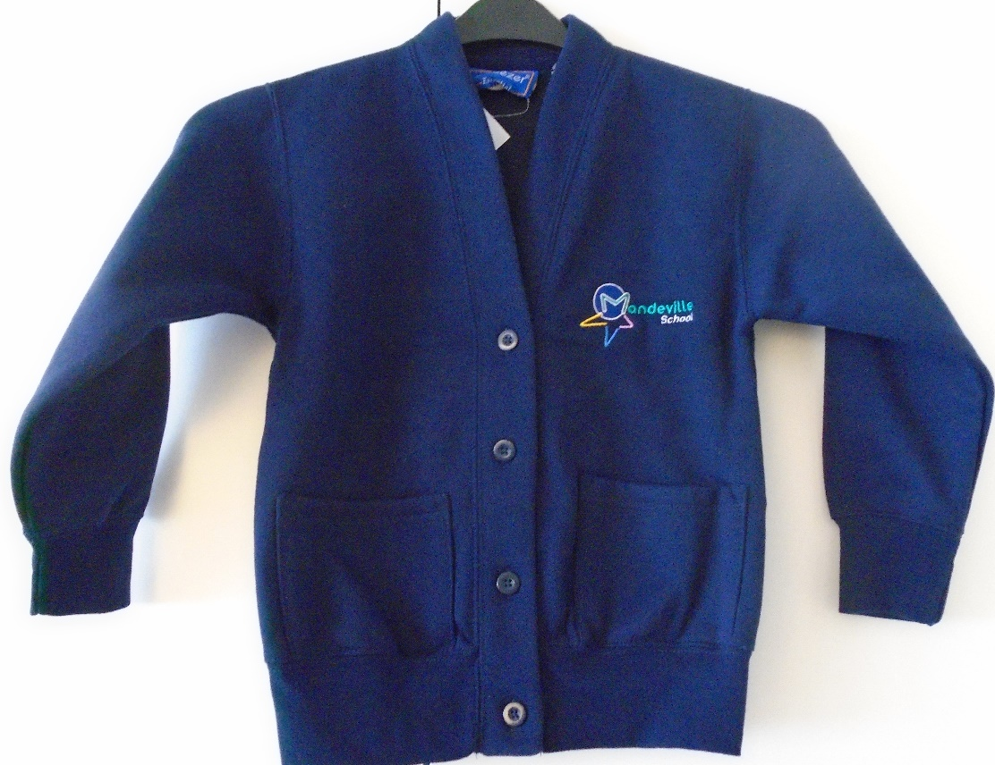
 |  | Available sizes
Navy Sweat cardigan |  | 26" (5/6yrs) | 28" (7/8 yrs) | 30" (9/10yrs) | 32" (11/12 yrs) | 34" (13 yrs)
Price: £11.80 each

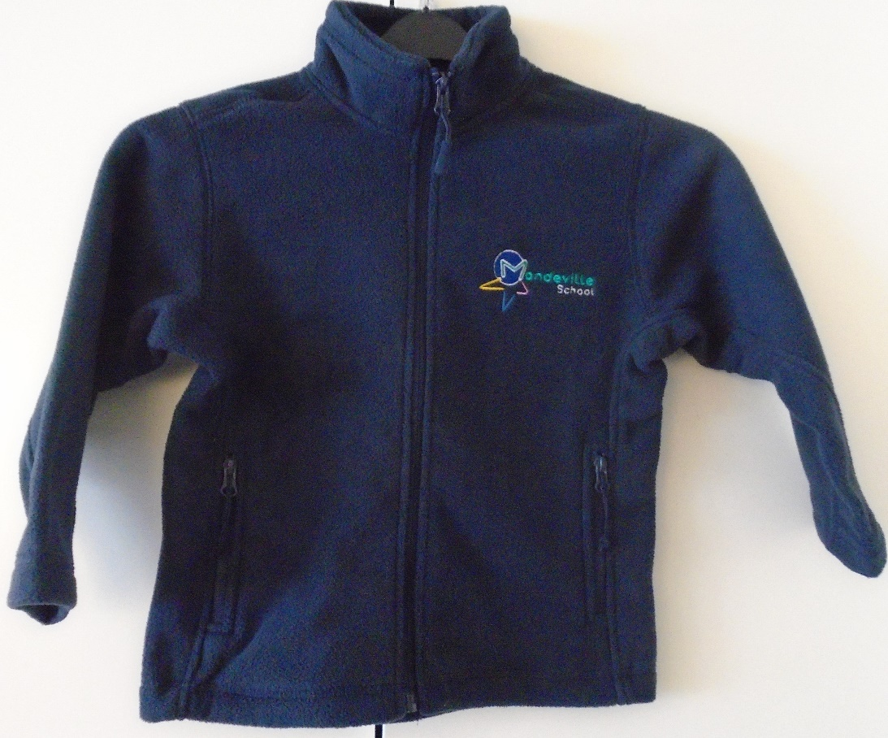

 |  | Available sizes
Navy Fleece Jacket |  | (5/6yrs) | (7/8 yrs) | (9/10yrs) | (11/12 yrs)
Price: £16.00 each

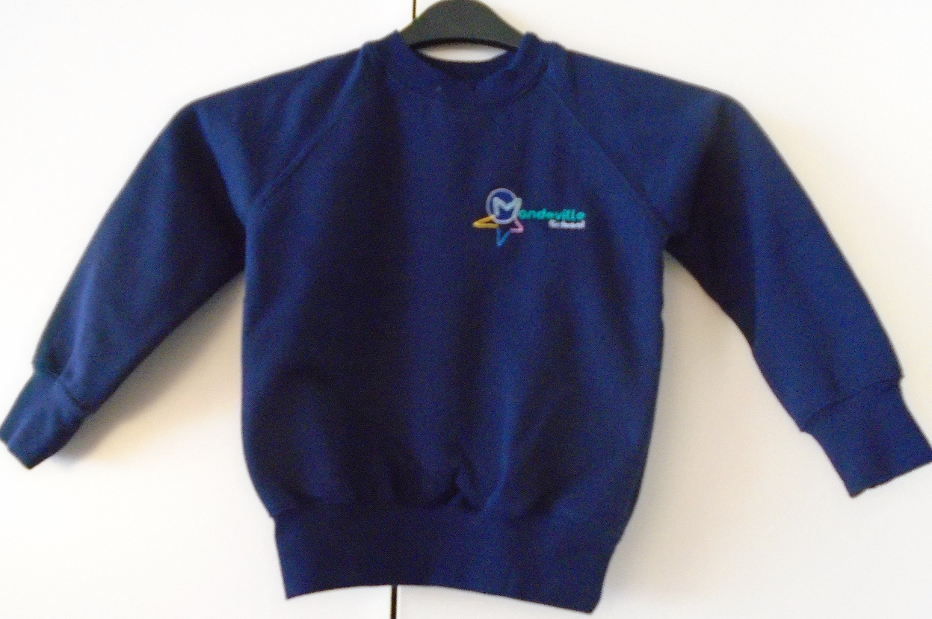

 |  | Available sizes
Navy Sweatshirt |  | 24" (4yrs) | 26" (5yrs) | 28" (6/7yrs) | 30" (7/8 yrs) | 32" (9/10 yrs)
Price: £12.50 each



