WHAT IS SPORT PREMIUM?
The Sports Premium is allocated to schools based on the number of pupils in Years 1-6. Schools with 17 or more pupils receive £16,000 + £10 per pupil.
The money is used to fund additional and sustainable improvements to the provision of PE and sport, for the benefit of primary-aged pupils, in the 2021 to 2022 academic year.
SPORT PREMIUM AT MANDEVILLE SCHOOL 2021/2022
Sport Premium Grant received: 2020/2021
£16,000 + £10 per child (£1410)
Total = £17410

 | Sport Provision in 2020/2021 | Funding
1. | Developing independence skills, mobility and gross/fine motor skills from their starting point (in September 2020) through a range of physical development teaching approaches; swimming, floor play, physio, sensory circuits. | £10755 additional scale 4 TA
2. | Yoga – Regular yoga sessions throughout the day enable to children to self-regulate, engage in the sessions at their own level, and experience the feeling of being calm. This will enable them to focus and engage more in their learning. | £5655
3. | Sports resources – Physical development, sensory circuits and body awareness resources for each class to allow children to access sensory integration, physio and floor play in class using the correct equipment. | £1000
 | Total: | £17410

 | Sport Provision in 2021/2022 | Impact
1. | Developing independence skills, mobility and gross/fine motor skills from their starting point (in September 2020) through a range of physical development teaching approaches; swimming, floor play, physio, sensory circuits. | - Due to Covid the swimming pool was not in use. With additional support in class, children were able to work on their independence skills, mobility and gross and fine motor skills. This also included meeting autistic children’s sensory needs through sensory circuits and specific programmes.  - Teachers received training on meeting children’s physical needs through sensory circuits and PE activities. The sports coach set up activities in the corridors for children to access throughout the day. He used videos and photos to show teacher how they can create many opportunities throughout the day to meet children’s sensory needs and physical needs. This enabled the teachers to be more creative on planning and teaching these skills to children throughout the day.  - Children made significant progress with developing their attention skills and physical skills during daily PE activities which were practised in the classroom, corridors, PE hall and outdoors, for example balancing exercises, sorting, push/pull exercises to develop muscle strength. This was also encouraged through functional activities, e.g. opening and pushing doors independently  - Sensory circuit activities set up in the corridors gave children more opportunities to access sensory integration and physical development activities throughout the day (rather than one timetabled slot in the hall during the day). These included organising, alerting, and calming activities performed in a particular order to meet children’s individual sensory needs. One child engaged in these sessions and started to follow instructions more willingly (initially found it challenging to attend in classroom activities and after every 5 minutes would seek to run, jump or climb on the furniture’s). He also started to participate in the activities in the correct order rather than becoming self-directed in the activities he chose to do. It was also noticed that during this period he started to join class lessons for longer periods of time and began to engage longer.  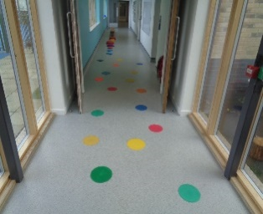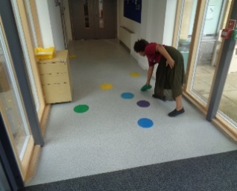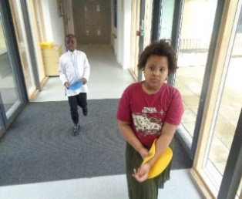  Children working on identifying coloured dots and counting in the corridor through physical activity.  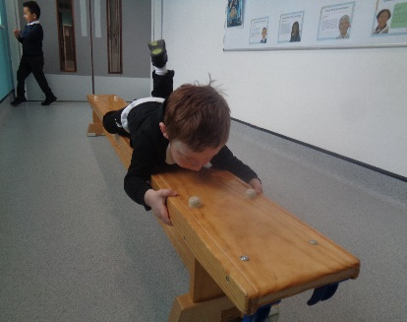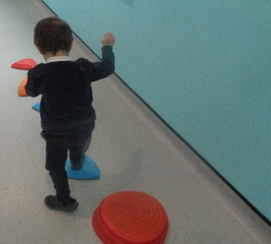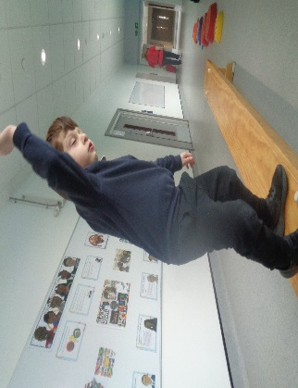  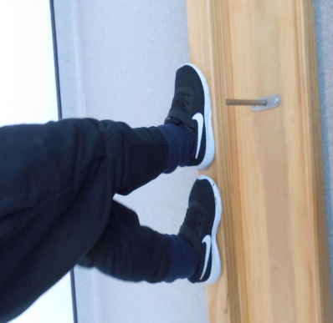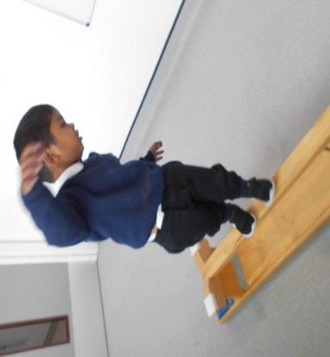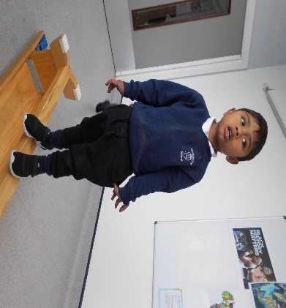  Children working in the corridor on sensory circuit activities and balancing  - PE Coach also supported staff in class in identifying children’s physical development needs. He went into each class and supporting with physical development targets/activity ideas which has been a different but effective way of working this year. By adding progressions to targets that are already set and creating new targets to support children in their daily routine in school has made a positive difference to children. They are more independent with their day to day routine, for example, children learnt to open and push doors on their own, carry their own resources (boxes with activities, scooter board, sensory circuit resources).  Quotes from staff and PE Coach:  Another child was also introduced to walking from the PMLD to ASC department as part of his daily routine. He was also encouraged to push the doors using both hands every time entering each department. He has also been walking up and down the stairs supporting himself independently by holding onto the stair rail and independently getting himself up from the floor; weight bearing using his hands and feet to push himself up from the floor. (IEP Target which was already set- To push open a door without a handle)  For one pupil, I introduced walking from the PMLD to ASC department as part of his daily routine. Overtime, he has progressed to walking up and down the stairs in ASC department with reduced support and supporting himself independently holding onto the stair rail.  (IEP Target which was already set - To manage getting on and off steps with reduced adult support (2, 3 steps).  To consistently pull himself up into the standing position using furniture as support)
2. | Yoga – Regular yoga sessions throughout the day enable to children to self-regulate, engage in the sessions at their own level, and experience the feeling of being calm. This will enable them to focus and engage more in their learning. | Yoga teacher left in February 2021. Children continued to practise basic yoga in class.  - All children slowly starting to build a relationship with the yoga teacher. 4 children participated in individual yoga and massage sessions on a daily basis. Their whole body was noticeably more relaxed during the sessions. They are now able to maintain a more relaxed posture after each session  - One child is able to coactively achieve and maintain a range of positions. He is relaxed and often smiles during these sessions. He is able to extend his body for several minutes at a time when lying on his tummy. He will coactively stretch out his arms in front and attempt to lift his head up
3. | Sports resources – Physical development, sensory circuits and body awareness resources for each class to allow children to access sensory integration, physio and floor play in class using the correct equipment. | - New scooter boards were bought for each class. This has enabled more children to use the scooter board as weight bearing activity (sensory integration programme) and for strengthening the upper body  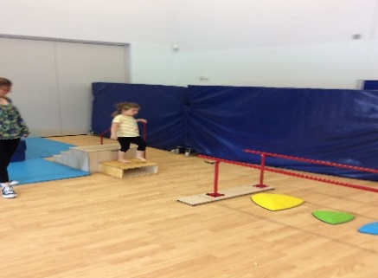  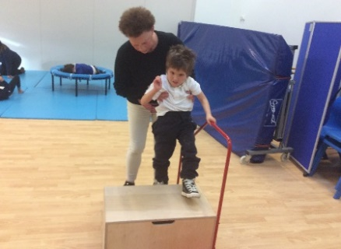  - Wooden steps with handrail was purchased to support children practising walking up and down steps with less support, encouraging them to eventually walk up and down the main stairs without a rail using alternating feet.  - Parallel bars – to support walking without the walker. Adam able to walk along bench using parallel bars to support his balance.  