This statement details our school’s use of pupil premium (and recovery premium for the 2022 to 2023 academic year) funding to help improve the attainment of our disadvantaged pupils.

It outlines our pupil premium strategy, how we intend to spend the funding in this academic year and the effect that last year’s spending of pupil premium had within our school.

School overview
Detail | Data
School name | Mandeville School
Number of pupils in school | 143
Proportion (%) of pupil premium eligible pupils | 35% (50)
Academic year/years that our current pupil premium strategy plan covers (3 year plans are recommended) | 2021 - 2023
Date this statement was published | 04.11.2022
Date on which it will be reviewed | July 2023
Statement authorised by | Denise Feasey  Headteacher
Pupil premium lead | Mundrika Bhanderi
Governor / Trustee lead | John Burgess
Funding overview
Detail | Amount
Pupil premium funding allocation this academic year | £69,250
Recovery premium funding allocation this academic year | £41,470
Pupil premium (and recovery premium*) funding carried forward from previous years (enter £0 if not applicable)  *Recovery premium received in academic year 2021 to 2022 can be carried forward to academic year 2022 to 2023. Recovery premium received in academic year 2022 to 2023 cannot be carried forward to 2023 to 2024. | £0
Total budget for this academic year  If your school is an academy in a trust that pools this funding, state the amount available to your school this academic year | £110,720

Part A: Pupil premium strategy plan

Statement of intent
- At Mandeville School we aim to use pupil premium funding to support pupils from disadvantage backgrounds with achieving positive outcomes in key areas of their development (dependent on their individual needs).
- We aim to train our staff in teaching and engaging our pupils within their learning using a wide range of teaching approaches. The pupils will achieve positive outcomes in the key areas of their development, which are identified through their cognitive ability, physical needs, sensory needs and behavioural needs leading them to achieve their individualised learning targets.
Although our strategy is focused on the needs of disadvantaged pupils, it will benefit all pupils in our school where funding is spent on whole-school approaches, such as high-quality teaching and training. Implicit in the intended outcomes detailed below, is the intention that outcomes for non-disadvantaged pupils will be improved alongside progress for their disadvantaged peers.
- Our strategy will be driven by the needs and strengths of each young person, based on formal and informal assessments,

Challenges

This details the key challenges to achievement that we have identified among our disadvantaged pupils.
Challenge number | Detail of challenge
 | Our observations and discussions with families at the pupil’s individual multidisciplinary Annual Review meetings, indicate that disadvantaged pupils need additional support to achieve their targets in communication and language and Literacy
 | Through our discussions with families of pupils on pupil premium we have found that the pandemic had a significant impact on pupils social and emotional development. Disadvantaged children did not have the quality of living space or access to outdoor space which had a significant impact on pupils social and emotional development.
Through observations and conversations with families, we find that disadvantaged pupils generally have fewer opportunities to develop their physical development due to a lack of safe outdoor space and due to the pandemic a lack of opportunity to visit outdoor parks.
Pupils did not have the opportunity to regularly carry out their physiotherapy and occupational therapy programmes whilst they were isolating at home. This had an impact on their physical and emotional development.
 | Discussions with families have highlighted that parents struggle with understanding their child’s behaviours and how to support their child.
 | Our assessment shows that majority of the children made the least progress in Literacy

Intended outcomes
This explains the outcomes we are aiming for by the end of our current strategy plan, and how we will measure whether they have been achieved.
Intended outcome | Success criteria
- Improve attainment for disadvantage pupils in communication & language. | Using a Total Communication approach, Pupils are able to consistently communicate in their preferred mode of communication (PECS, Makaton, body signing, objects of reference and gestures).  Through Attention Autism lessons, children make progress from their starting point in attending to the sessions and vocalising/ saying more words related to the activity.
- Improve pupils’ attainment in physical development and personal, social, emotional development through physical activities and meeting their sensory needs | Through 1:1 support and small group sessions, pupils make progress with their mobility, fine/gross motor skills, independence skills and self-help skills (eating, dressing, undressing, toileting) from their starting point in September 2022 through a range of teaching approaches, e.g. floor play, swimming, sensory circuits to self-regulate, yoga, eating a wider range of foods through food exploration and toilet training. Also, pupils develop cycling skills using specialist bikes.
- Training staff on using sensory integration programmes throughout the day, enables them to confidently carry out pupils’ programmes. | Staff have a good understanding of alerting, organising and calming activities to meet the pupils’ sensory needs. They carry out activities with the pupils with an understanding of what type of activity the pupil needs.  Pupils are more regulated when sensory needs are met. This leads them to be more focussed and ready to learn which enables them to make better progress in all learning areas.  Pupils participate in a range of activities which meet their sensory needs, allowing them to regulate, focus and be ready to learn.
- Through music therapy pupils make progress with their communication skills and personal social emotional development (play skills, developing positive relationships with adults/peers/siblings, developing confidence within self) | Pupils achieve positive outcomes with developing positive relationship and interactions with therapy partner; increase vocalisations and gain confidence within self. They develop some stability with their emotional, physical and emotional well-being. The small group sessions will allow pupils/siblings to form relationships together and begin to understand some fundamental social skills such as turn taking, sharing and waiting.
- Training staff on engaging pupils through a wide range of teaching approaches dependent on pupils’ needs (outdoor learning, sensory stories, schemas, exploratory/ messy play, smart platform, rebound therapy, positive looking, phonics). | Pupils engage in a range of motivating activities throughout the day (dependent on their needs) which enhances their learning opportunities and making progress from their starting point in Sept 2022.
- Increase pupils play skills through well planned play group sessions for specific pupils with some imaginative play skills and communication skills. | Selected small group of pupils with some imaginative play skills and communication skills will develop and enhance their play skills, social skills and communication skills with other pupils of similar abilities
- Pupils have 1:1 tutoring for 15 hours to enhance their learning on key skills identified on their IEP targets. | Pupils make progress in their learning through 1:1 tutoring. This learning is generalised across settings, people and between home and school
- Supporting parents in understanding their child’s behaviours and strategies they can use to support their child where behaviours are a barrier to their learning.  - Ensuring consistency in approaches between home and school to help child achieve their full potential | Parents have a better understanding of their child’s behaviours which are a barrier to learning. They are able to observe their child, understand why their child is behaving this way and how they can support their child through strategies which are consistent between home and school.

Activity in this academic year
This details how we intend to spend our pupil premium (and recovery premium funding) this academic year to address the challenges listed above.

Teaching (for example, CPD, recruitment and retention)
Budgeted cost: £15,600
Activity | Evidence that supports this approach | Challenge number(s) addressed
Training on using Total Communication throughout the day - Makaton, PECS, communication boards, object of reference (all visuals) to support children’s communication & understanding. CPD on using | 2021-2022  The total communication approach is about finding and using the right combination of communication methods for each person. This approach helps an individual to form connections, ensures successful interactions and supports information exchanges and conversations. A combination of methods are used, which reinforce each other and strengthen meaning for the individual.  https://www.sense.org.uk/information-and-advice/communication/total-communication/  Wide research on visuals supporting communication and understanding in children with autism and severe learning difficulties.  https://www.autism.org.uk/advice-and-guidance/topics/communication/communication-tools/visual-supports  A lot of research has been conducted to test the effectiveness of using signs and symbols to help people communicate, develop language and literacy skills.  https://makaton.org/TMC/TMC/About_Makaton/Research.aspx | 1, 5
Evaluation | Progress made
Training staff on using Attention Autism as an approach to develop children’s communication & language and literacy skills (focussing on all levels dependent on child’s ability) | Attention Autism is a learning approach which helps develop autistic children’s attention, natural and spontaneous communication and pre-literacy skills (identifying objects)  http://blog.soton.ac.uk/edpsych/files/2019/09/Attention-Autism-March-2019-Fiona-Marsh.pdf | 1, 5
Training for staff on the physical development curriculum. Staff meet with the sports coach to plan the sessions to meet the children’s individualised learning targets.  Training for staff on using sensory integration programmes throughout the day. Focus on deep pressure | 2021-2022  Research shows that pupils with autism do not process information in the same way others do. Meeting pupils’ sensory needs allow them to regulate self, be able to focus and ready to learn and absorb what is happening around them.  https://www.autism.org.uk/advice-and-guidance/topics/sensory-differences/sensory-differences/all-audiences | 2, 3
Training staff on Special Needs Yoga | Through yoga for special needs, pupils gain strength, balance and flexibility within themselves. “Yoga is a lifelong practise for developing inner peace and calm. Taking the child out of stress and into a relaxed state creates the optimum condition and possibility for positive change”.  https://specialyoga.co.uk/ | 2, 3
Positive Looking training | Positive Eye delivers a wide range of tailored training for VI, covering all aspects of teaching children and young people with vision impairments – from accessing the curriculum to social skills and how to support inclusion.  https://positiveeye.co.uk/ | 5, 6
Clevertouch training | 2021-2022
Aromatherapy – staff to use touch and massage to communicate caring and understanding with the children. This will allow stress relief for those who have prohibitive physical and mental conditions, as well as autistic children who often feel dysregulated. | Provides the learner with the skills to provide therapeutic treatments to incorporate into existing care regimes. Teaches learners about touch and massage to communicate caring and understanding with the children and as a means of stress relief for those who have prohibitive physical and mental conditions.  https://ifaroma.org/en_GB/home/aromatherapy-awareness-week | 1, 5
Training on teaching phonics to children with severe learning difficulties and appropriate resources which are meaningful. | Teaching phonics systematically supports children in making connections between the sound patterns they hear in words and the way that these words are written. For children with severe learning difficulties, it helps to encourage spoken words to communicate.  https://educationendowmentfoundation.org.uk/education-evidence/teaching-learning-toolkit/phonics  https://www.phonicsforpupilswithspecialeducationalneeds.com/ | 1, 5,6
Training on using Sensory Stories to | A sensory story activates each of the senses to encourage engagement in a range of learning situations. These range from simple engagement to knowledge recall, memory, communication, vocabulary development, social skills and literacy skills. | 1, 5, 6

Targeted academic support (for example, tutoring, one-to-one support structured interventions)
Budgeted cost: £94,994
Activity | Evidence that supports this approach | Challenge number(s) addressed
One to one tutoring through National Tutoring Programme, focusing on pupils individualised learning targets (mainly communication & language, person social emotional development and literacy) | Through the recovery premium (https://www.gov.uk/government/publications/recovery-premium-funding/recovery-premium-funding)  All pupils will receive one to one tutoring for 15 hours, to enhance pupils engagement and learning using a wide range of approaches. | 1, 2, 3
One to one support and specific in class training by sports coaches ensure pupils are able to engage in physical activities and sensory integration programmes throughout the day and as when needed.  Purchasing specialist bikes will give pupils opportunities to practice cycling and increase their physical activity and strengthen their mobility. | DfE guidance and action for healthy kids highlights the importance of physical activities for all pupils, and especially for those with severe learning difficulties. Action for healthy kids states that nearly 20% of all children and adolescents have a chronic condition or disability (National Center on Physical Activity and Disability), and the levels of participation in physical activities are much lower than their non-disabled pupils.  https://www.actionforhealthykids.org/including-all-children-health-for-kids-with-disabilities/ | 2, 3
Additional staff to allow pupils to work one to one on their mobility, physio and sensory integration programmes | Pupils with severe learning difficulties need one to one support in order to focus on and gain access to the activity and be prompted to understand what they need to do. | 1, 2, 3
One to one and small group music therapy sessions | Music therapy is provided by Ealing Music Therapy.  “Through the use of music therapy, children and young adults can help make connections and build confidence such as people interactions and help put their emotions into words”.  https://www.ealingmusictherapy.org/ | 1, 2, 4
Planned group sessions for specific pupils with similar play skills. | Pupils with autism and severe learning difficulties struggle to understand basic social skills such as turn taking, sharing and waiting. They rarely show awareness in others and will often play by themselves. | 1, 2, 7
A wide range of teaching approaches to deliver effective lessons for children with profound multiple learning difficulties and severe learning difficulties, which engages all pupils to make better progress in all areas of their learning. | Pupils learn better when they have opportunities to learn through a range of teaching approaches which engage them and motivate them in their learning.  Using specialist resources like the Smart Platform, Eyegaze, positive looking, Clevertouch, sensory stories etc allows children to access the curriculum leading to better progress in all areas of their learning. | 1, 2, 3, 5, 6, 8, 9
Training and supporting parents in understanding their child’s behaviours and strategies they can use to support their child where behaviours are a barrier to their learning  Teachers meet with parents to discuss child’s behaviour support plan and strategies used. | Evidence built up at Mandeville School overtime, shows that consistency between home and school enhances pupils learning.  Parents understanding their child’s behaviours and been able to support them effectively supports the well-being of parents, the child and the school staff.  National Autistic Society | 1, 2, 3, 5, 8, 9

Wider strategies (for example, related to attendance, behaviour, wellbeing)
Budgeted cost: £
Activity | Evidence that supports this approach | Challenge number(s) addressed

Total budgeted cost: £110,594

Part B: Review of outcomes in the previous academic year
Pupil Premium strategy outcomes
2021-2022 Our assessment shows that:
Pupils on PPG in KS1 achieved 53% and in KS2 52% of their individual targets in Communication and Language, compared to those not on PPG achieving 26% in KS1 and 49% in KS2
Pupils on PPG in KS1 achieved 40% and in KS2 42% of their individual targets in Personal Social and Emotional development, compared to those not on PPG achieving 30% in KS1 and 58% in KS2
Pupils on PPG in KS1 achieved 24% and in KS2 47% of their individual targets in Physical Development, compared to those not on PPG achieving 36% in KS1 and 39% in KS2
Pupils on PPG in KS1 achieved 38% and in KS2 30% of their individual targets in Literacy, compared to those not on PPG achieving 28% in KS1 30% and 30% in KS2.
Pupils on PPG in KS1 achieved 50% and 38% in KS2 of their individual targets in Maths, compared to those not on PPG achieving 41% in KS1 and 33% in KS2

KS1 - Pupils on PPG made similar levels of progress to those pupils who are not on PPG except in Physical Development.

KS2 - Pupils on PPG made similar progress in all areas of learning than pupils who are not on PPG, except in Personal Social Emotional Development

2022-2023 Our assessment shows that:

Pupils on PPG in KS1 achieved 52% and in KS2 53% of their individual targets in Communication and Language, compared to those not on PPG achieving 59% in KS1 and 44% in KS2
Pupils on PPG in KS1 achieved 43% and in KS2 43% of their individual targets in Personal Social and Emotional development, compared to those not on PPG achieving 45% in KS1 and 46% in KS2
Pupils on PPG in KS1 achieved 42% and in KS2 50% of their individual targets in Physical Development, compared to those not on PPG achieving 53% in KS1 and 41% in KS2
Pupils on PPG in KS1 achieved 44% and in KS2 52% of their individual targets in Literacy, compared to those not on PPG achieving 47% in KS1 and 59% in KS2.
Pupils on PPG in KS1 achieved 40% and 43% in KS2 of their individual targets in Maths, compared to those not on PPG achieving 68% in KS1 and 41% in KS2

KS1 - Pupils on PPG made similar levels of progress to those pupils who are not on PPG.
Except - Physical development pupils on PPG made less progress and significantly less progress in Maths.

KS2 - Pupils on PPG made similar progress to pupils who are not on PPG.
Except – Communication and Language and Physical development pupils on PPG made more progress than those not on PPG.

Evidence of Impact 2022-2023
Sensory strategies. Using sensory integration programmes throughout the day - OT

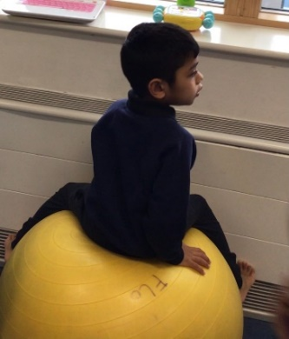
Pupils have been more focussed and ready to learn when their sensory needs have been met. For some children, a range of different activities were tried to understand what actually met the child’s sensory needs.

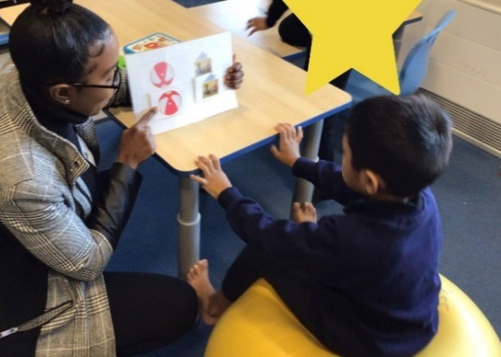
Child A continues to make progress in self-regulation by completing his sensory circuits at regular intervals ending with special yoga. After each sensory diet top up, Child A returns to the classroom calm and regulated and has been able to engage and access learning much more.
Physio ball helps child B to regulate his body, it calms and relaxes him, allowing him to focus. Sitting on a physio ball during an activity also helps his concentration.
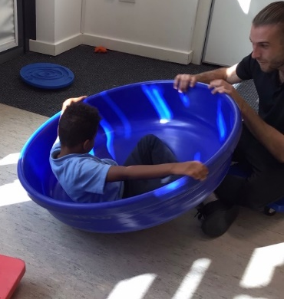
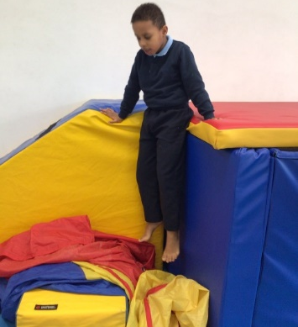
Child C is exploring the adventure room. He is climbing, jumping and running. He is showing progress on his physical development. Child C is enjoying the spinner with his PE teacher. He likes to spin and he tries to keep good balance.

Colourscape

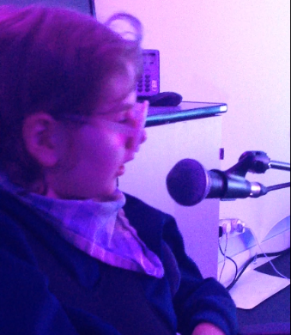
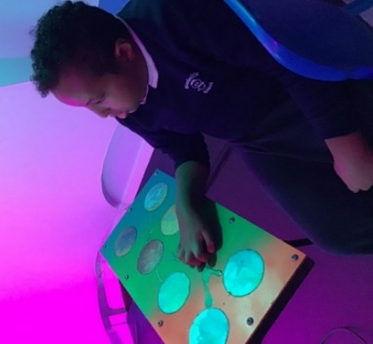
In Colourscape sessions, after being modelled by adult to play the hand drum, Child A was moving his hand independently. He also engages in turn taking with the adult. When the adult starts singing he stops and listens, but as soon as the adult stops, he starts playing music. During the sessions he is also engaged in tracking the lights and making hand movements to activate different music. Child A has been developing his cause & effect skills through several activities. Child A is more engaged in the sessions and is taking the initiative to move his hands on the soundboard to activate the lights and sounds in the room. Staff encourage him to stand up to use the floor board.

Colourscape is helping children to respond and link the light, music and colour. Helping children to learn about the colours. Children are using the senses e.g. eyes, hands to touch the buttons. Child B used her voice to change the colours in the room. She was in awe of the effect she was having on the room.
Child C used vocalisations and body movements with his hands and feet to activate sound and light.

During the Explorers sessions, the pupils have learnt to:
Explorers group – with the Speech and language therapist
milestones

Transfer and generalise their ability to transition to different areas around school, activities, and staff members.
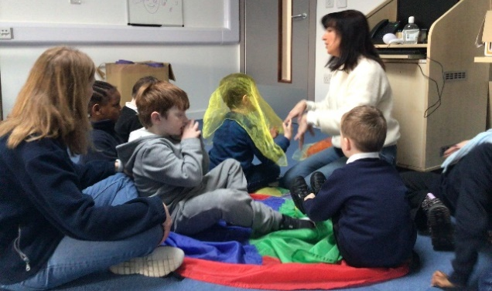
Follow new structures which include: waiting for their name to be called, waiting for their turn, turn-taking and sharing resources, and anticipating the outcome of their creation or cause and effect.
Develop their independence in play and to produce a play sequel. They are able to choose and explore a variety of activities and some are able to ask for help when needed.
Self-monitor to generate appropriate language relating to the activities. E.g. one child was not using verbal expressive language in the beginning through play, but only repeated familiar learned phrases and some pupils only used gestures, but over time they generated new ways of communicating to form simple language structures within their play.
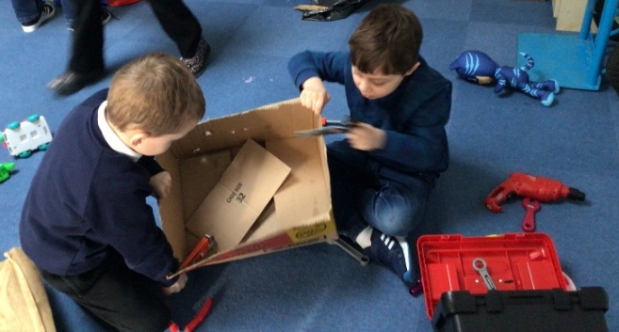
Share their ideas with peers and developed collaborative imaginative play. For example, in the beginning, only two pupils started to build the space rocket, and over time more pupils joined in and at the end of a couple of sessions, all pupils ended up riding on the rocket, or pushing one another. At the end of the rocket building, every child showed pride in their end product as we rode on the rocket through school, stopping at some classes and some pupils explained that it is a rocket and we’re going to the moon. Each child followed instructions to get off at their planet (class number) when they heard their name and the others knew to stay seated until we reach their class.
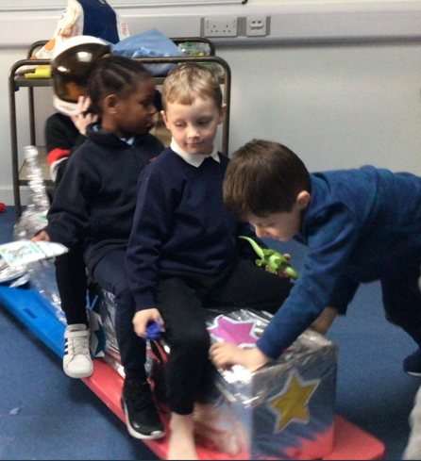
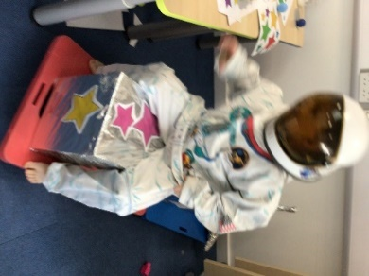
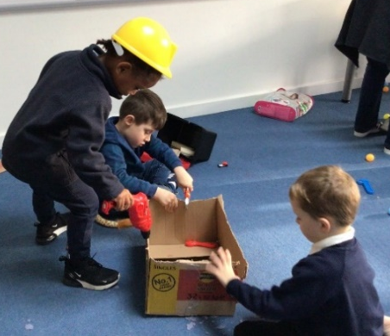

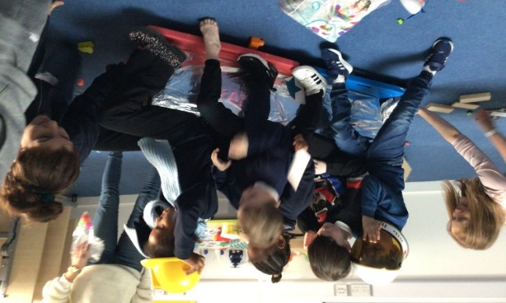

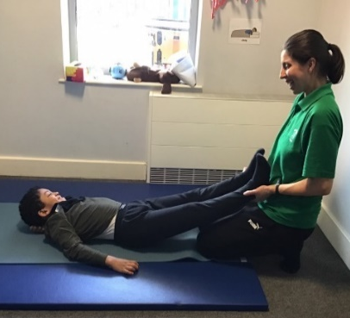
Yoga

Yoga is embedded into our everyday classroom routine and beneficial in conjunction with Intensive Interaction, Aromatherapy and Physiotherapy. Yoga has enabled pupils to be more regulated and calm. They have experienced a sense of calm within themselves where they have been able to stop actively moving around and feel the energy and calmness around them.. It has also allowed them to be more focussed on their learning. The pupils have been curious to explore the vibrations of the singing bowl on different parts of their body.

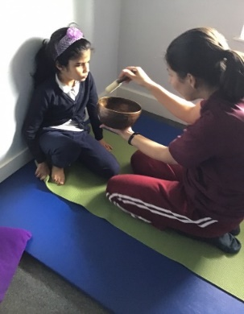
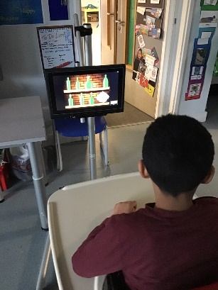
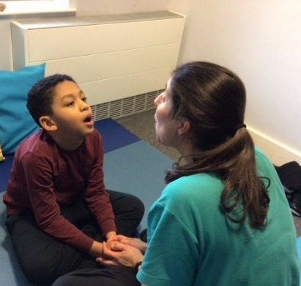
Child A was able to sustain his attention for 5 minutes. He is now more willing to stretch his arms and legs during yoga. He was also able to relax and stay still for 5 minutes while having a foot massage and listening to the chimes. After the yoga session Child A is ready to engage in other activities e.g. Eye Gaze.
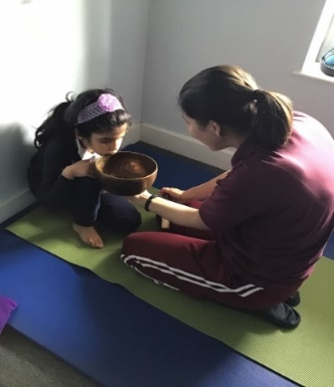
Child D really benefited from the yoga sessions. She will now join me on the mat without any adult prompting. She can sit opposite the adult cross legged listening to the singing bowl sound and looking at the bowl. When the adult sings Omm, Child D gives really good eye contact for a long period of time and smiles a lot. She has enjoyed deep pressure down her arms and legs. With adult support Child D was able to bring to her knees to her chest and rocked a bit side to side. She smiled when adult stretched her legs and gave them a small pull. Child D tolerated side twists while laying down for a couple of seconds each side. She relaxed throughout the session and relaxed even more during the foot massage and while listening to the chimes.
Child B is now doing really well with yoga. He completes this as part of his sensory circuit (first he does his monkey bars and then goes to a quiet place to do yoga stretching). He has demonstrated that he is calmer after his session on the monkey bars followed by a yoga session.

Child C has responded to yoga with reduced impulsivity, developed concentration, supported emotional regulation and to manage anxiety

Positive Looking – VI specialist

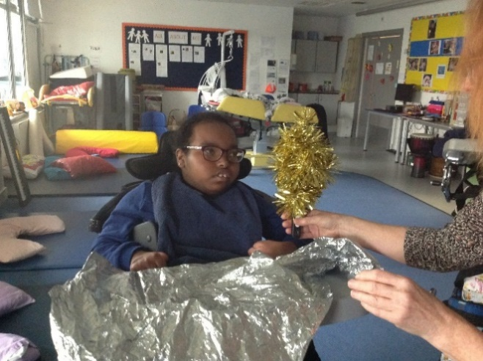
Positive Eye
Involves observing closely the child’s functional visual skills to see how they use their vision (e. g fixation, following, visually directed reach, transferring gaze) This then informs you where the child best sees, and which resources to use to stimulate their vision
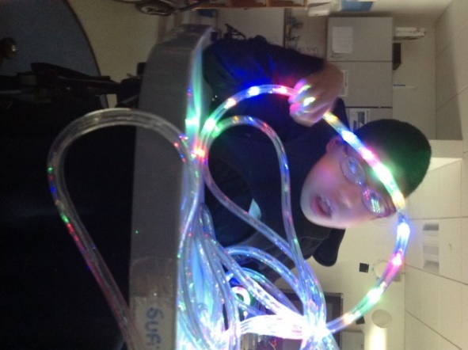
Familiarity is also important – not using too many objects/ materials so that the child has the opportunity to understand and process what they see- (may have to see something many, many times before it has any meaning for them)
Resources are then selected or made and the classroom adapted (displays, decluttering backgrounds) to promote the child’s visual skills whilst they play, with the importance of increasing contrast and reducing complexity
The child’s visual skills assessment and what they are focusing upon are then included in their visual passport / IEP, which are shared with parents
The principles of positive eye, promoting visual attention and engagement, are relevant to all our children
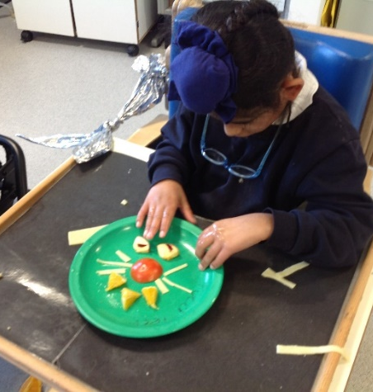
Child B was confidently choosing by using objects on a black background and the tray is covered with black laminating paper to enhance his vision when objects are placed on it.
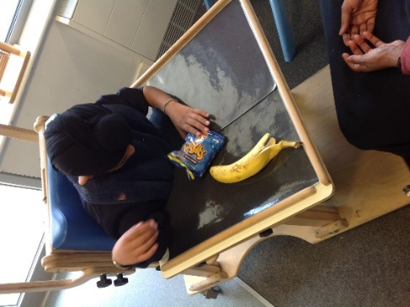
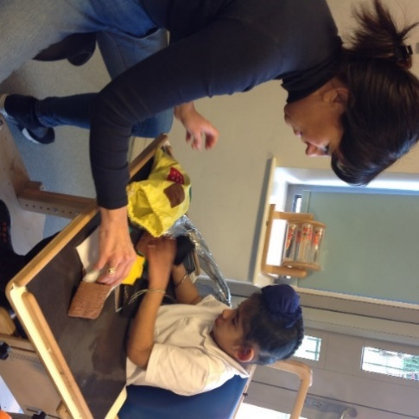

Sensory stories – staff and parents

Quote from parent training:
“we need more sessions like this to empower parents to help out our children at home. School can not provide or help our children alone. As a team, parents can provide more support to SEN chidlren”
Phonics

In the PMLD classes - Phonics stage 1 is embedded naturally in our everyday burst/ pause conversations with our children – using a rhythmical voice and varied voice intonation allowing children to respond and take their turn. Children’s names - clapping /singing /drumming their names is used frequently.
Literacy – Call and response simple stories and rhymes are used supported with multi-sensory props. Rhymes, songs and simple repetitive stories are made up to match the children’s interests. Change intonation is effectively used. Listening skills are developed using high quality instruments in a distraction free environment so that children can develop show their preferential responses and make choices.
Autism classes – example Child A benefits from small group phonics sessions 3 times a week. She enjoys these sessions very much and engages with Makaton signing, copies number of sounds in her name on a drum, is able to sort items, pictures and photos beginning with the phase 2, set 1 sounds (s, a, t, p). She attempts to verbally copy these sounds, takes turns and waits during what’s in the bag activity. She copies graphemes in large format using giant pencil and A3 sized paper with some verbal directions. In everyday situations, Child A learned to wait and be more patient during transitions and is able to do so calmly while listening to phonics songs.

Some classes use phonics in small groups Phase 1-3 and during whole group during ‘good morning’. The can see significant progress in terms of communication and language. Children are using language more spontaneously and language is clearer.
Child B was engaged during the phonics session activity matching objects to the correct pairing. She was supported and hand on hand prompts were used assist her. Good job!

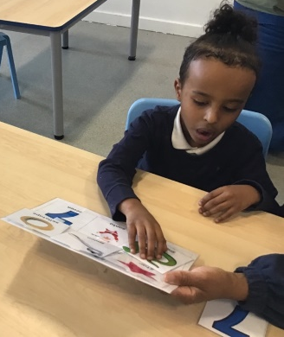

Child C is matching picture to picture all beginning with letter “S”.

Training on using Total Communication - SaLT

Training on Total Communication has enabled staff to allow pupils to communicate approach, Pupils are able to consistently communicate in their preferred mode of communication (PECS, Makaton, body signing, objects of reference and gestures).

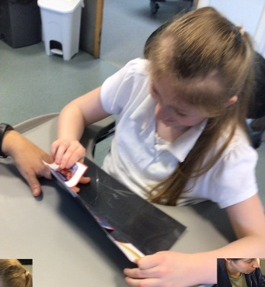
The total communication approach is about finding and using the right combination of communication methods for each person. This approach helps an individual to form connections, ensures successful interactions and supports information exchanges and conversations. A combination of methods are used, which reinforce each other and strengthen meaning for the individual.

Child A is consistently exchanging PECS to make request during planned sessions.
Child A has started to vocalise some words functionally and to copy some actions.
She is managing to wait for motivating activities during longer periods with the use of now/next boards and symbols. She is managing her emotions better when it is time to finish an activity when she is presented with the tambourine, countdown and finishing song.
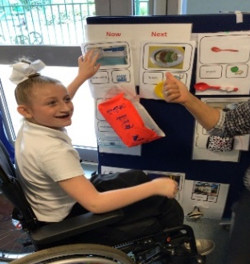
At snack time Child B is using PECS to choose his snack. With support, he is picking the photo and handing it to staff. Staff have been modelling to him how to request for a drink during the day by showing him where the photo is kept. He is now responding to this.

Child C uses PECS and objects of reference to express her likes and dislikes and to show that she understands what is happening next.

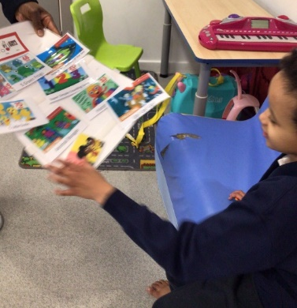
Child D was able to pick the photos of her favourite songs during songs choices

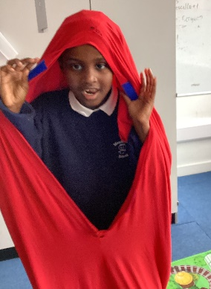

Child E is exploring the body sock, she had fun hiding as she could predict the adult calling her name and asking where she was. She asked an adult to join her inside the body sock through gesturing and vocalisation

Child f requested to go to the toilet during class time. He walked to an adult, gave them eye contact while tapping his torso and when asked if he needed help he took their hand to walk them to the door. With a little gestural and verbal prompting he pointed to the toilet symbol we have by the door.
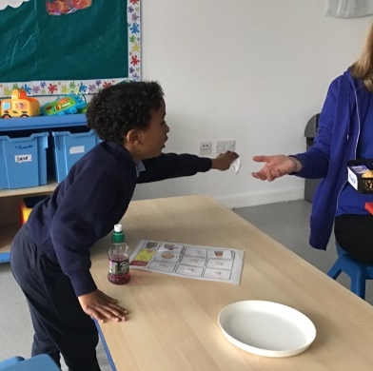

Child G is reaching to give the symbol for his snack. He then moves around the table to put it into the adults hand

Attention Autism - SaLT

Attention Autism sessions has enabled children to show greater curiosity, attend and focus on the activity for longer, to increase eye contact and vocalisations and some children have started to say words related to the activity.

Following the training, Stage 1, 2 and 3 are now implemented across the school. The staff are now more confident at leading the sessions and giving pupils opportunities to progress from Stage 1 – 3. Pupils are now predicting and requesting at stage 2 and have learnt to take turns. Some are completing an activity independently at stage 3. The approach is used in all lessons including PE to gain attention.

Child A is now able to join Attention Autism session at stage 2, where he has happily made flowers with foam.
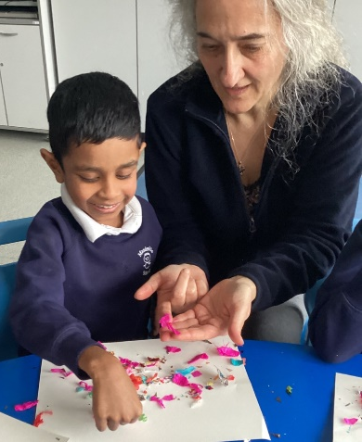
During the attention building session Child B counted up to three and started playing the drum using his hand. He beat it three times (the correspondence was probably by chance but his verbal communication was clear and in context). He also finished the sentence “Ready, Steady….” by saying “Go”.

During stage 2 of attention building activity, Child C was able to apply glue to the paper and stick the confetti down. He looked at his work, demonstrating good eye-hand coordination.
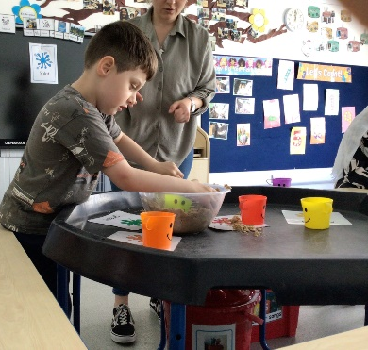

During stage 3 of Attention Autism, Child D is super excited to build his own sandcastle. He takes the lead, chooses the cup he likes, builds his sandcastle and then splats it

Aromacare

The benefits of aromacare are:
- Help improve physical and emotional wellbeing
- Stress relief and relaxation, calming and mussels relax
- Self-care
- Concentration /focused
- Communication
- Constipation
- Oils/Massage/touch - increases oxygen -improves blood circulation.

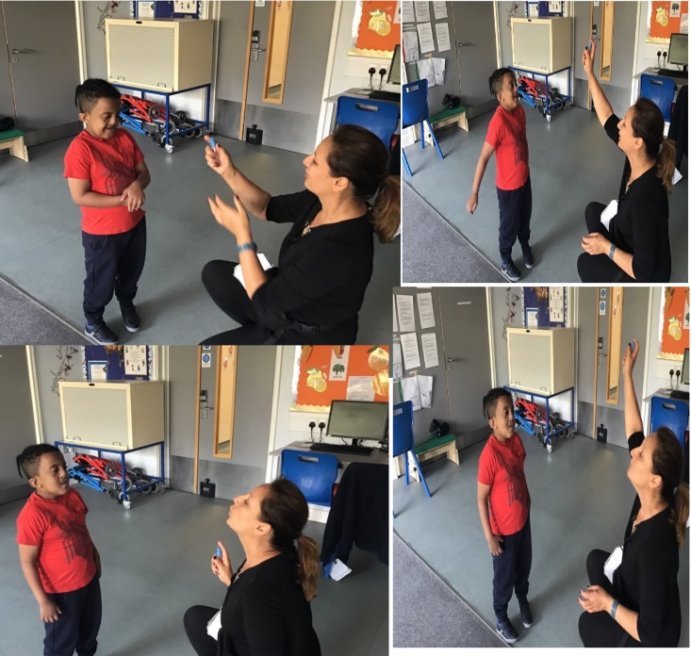
Aromacare blends well to Write dance sessions. (see write dance below)
Teacher starts with a breathing - diffuser and spray with oil and continuous Write dance structure. The lesson finishes with relaxing, including spray and hand massage with oil.
Child A spontaneously asked for more spray with geranium oil by signing "more", waiting and enjoying inhaling and exhaling.

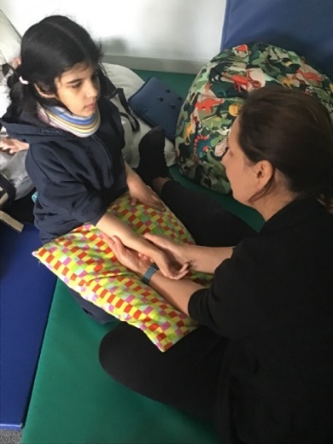
Child B has started to do Aroma massage and story massage. Whilst doing the story massage he lies on his tummy and is very relaxed and happy.
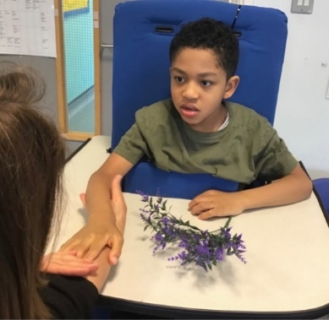
Child C relaxed and enjoyed an aromatherapy massage on her arm and back. She showed awareness of it being massaged by looking at her arm and opening her hand. She was so deeply relaxed

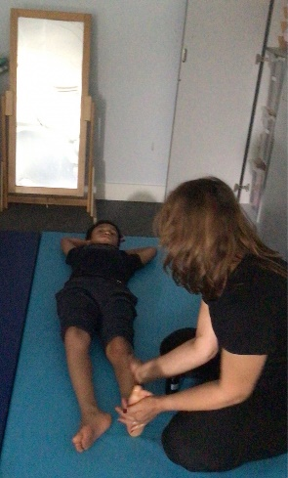
Child C was very engaged and focused during the 20-minute write dance lesson. She independently explored the lotion on her tray with both hands while looking and smiling at adult.
Child D was happy to experience the feel of aromatherapy oil on his leg. It was a sunflower oil with a drop of marjoram oil. Child D showed he enjoyed it by smiling, vocalizing and waiting for more.
Child D love and focuses on stroking from ankle to knee several times and shows preference by giving a dip eye contact. He breathed deeply and evenly when he received a deep finger hart’s movement on his calf.

Write dance

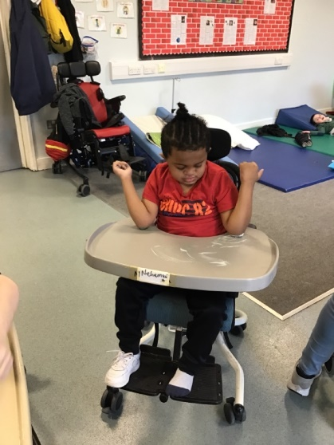
Child A was confidently making marks with a paint brush on his tray during a write dance session.
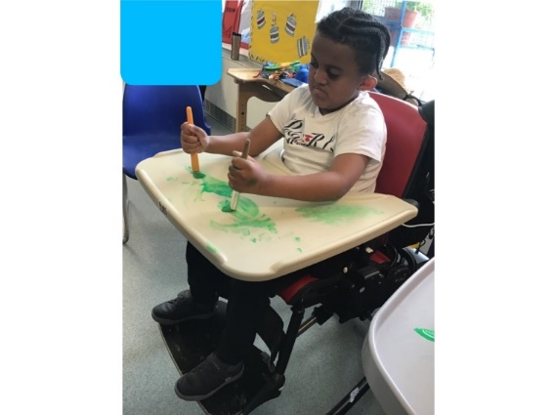
During the Write dance session, Child A happily used his elbows and made different movements
Child A spontaneously and independently joins a write dance session. He followed two keyword instructions
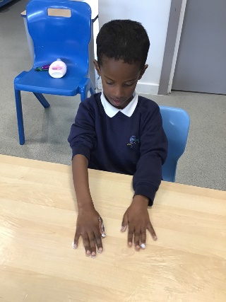
Child B has been participating Write Dance during the whole school year. He has developed his skill to follow instructions and make movements according to the music. He has been exploring a variety of materials, such as foam, paint, toothpaste, mixture of custard cream-water –cocoa, sand and using writing tools to mark make. Child B is now able to draw lines and circles in different materials.
Najib is independently mark making in baby lotion during write dance. He makes horizontal lines with his hands.

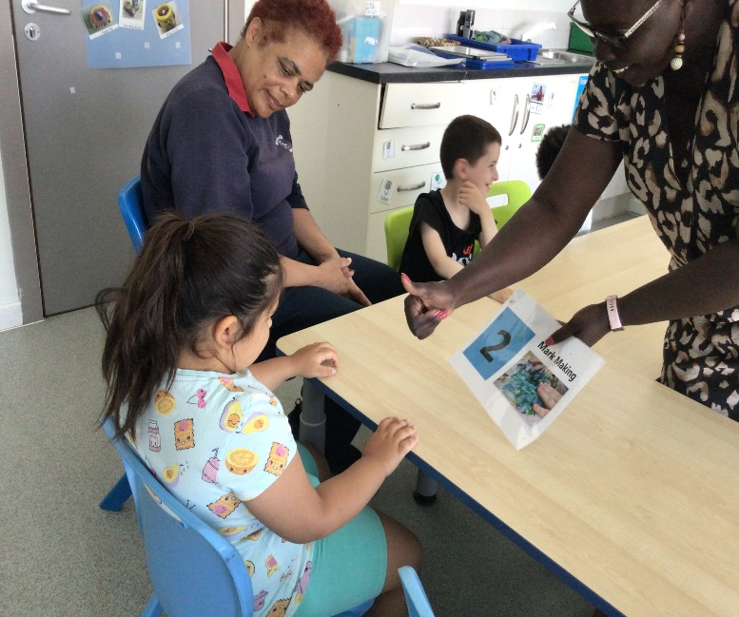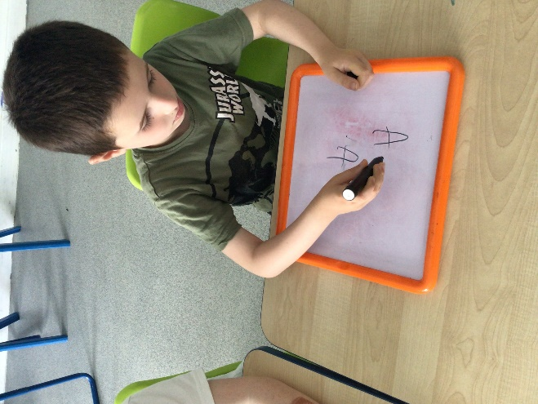
Children have learned to form letters following write dance lessons.
National Tutoring scheme

At the start of the tuition programme, Child A would try to run out of the room and would cry to show that he did not want to go to the group room for his one-to-one session. After a number of sessions Child A engaged in mark making activity. He was able to unscrew the lid and use the paint marker to colour a picture. He also explored stacking cups and tried to build a tower. He participated in interactive communication during singing action songs. Child A was attentive and focused during his one to one session. His engagement to task was very good.

Child B can now understand some pictures of places around him and has started to make choices. With Intensive Interaction, his eye contact has really improved. He is more confident now even during group activities, he shows excitement and curiosity.

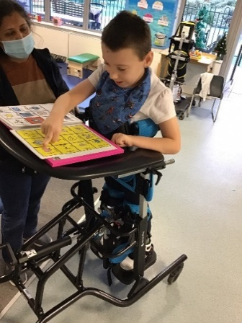
With the 1:1 support, Child C’s spitting behaviours decreased and he started to engage in classroom activities more readily. Tutor report - Child C enjoyed copying actions and singing along with me. He then maintained focus when asking for motivating objects using the PECS style approach. He also used his words and asked for more of his favourite item. Child C completed two worksheets matching numbers to quantity up to 10 using colours as a reference. Child C's engagement was good and he managed to stay focused for more than 20 minutes on one activity.

Child D made progress with communication skills and personal social skills through 1:1 session. He has started using a high teach device for communication Grid3 app on the IPad.
Science – Professor bubble works

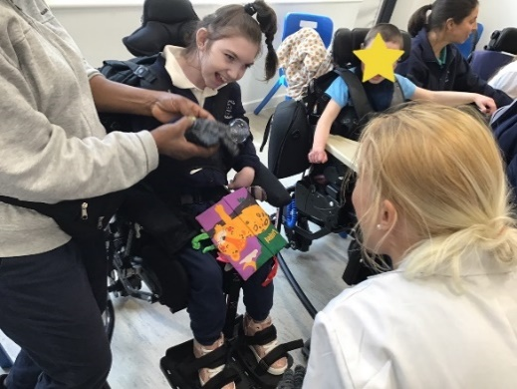
Child A was very engaged throughout the bubble workshop .She was observing, listening and feeling the bubbles, air, water and cold.
She loves to explore all activities and sustain attention during the entire session.Child A was vocalising and laughing for the whole sesion .

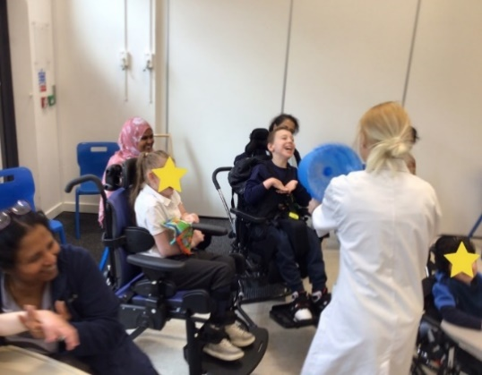
Child B was very engaged throughout the bubble workshop. He was observing, listening and feeling the bubbles, air, water and cold. Child B shows determination by reaching and moving the whole body during a workshop. He loved to explore all activities and sustained attention during the entire session.

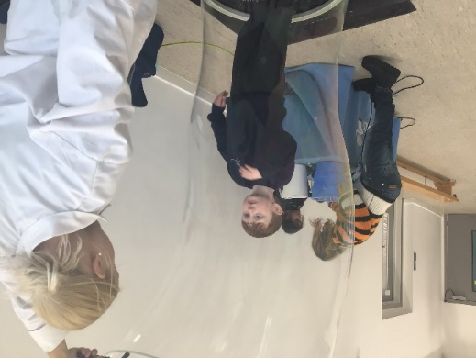

Child C was focused and curious as the bubble coverd his whole body

Additional staff to allow pupils to work one to one on their mobility, physio and sensory programmes
During the Swimming session, Child A swims confidently and started using steps in the pool; with close adult supervision and a helmet, he could walk in and out of the pool. Child A is very happy and confident in the water. Child A will use various equipment in the pool to improve his swimming on both his front and back. Child A is very independent in the pool and can swim on his front with flotation aids when on his back he needs a little help and encouragement from an adult. Child A can now touch the bottom of the pool so he has been walking without any flotation aids across the pool. Child A can exit and enter the water over side of the pool and will now walk down and up the steps by himself

Child B get stronger on his legs every day. He is able to stand independently. He practises standing and other physio exercises every day.
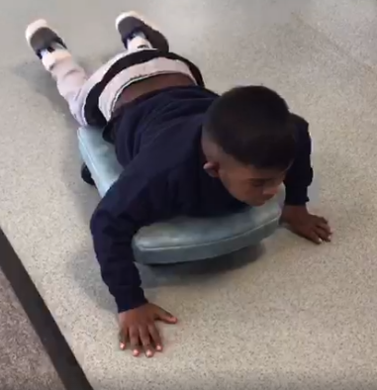

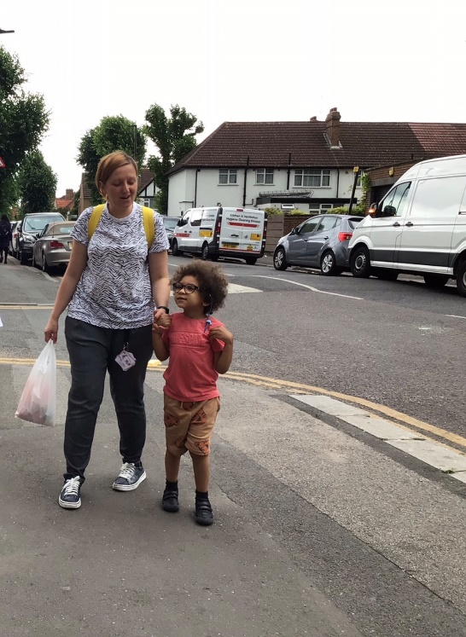
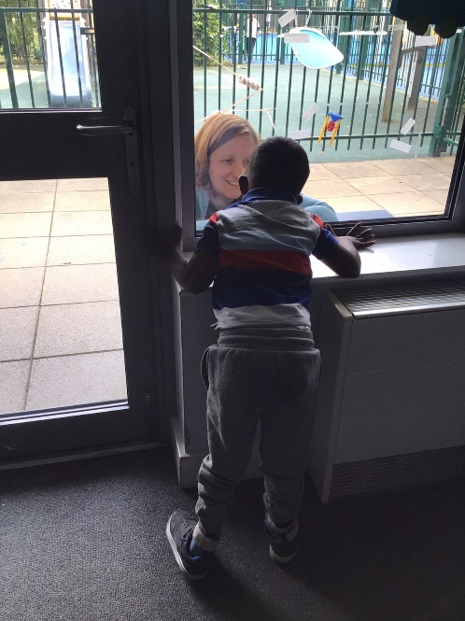

Child C is supported with sensory circuits and is able to regulate emotions more easily He has enjoyed weekly walks in the community
Child D developed his confidence to walk to the shop. He learned to stop before crossing the road.
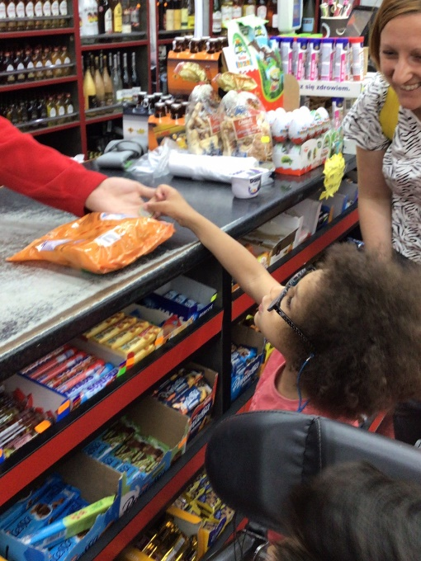
Child E can now walk up the stairs with less support and started to climb on equipment such trampoline independently. Child E has started to understand the school routine. He has started also to show excitements when he knows through pictures what is coming next. His attention has increased he can stay focused for up to 10 minutes and easily will follow what is coming next. During group activities such as phonics, drama and bucket time has started to participate with support.
Child F can now share the big swing and the small trampoline in class.
She is also happy to share the big trampoline during rebound therapy.
Child F attempts to wash her hands independently.
She is now putting her food scraps on a separate plate instead of throwing them on the floor or over her head.
When prompted by an adult she can tidy up her snack plate by putting the rubbish in the bin and the plate in the sink.
She will independently take her shoes and socks off for rebound therapy.

Child G has had additional 1:1 support this academic year (provided by school) to help support him in managing his own behaviour and to access learning and encourage engagement in activities. This extra support (arranged with existing staff members) helped Child G to access all areas of the curriculum. He is now much calmer, his communication has improved, his verbal skills have improved, and he is now engaging in both group and individual lessons.
Child H has started rebound therapy this term and thoroughly enjoys it. He actively looks forward to the sessions each week. Child H has started to use his voice more when on the trampoline. He is also very motivated to follow instructions and his eye contact has increased when listening to the instructor speak. Child H has also started to be able to copy certain moves done by the instructor and has successfully performed a seat drop and knee drop on a couple of occasions.
An additional person during play time every day has support Child I with catching, throwing and kicking ball.

Child J brushed his teeth independently for 1 minute
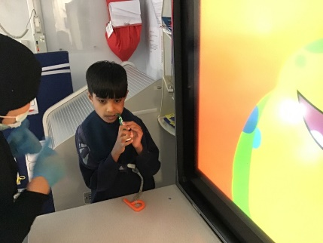

Child K recovered well after foot surgery. Swimming sessions and daily physio work well, and now he is using his walking frame again. During swimming sessions, he is able to walk with minimal adult support. He enjoys using and asks to go for a walk during PE.
Hydrotherapy is a key to his physical development.
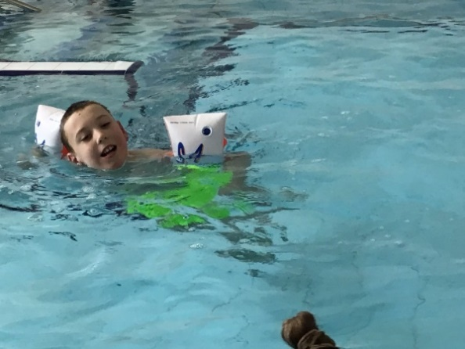

Child L has benefitted from an individual approach to support her with emotional regulation including movement breaks, deep pressure and calming sensory activities

Smart Platform
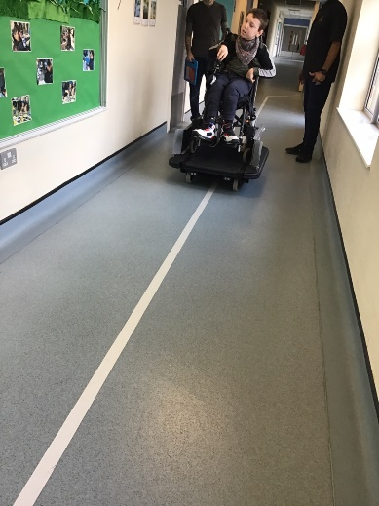
Child A has started learning how to use the Smart Platform. He can press the joystick and initiate the platform to go left and right also straight. This supports his independence and confidence.

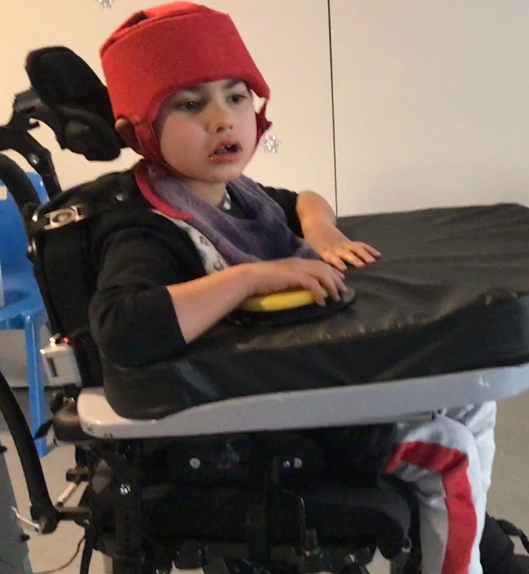

Child B is able to move his chair by pressing a switch giving him independence whilst moving across the room.

Music therapy

Music therapy has enabled pupils to:
- Develop positive relationship and interactions with therapy partner through exploring instructions, turn taking and sharing. Child A continues to explore different instruments in the room often choosing new instruments to play with each week including the ocean drum, the wind chimes and tambourine. When the therapist stops playing the piano Child A will come over to her to communicate that he wants her to continue by placing her hands back on the keys. Child B enjoyed playing instruments using his feet. He likes the feel of different textures on the bottom of his feet. He will take his shoes and socks off each session and will enjoy walking along the carpet or standing on the drum. In some sessions the therapist has encouraged Child B to use his feet to tap on the drum. He has enjoyed this and communicated that he has wanted this to continue.

- Increase vocalisations and gain confidence within self. To support Child C’s communication and develop his play skills the therapist has developed this into the stop/go game which the therapist introduced last term. When the therapist stops the therapist will say ‘ready, steady.’ and will wait for Child C to say ‘go’. Child C now anticipates this game during joint music-making.
Child E has been attending the “Find our Voice” Music and SLT Group Therapy sessions since September. He really enjoys these sessions and has been working on his vocalisations of sound. He is using sounds more readily and developing the confidence to use them.

- Develop some stability with their emotional, physical and emotional well-being. Child D loves Disney songs and in particular Frozen. This has become a regular feature in sessions. During improvised sections in the song Let It Go Child D is able to explore free vocal expression exploring different melodic vocalisations enabling him to express himself in different ways.

FIND YOUR VOICE (Group session by Music therapist and SaLT:
Find Your Voice group provided a safe and predictable environment for the pupils to explore and develop their communication skills. These included facial expression, oral-motor skills, use of breath and generation of voice and created opportunities to follow instructions e.g. “can you collect all of the whistles?”. These skills could then be applied to playing simple blowing instruments along to singing songs.
The group enabled pupils to:
- Develop their observation and awareness of one another. They developed their ability to collaboratively sing and play together.
- Overtime, with consistency and repetition, learn songs by memory or by reading lyrics and, as a result, were able to anticipate parts of the song and sing along.
- Explore singing. One pupil in particular, by the end of the group was able to independently sing a full song without prompting.
- Engage in the activities and sit for the full 30-minute session, by having consistent staff to support the children and having sensory regulatory strategies
- Grow in confidence. Over the year; there were increased instances of spontaneous voice production and interactions within the group.

Externally provided programmes
Please include the names of any non-DfE programmes that you purchased in the previous academic year. This will help the Department for Education identify which ones are popular in England
Programme | Provider
NA

Service pupil premium funding (optional)
For schools that receive this funding, you may wish to provide the following information:
Measure | Details
How did you spend your service pupil premium allocation last academic year? | N/A
What was the impact of that spending on service pupil premium eligible pupils? | N/A

